Supplementary Figure S1. Cohort Attrition to Derive RCT-Like Populations Using RWD to Emulate Each IMpower RCT Using Flatiron Enhanced Datamart and Clinico-genomic Database.
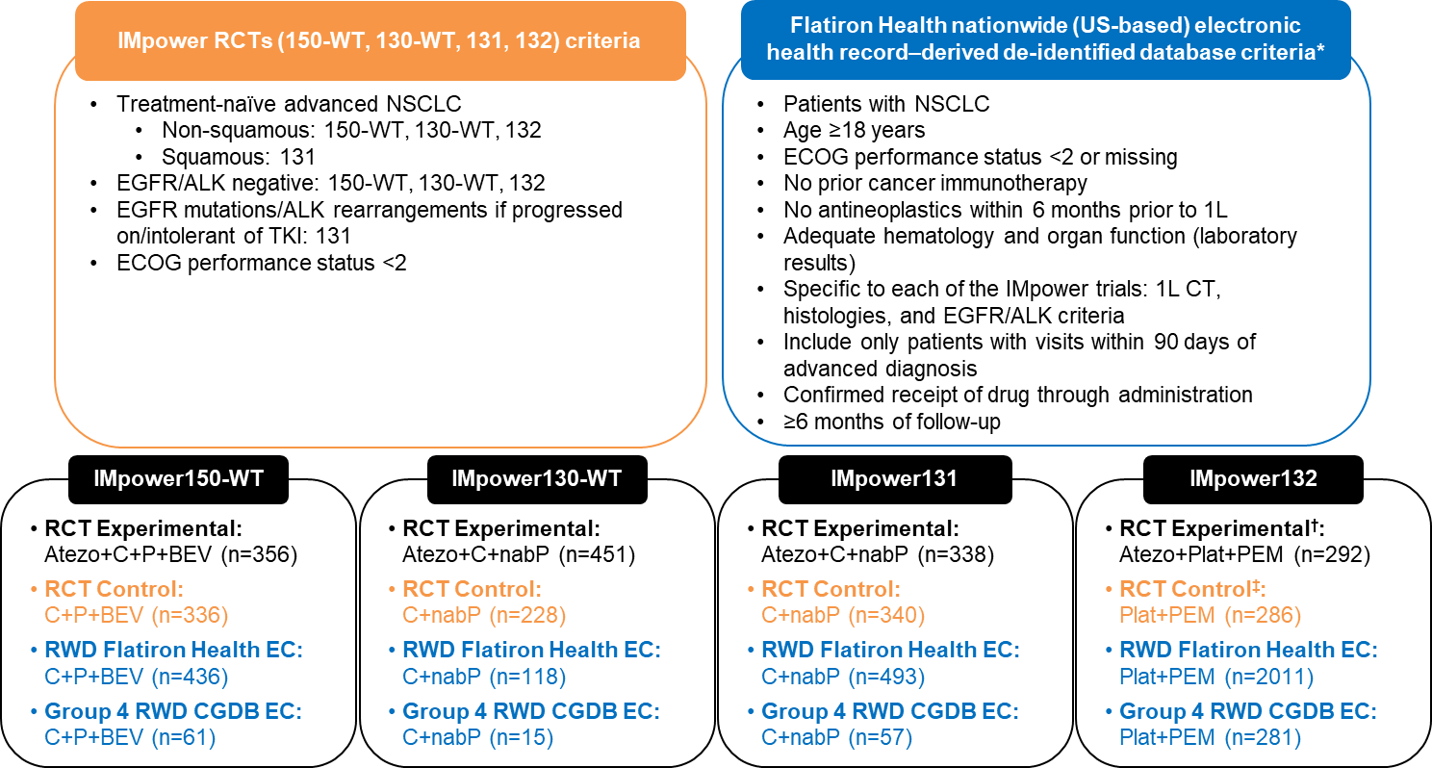
ALK, anaplastic lymphoma kinase; Atezo, atezolizumab; BEV, bevacizumab; C, carboplatin; CIT, cancer immunotherapy; CGDB, clinico-genomic database; CT, chemotherapy; EC, external control; ECOG, Eastern Cooperative Oncology Group; EGFR, epidermal growth factor receptor; nabP, nab-paclitaxel; NSCLC, non-small cell lung cancer; P, paclitaxel; PEM, pemetrexed; PFS, progression-free survival; Plat, carboplatin/cisplatin; RCT, randomized controlled trial; RWD, real-world data; TKI, tyrosine kinase inhibitor; WT, wild type. * Due to limited data availability in RWD, not all inclusion and exclusion criteria were applied. Concomitant illness and co-medication are among the important inclusion and exclusion criteria that were not applied. † WT intent-to-treat population.

