Supplementary Figure S1
Overall survival among patients diagnosed with metastatic KRAS mutant lung cancer (n=287); time origin is date of initial diagnosis of metastatic disease.

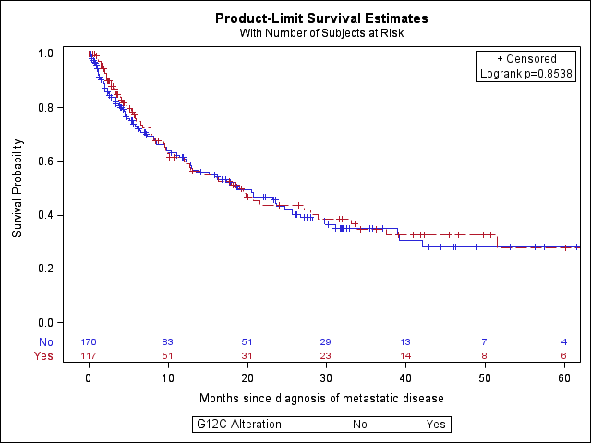
Median OS
G12C: 19.1 months (95% CI 12–29)
Non-G12C: 18.8 months (95% CI 13–26)

