Figure S2 Legend: Changes in peripheral blood CD4 Teffector cells, Tregs, CD8 T cells and NK cells were assessed by flow cytometry using PBMCs collected pre-dose at the indicated time points: CYCLE 1, DAY 1 (C1D1); CYCLE 2, DAY 1 (C2D1); CYCLE 3, DAY 1 (C3D1); CYCLE 4, DAY 1 (C4D1). C1D1 samples are baseline. Data shown are mean ± SD for vopratelimab (JTX-2011) monotherapy at 01.mg/kg (n=7) (A), vopratelimab (JTX-2011) monotherapy at 0.3 mg/kg (n=8) (B), vopratelimab (JTX-2011) 0.1mg/kg + nivolumab (n=7) (C), or vopratelimab (JTX-2011) 0.3mg/kg + nivolumab (n=11) (D).

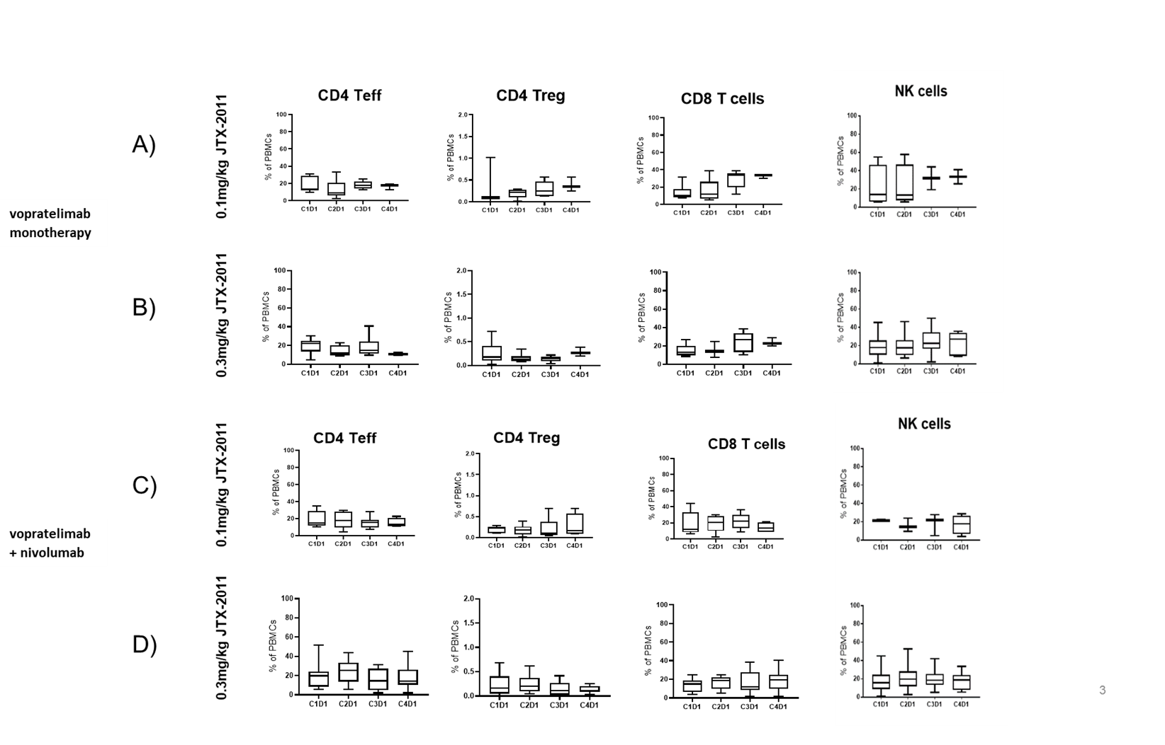
Figure S2. Vopratelimab (JTX-2011) treatment does not induce significant changes in immune cell subsets in peripheral blood.

