Figure S3 Legend: Target engagement by vopratelimab (JTX-2011) was assessed on peripheral blood CD4 T cells following dosing with vopratelimab. A target engagement score of ≥ 70%, indicated by the dotted line, was deemed saturating in our assay. Data are population level analysis and are plotted as mean ± SD (standard deviation).

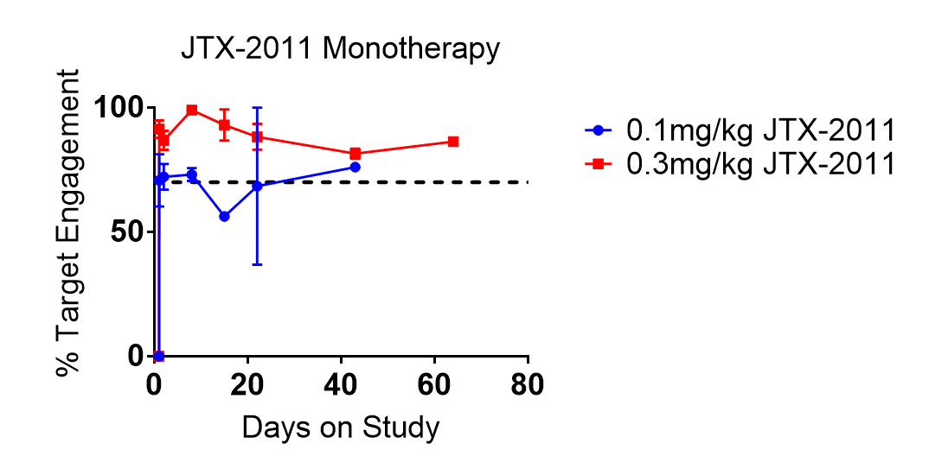
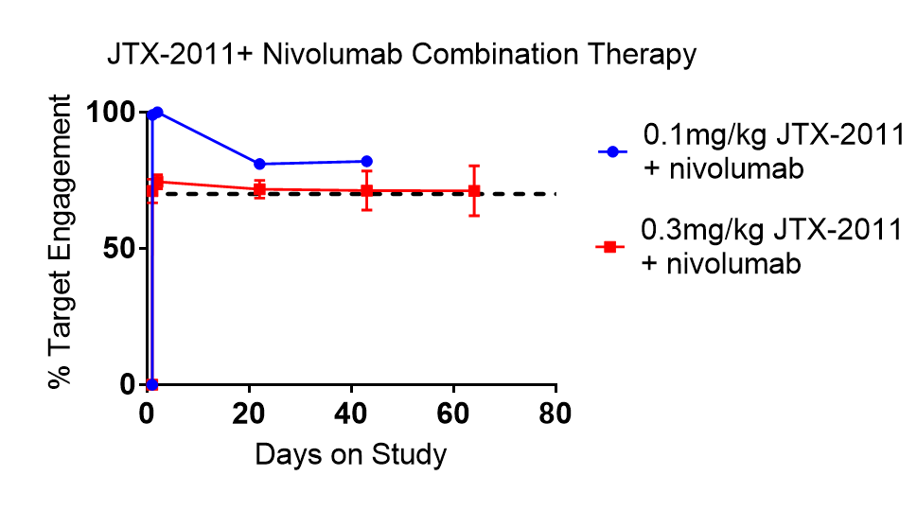
Figure S3. Vopratelimab (JTX-2011) saturates ICOS on peripheral T cells at doses above 0.1 mg/kg q3w

