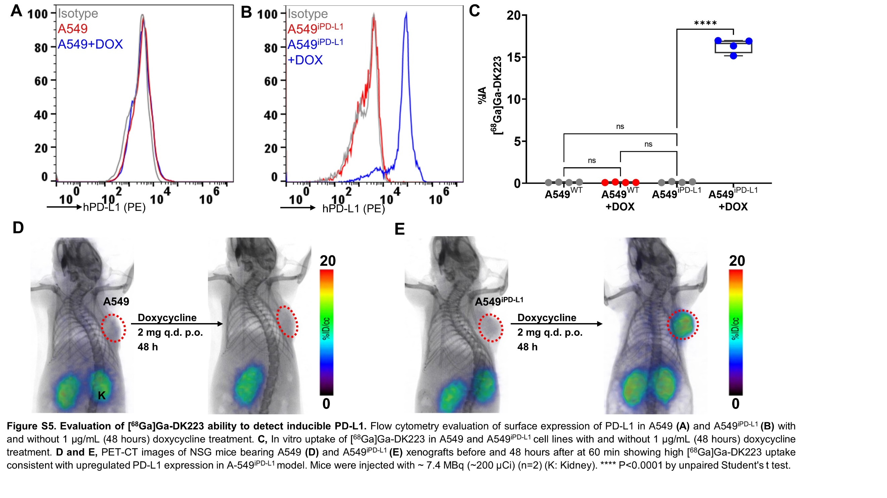

**Figure S5.** **Evaluation of [68Ga]Ga-DK223 ability to detect inducible PD-L1.** Flow cytometry evaluation of surface expression of PD-L1 in A549 **(A)** and A549iPD-L1 **(B)** with and without 1 µg/mL (48 hours) doxycycline treatment. **C,** In vitro uptake of [68Ga]Ga-DK223 in A549 and A549iPD-L1 cells with and without 1 µg/mL (48 hours) doxycycline treatment. **D and E,** PET-CT images of NSG mice bearing A549 **(D)** and A549iPD-L1 **(E)** xenografts before and 48 hours after doxycycline treatment. PET-CT at 60 min shows high [68Ga]Ga-DK223 uptake in A-549iPD-L1tumors. Mice were injected with ~7.4 MBq (~200 µCi) [68Ga]Ga-DK223 (n=2) (K: Kidney). **** P<0.0001 by unpaired Student's t test.