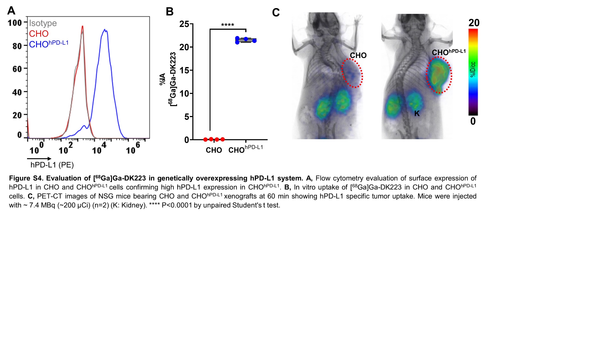

**Figure S4.** **Evaluation of [68Ga]Ga-DK223 in genetically hPD-L1 overexpressing model. A,** Flow cytometry evaluation of surface expression of hPD-L1 in CHO and CHOhPD-L1 cells. **B,** In vitro uptake of [68Ga]Ga-DK223 in CHO and CHOhPD-L1 cells. **C,** PET-CT images of NSG mice bearing CHO and CHOhPD-L1 xenografts at 60 min showing high tumor uptake in CHOhPD-L1. Mice were injected with ~ 7.4 MBq (~200 µCi) (n=2) (K: Kidney). **** P<0.0001 by unpaired Student's t test.