Effects of tepotinib plus gefitinib in patients who had previous treatment with drugs called EGFR inhibitors to treat a type of lung cancer with extra copies of the MET gene

What was INSIGHT and why was it carried out?
INSIGHT was a phase II study, where researchers looked at how effective the drug combination of tepotinib plus gefitinib was in stopping the growth and spread of lung cancer in patients with non-small cell lung cancer (NSCLC) who had previously tried treatments with drugs called EGFR inhibitors.

What is tepotinib?
Tepotinib is a type of targeted (sticks to a specific protein) anticancer drug called a MET inhibitor, which specifically binds to the MET protein. The MET protein normally plays a role in organ development, but when the MET protein becomes altered it can lead to excessive cell growth and cancer.
For patients with NSCLC, it is common to see EGFR gene alterations in their tumors, and therefore receive treatments such as gefitinib, which is a targeted EGFR inhibitor. These tumors may also develop a MET gene alteration (commonly MET amplification), which is a mechanism of resistance to EGFR inhibitors. This results in two gene alterations that need to be targeted with a combination treatment. There are currently no approved targeted treatment options available for patients with NSCLC who have both EGFR and MET gene alterations. Chemotherapy is the current standard of care, but its outcomes are not very promising for these patients, and may often cause unwanted side effects, as it attacks all rapidly dividing cells in a patient’s body. Combination treatments targeting both EGFR and MET gene alterations, such as tepotinib plus gefitinib, are being evaluated and show promising initial results.

Who was included in this study and what treatments did the participants receive?
Participants were adults with advanced/metastatic NSCLC, a type of lung cancer that has started spreading to other parts of the body. Prior to enrolling in this study, all participants had undergone treatment with EGFR inhibitors.
There were 55 participants enrolled in total in the INSIGHT study, from which 31 were randomly assigned to be treated with tepotinib plus gefitinib and 24 were randomly assigned to be treated with chemotherapy. Tepotinib plus gefitinib were taken orally in the form of 3 tablets daily, while chemotherapy was administered intravenously every 21 days and required clinical visits.
- Among all participants, there were 19 patients with MET amplification (an increased number of MET gene copies, which increases MET protein production; this is a situation that leads to cancer cell growth). Of these 19 patients, 12 were randomly assigned to receive tepotinib plus gefitinib and seven were randomly assigned to receive chemotherapy.

How was the effectiveness of tepotinib plus gefitinib measured?
The main question (also known as the primary endpoint) that the researchers wanted to answer was:
- How long did participants live with their cancer before it got worse or before they died due to any cause, related or unrelated to cancer (progression-free survival)?
Other questions (secondary endpoints) included:
- How long did participants live (overall survival) after starting treatment?
- What percentage of the study participants’ tumors showed a response to treatment (objective response rate)? This response may refer to either complete disappearance of tumors (complete response) or tumor size decrease by at least 30% (partial response)
- How long did the effect last in the participants before the tumor started growing again (duration of response)?
- What side effects did the participants develop during treatment?

What were the efficacy results from all patients in the INSIGHT study?
Participants who received tepotinib plus gefitinib lived with their cancer for an average of 4.9 months before it got worse or before they died due to any cause, while participants who received chemotherapy lived for an average of 4.4 months. This means that there was no significant difference observed between the two different treatments when all participants in the study were assessed.

What were the efficacy results in patients with MET amplification?
Tepotinib plus gefitinib treatment was more effective than chemotherapy in those patients who had MET amplification. 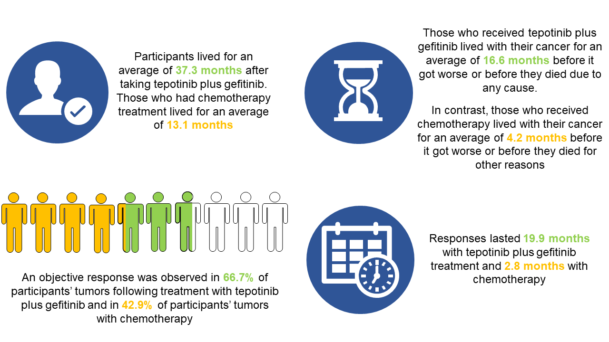

Why is this study important?
The INSIGHT study confirms that tepotinib (a drug aiming to control MET alterations) in combination with an EGFR inhibitor drug, such as gefitinib, benefits patients with advanced NSCLC with confirmed MET amplification. The exploratory results from the INSIGHT study have also provided the rationale for a larger clinical trial, INSIGHT 2. Researchers in this study look at how effective the drug combination of tepotinib plus osimertinib is in stopping the growth and spread of lung cancer in patients with advanced NSCLC who had previously been treated with osimertinib alone (which is the standard of care as first-line treatment for NSCLC tumors with EGFR mutation) and experienced cancer progression due to MET amplification.

