Supplementary Figure S3. The level of mutant and wild-type circulating DNA in baseline plasma samples by patient.
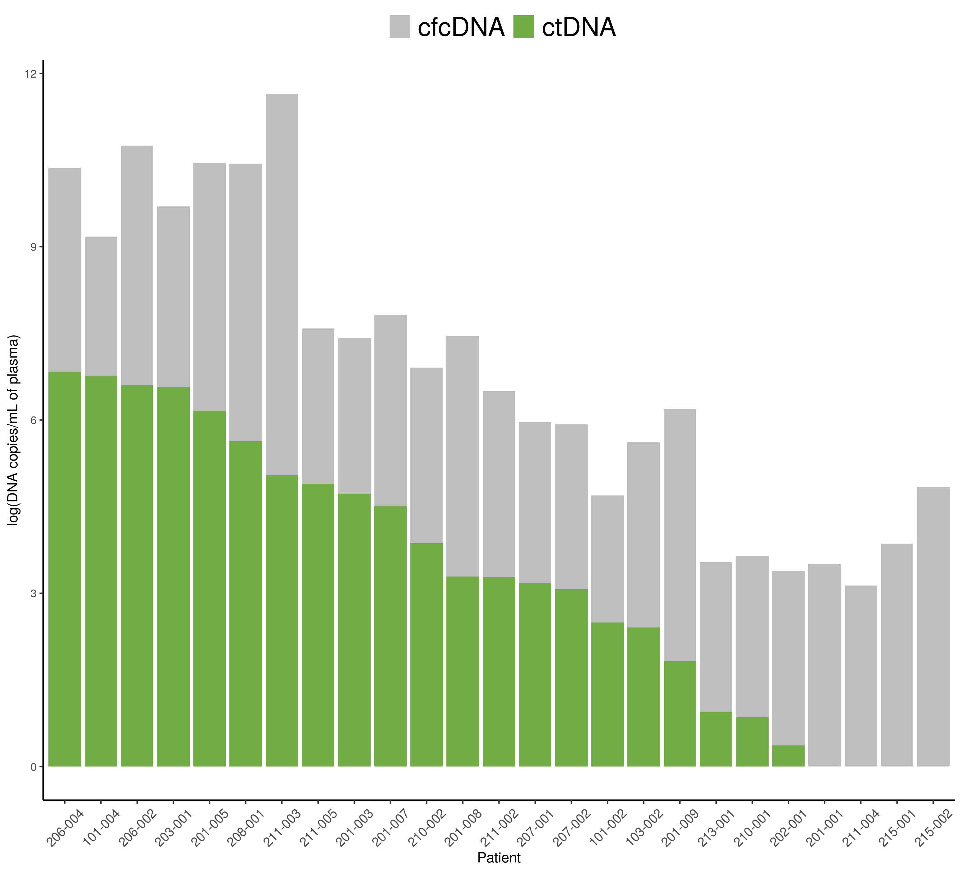
Abbreviations: cfc-DNA: Cell-free circulating DNA; ctDNA: Circulating tumor DNA.
Note: cfcDNA, (corresponding to mutant and wild-type copies) was detected in 100% (25 out of 25) of patients whereas ctDNA (corresponding to mutant copies) was detected in 84.0% (21 out of 25) of patients considering the mutation with the highest allelic frequency per patient.

