CellTiter-Glo® Luminescent Cell Viability Assay (CTG)

Cell culture
SK-BR-3 (Human breast cancer, ATCC) were cultured in McCoy's 5a (Catalogue number: 12330-031, Gibco) plus 10%FBS (Catalogue number: FND500, lot number: 11G271, ExCell). AU565 (Human breast cancer, ATCC), HCC2218 (Human breast cancer, ATCC), HCC1954 (Human breast cancer, ATCC), KYSE-410 (Human esophageal cancer, DSMZ), NCI-H1781 (Human bronchioloalveolar carcinoma, ATCC), NCI-H2170 (Human squamous NSCLC, PUMC), NCI-N87 (Human gastric cancer, ATCC) were cultured in RPMI-1640 (Catalogue number: C22400500BT, lot number: 8118117, Gibco) plus 10% FBS. OE19 (Human esophageal cancer, DSMZ) were cultured in RPMI1640 plus 10% FBS and 2 mM L Glutamine. EFM-192A (Human breast cancer, CoBioer) and ZR-75-30 (Human breast cancer, ATCC) were cultured in RPMI1640 plus 20% FBS. All cells were incubated at 37°C, 5% CO₂.

Drug treatment
KN026 (Alphamab), trastuzumab (Alphamab) and pertuzumab (Alphamab) were all diluted with medium. KN026 was diluted with final concentrations of 676.52, 169.13, 42.28, 10.57, 2.64, 0.88, 0.22, 0.055, and 0.014 nM; trastuzumab was diluted with final concentrations of 687.13, 171.78, 42.95, 10.74, 2.68, 0.67, 0.17, 0.042, and 0.01 nM; pertuzumab was diluted with final concentrations of 675.67, 168.92, 42.23, 10.56, 2.64, 0.66, 0.17, 0.041, and 0.01 nM. Dinaciclib (CDK12 inhibitor, Beyotime, SC6628) and positive control cisplatin were diluted with dimethyl sulfoxide (DMSO, Catalogue number: D2650, lot number: 0666C081, Sigma) with final concentrations of 100, 33.33, 11.11, 3.70, 1.23, 0.41, 0.14, 0.046, and 0.015 nM for dinaciclib and final concentrations of 100, 33.33, 11.11, 3.70, 1.23, 0.41, 0.14, 0.046, and 0.015 μM for cisplatin.

Procedures
Adjust cell density to the appropriate number with medium, add 90μL cell suspensions (1500~8000 cells) to each well of 96-well plates (Catalogue number: 3610, Corning). For combination treatment, 80uL cell suspensions were used to seed. Then, Incubate the plates overnight in humidified incubator at 37°C with 5% CO2. Add 10 µL compound solution (10X) to each well (triplicates). Incubate the plates for incubator at 37°C with 5% CO₂ for three days. After that, add 50 μL CellTiter-Glo® Reagent (Catalogue number: G7572, lot number: 0000309060, Promega) to each well. Mix contents for 2 minutes on an orbital shaker to facilitate cell lysis. Allow the plate to incubate at room temperature for 20 minutes to stabilize luminescent signal. Record luminescence using EnVision 2104 Multi Label Reader. The surviving rate (%) formula= (Luminesence_{sample}-Luminesence_{medium control})/ (Luminesence_{vehicle control}-Luminesence_{medium control}) x100%. Use GraphPad Prism 5.0 software, display sigmoidal dose response- surviving rate graph by a nonlinear regression model to calculate the inhibitory concentration at 50% of maximum (EC₅₀), defined as absolute value of concentration for 50% of maximal inhibitory effect. If absolute EC₅₀ cannot be estimable, a relative EC₉₅, defined as concentration for 95% of inhibitory effect relative to the maximum inhibitory effect is calculated. The data also included the maximum inhibition rate.

Results
The figures below showed relative cell viability of various cell types treated with indicated compounds. The x axis denotes the concentrations of biologics regardless of single or combination treatment. Meanwhile, we performed Loewe synergy and antagonism analysis to show synergistic or antagonistic effects between two drugs in the table below.

Figures: in vitro pharmacology: relative cell viability of various cell types treated with indicated drugs or combinations

- NCI-N87 B. AU565
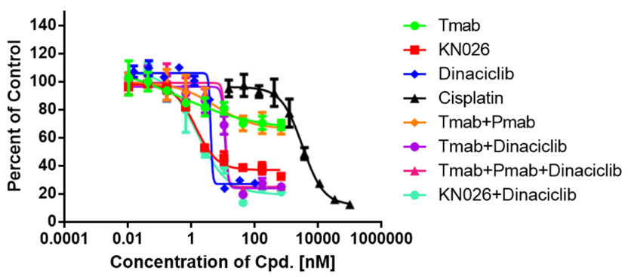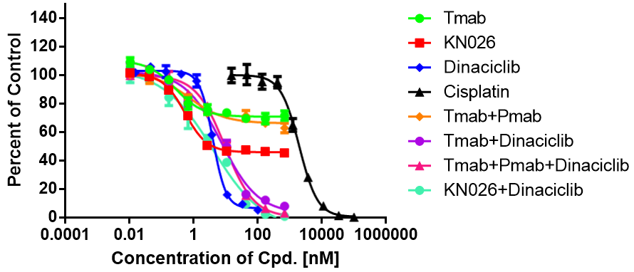

C. EFM192A D. HCC1954
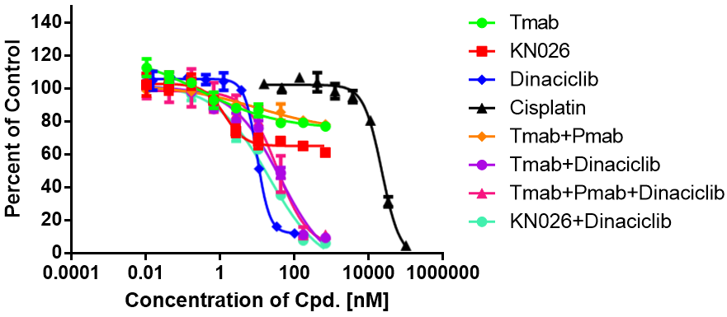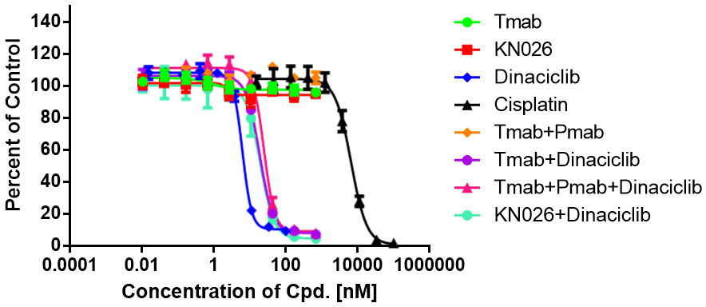

E. HCC2218 F. SK-BR-3
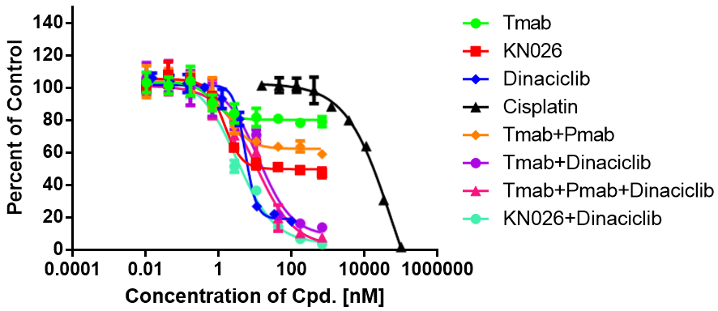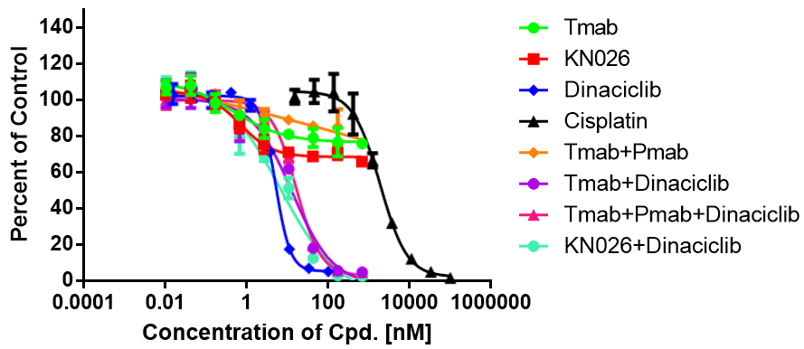

G. KYSE-410 H. OE19
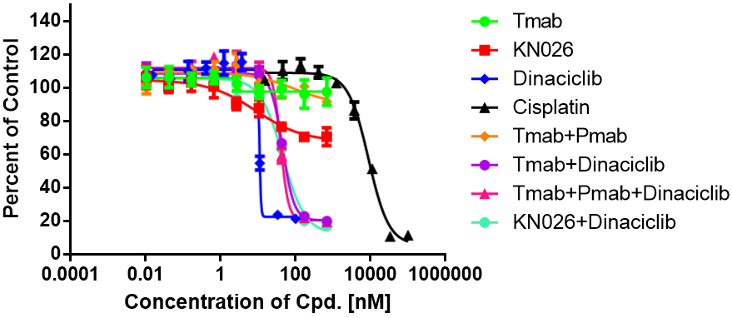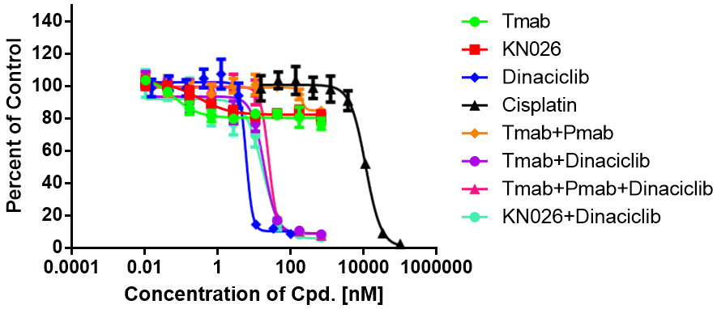

I. ZR-75-30 J. NCI-H2170
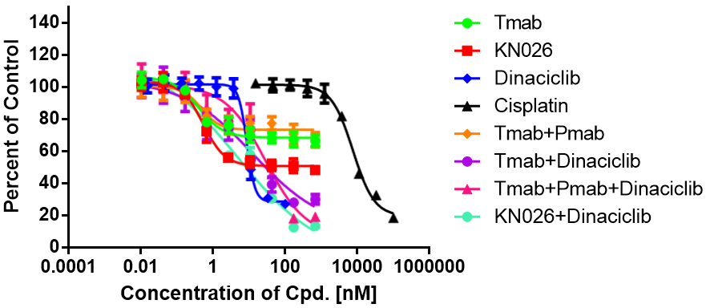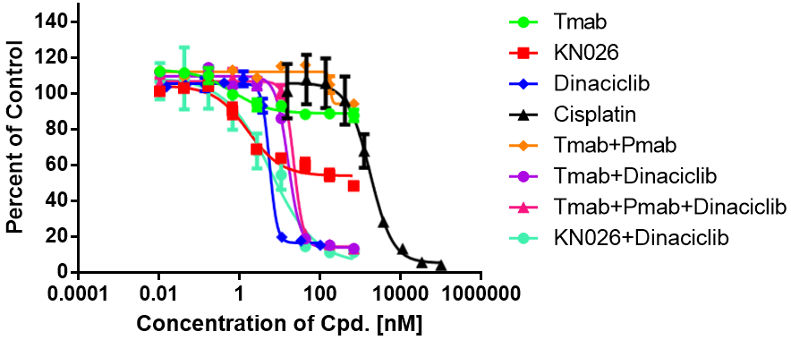

K. NCI-H1781
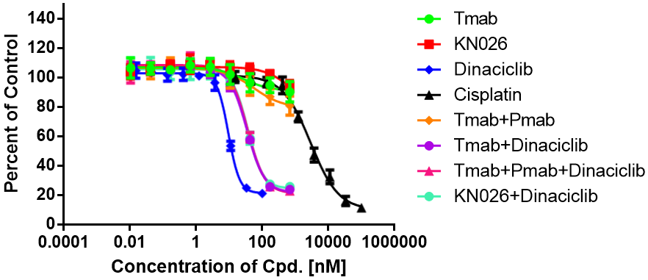
Abbreviations: Tmab, trastuzumab; Pmab, pertuzumab
Relative cell viability of various cell types treated with indicated compounds: A) NCI-N87: human gastric cancer cell line; B) AU565: human breast cancer cell line; C) EFM-192A: human breast cancer cell line; D) HCC1954: human breast cancer cell line; E) HCC2218: human breast cancer cell line; F) SK-BR-3: human breast cancer cell line; G) KYSE-410: human esophageal cancer cell line; H) OE19: human esophageal cancer cell line; I) ZR-75-30: human breast cancer cell line; J) NCI-H2170: human squamous non-small cell lung cancer cell line; K) NCI-H1781: human bronchioloalveolar carcinoma cell line.

Table: Loewe synergy and antagonism analysis summary for KN026 in combination with CDK12 inhibitor dinaciclib or trastuzumab in combination with dinaciclib
Generic subtype | Cell line | Absolute EC₅₀ (nM) |  | Pharmacological effect with dinaciclib |  | Maximum inhibition
 |  | KN026 | Tmab | KN026 | Tmab | KN026 | Tmab + Pmab | Tmab +  Dinaciclib | Tmab + Pmab + Dinaciclib | KN026 + Dinaciclib
HER2/CDK12 co-amplified | NCI-N87 | EC₅₀ 4.0 nM | >687.13 | Addictive | Addictive | 67.49% | 33.11% | 74.79% | 74.25% | 78.55%
 | AU565 | EC₅₀ 3.8 nM | >687.13 | Addictive | Addictive | 54.54% | 37.09% | 92.00% | 96.82% | 99.11%
 | EFM-192A | >676.52 (relative EC₉₅ 5.2 nM) | >687.13 | Addictive | Addictive | 38.76% | 21.64% | 90.55% | 88.72% | 93.94%
 | HCC1954 | >676.52 (relative EC₉₅ 2.0 nM) | >687.13 | Addictive | Addictive | 4.98% | -5.11% | 92.79% | 91.95% | 95.45%
 | HCC2218 | >676.52 (relative EC₉₅ 6.2 nM) | >687.13 | Addictive – synergy | Addictive | 52.40% | 40.81% | 86.09% | 92.25% | 96.28%
 | SK-BR-3 | >676.52 (relative EC₉₅ 4.0 nM) | >687.13 | Addictive | Addictive | 34.04% | 24.05% | 95.15% | 95.37% | 97.48%
 | KYSE-410 | >676.52 (relative EC₉₅ 107.0 nM) | >687.13 | Slight antagonism | Slight antagonism | 29.34% | 8.23% | 79.95% | 80.53% | 83.06%
HER2 amplified/CDK12 non-amplified | OE19 | >676.52 (relative EC₉₅ 1.0 nM) | >687.13 | Addictive | Addictive | 19.06% | 15.00% | 91.52% | 92.36% | 93.29%
 | ZR-75-30 | >676.52 (relative EC₉₅ 3.2 nM) | >687.13 | Addictive – synergy | Addictive | 51.69% | 32.85% | 69.98% | 80.82% | 86.57%
 | NCI-H1781 | >676.52 (relative EC₉₅ 712.0 nM) | >687.13 | Slight antagonism | Slight antagonism | 5.87% | 19.04% | 76.05% | 77.07% | 74.12%
 | NCI-H2170 | >676.52 (relative EC95 14 nM) | >687.13 | Addictive | Slight antagonism | 51.59% | 5.74% | 86.55% | 86.68% | 88.71%
Abbreviations: EC₅₀, concentration for 50% of maximal inhibitory effect; Relative EC₉₅, concentration for 95% of inhibitory effect relative to the maximum inhibitory effect; Tmab, trastuzumab; Pmab, pertuzumab.

