**SUPPLEMENTARY DATA**

**Supplementary Figure 1. A.** GIS distributions in *BRCA1/2* mutant and WT tumors in our cohort (top) and in TCGA breast and ovarian cancers (bottom). **B.** The Venn diagram showing the overlap between panel-Sig3, GIS and *BRCA1/2* mutations. **C.** PFS for two GIS categories using a threshold of 49 instead of 42. **D-E.** Cox regression models with 49 GIS threshold without *BRCA1/2* mutation status (top) and with *BRCA1/2* mutation status (bottom).

**­­­­­­­­­­**

|  |
| --- |
|  |
| **Supplementary Figure 2**. A. The distribution and the cosine similarities with the most compatible signatures in COSMIC catalog of three signatures that was discovered with SigProfiler from 37 WES tumors. **B-C**. KM curves comparing PFS of samples selected by different SigA (the most similar to Sig3) exposure thresholds; (top) larger than 25 and (bottom) zero. **D.** The SigA exposures in the WES-Sig3+ (5% FPR) and WES-Sig3- patients. **E.** Number of samples comparing categories based on SigA exposures to other HRD measures. |

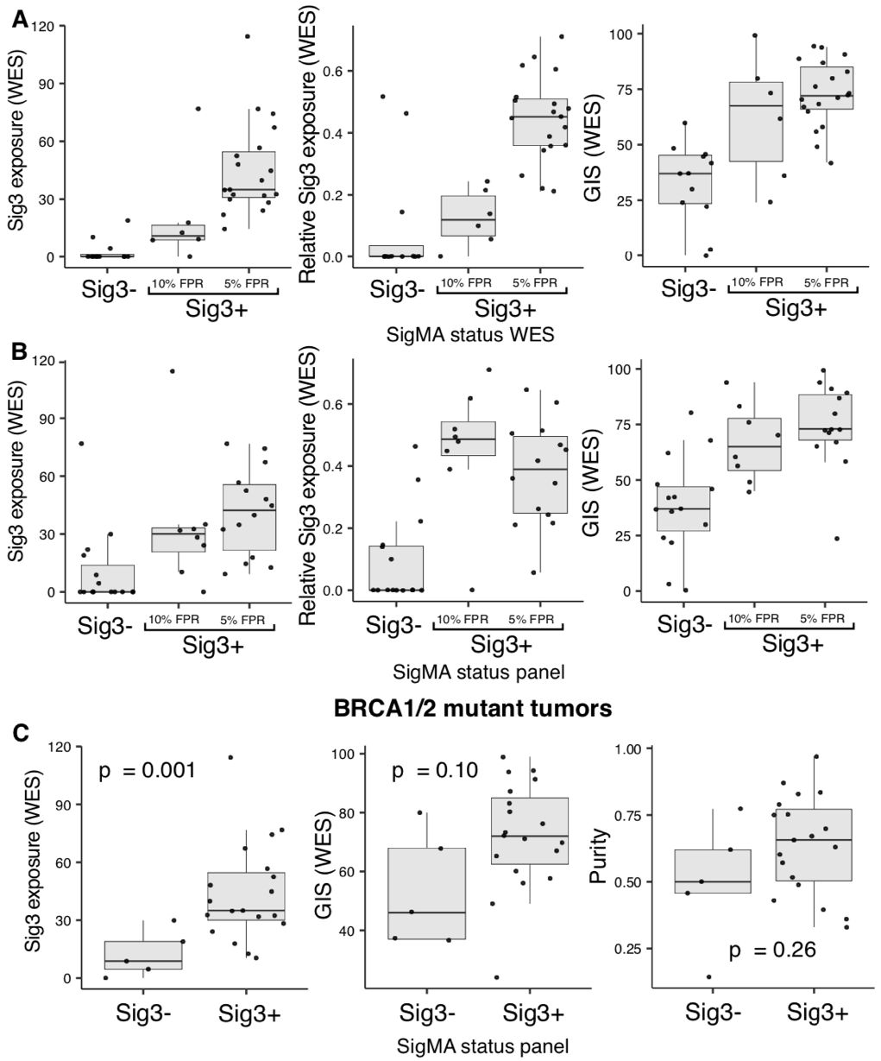**Supplementary Figure 3.** **A.** Relative (left) and absolute (middle) Sig3 exposure calculated with NNLS, and GIS (right) from WES data for three groups of samples based on their SigMA score (Sig3- samples and Sig3+ samples defined by 10% and 5% FPR thresholds; 5% threshold is used in Fig1). **B.** Same as panel A but with groups on x-axis are based on SigMA scores from panels. The 10% FPR threshold is used in Fig1-3. The values on the y-axis are still calculated from WES data. **C.** The absolute Sig3 exposure (left) and GIS (right) from WES data in the groups based on the Sig3 status from WES and panels. **D.** The *BRCA1/2*mut Sig3- samples are compared to WT Sig3- and Sig3+ samples. All the distributions in each panel are compared but only the significant ones are marked.

|  |
| --- |
|  |

|  |
| --- |
|  |
|  |  |



**Supplementary Figure 4.** The number of patients that are *BRCA1/2*mut in different Sig3 categories. (Left) Panel-Sig3, (Right) WES-Sig3.

|  |
| --- |
|  |
| **Supplementary Figure 5.** A-B. Comparison of PFS according to GIS and Sig3 from panel for GIS thresholds of 42 and 49, respectively**.** Sig3+/GIS- group contains 1 and 2 patients respectively for paels A-B, both were censored and had low PFS values. As a result, they were not informative and are not shown**. C,** grouping based on Sig3 exposure calculated with NNLS is compared to SigMA classification. NNLS+ indicates a Sig3 exposure greater than zero. |

|  |
| --- |
|  |
| **Supplementary Figure 6.** Cox regression where each of the HRD measure (Sig3 status from panel with SigMA, Sig3 status from WES with SigMA, GIS from WES and *BRCA1/2*mut status (from left to right) is combined with the same potentially confounding covariates. |

|  |
| --- |
|  |
| **Supplementary Figure 7.** Influence of gene amplification implicated in resistance to PARP*i* on PFS. **A,** KM curves for four other genes that have a non-significant negative influence on PFS. **B,** Comparison of PFS in four categories based on *ATR* amplification and Sig3 status. |