**Supplementary Figure S3**

Characterization of the anti-tumor effects of selective KRAS G12C inhibitors in the H23 brain tumor model *in vivo*. **A.** Experimental schematic of drug efficacy study in the intracranial H23 model. **B**. Bioluminescence imaging of H23 tumors in mice before and after 3 weeks of daily drug treatment. **C.** Total flux post/pre ratio. **D.** Total flux follow-up/pre ratio. **E.** Total flux follow-up/post ratio. **F.** Probability of survival in the H23 intracranial model (p=0.26 by log-rank test). **G**. Representative microscopic images of immunohistochemistry for Ki-67 and p-ERK in intracranial H23 tumors after 2-day treatment of mice. **H**. Quantification of % positivity of Ki-67 and p-ERK immunohistochemistry. The Mann-Whitney test was used for comparison.

**A**

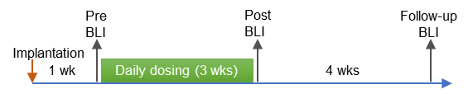

**B C**



**Adagrasib**

**Adagrasib**

Vehicle

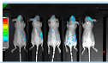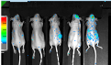

Pre

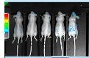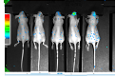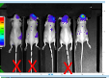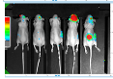

3 wks

3 wks

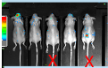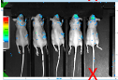

Post

Adagrasib

**D E F**



Adagrasib

**Adagrasib**

**Adagrasib**



**G**

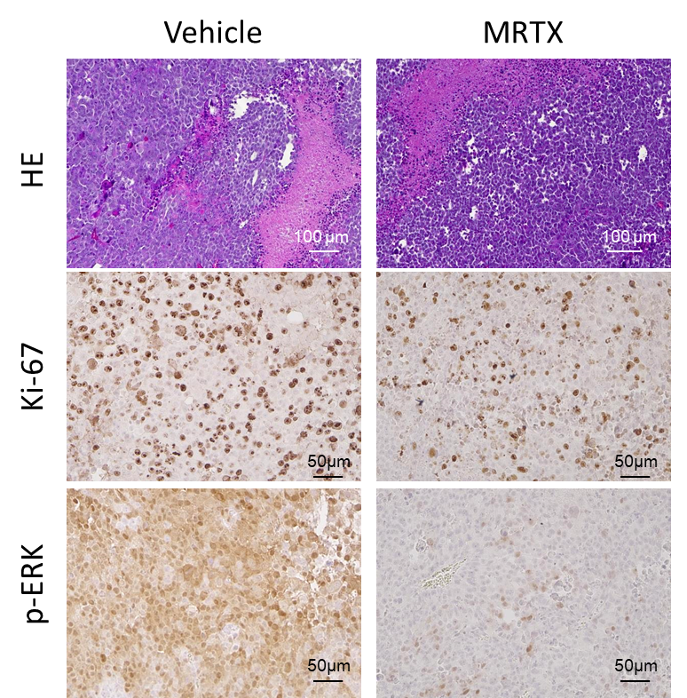

Adagrasib

**H**



**Vehicle Adagrasib**

**Vehicle Adagrasib**