Supplemental Figure S3. Summary of the most commonly altered genes at baseline.
- Summary of the most commonly altered genes at baseline in patients enrolled in all phases of the study with >10 total alterations visualized by patient using Oncoprint (1).
- Summary of the most commonly altered genes in patients enrolled in all phases of the study with >10 total alterations. This includes copy number alterations, sort variants, and rearrangements of known, likely, and unknown significance.

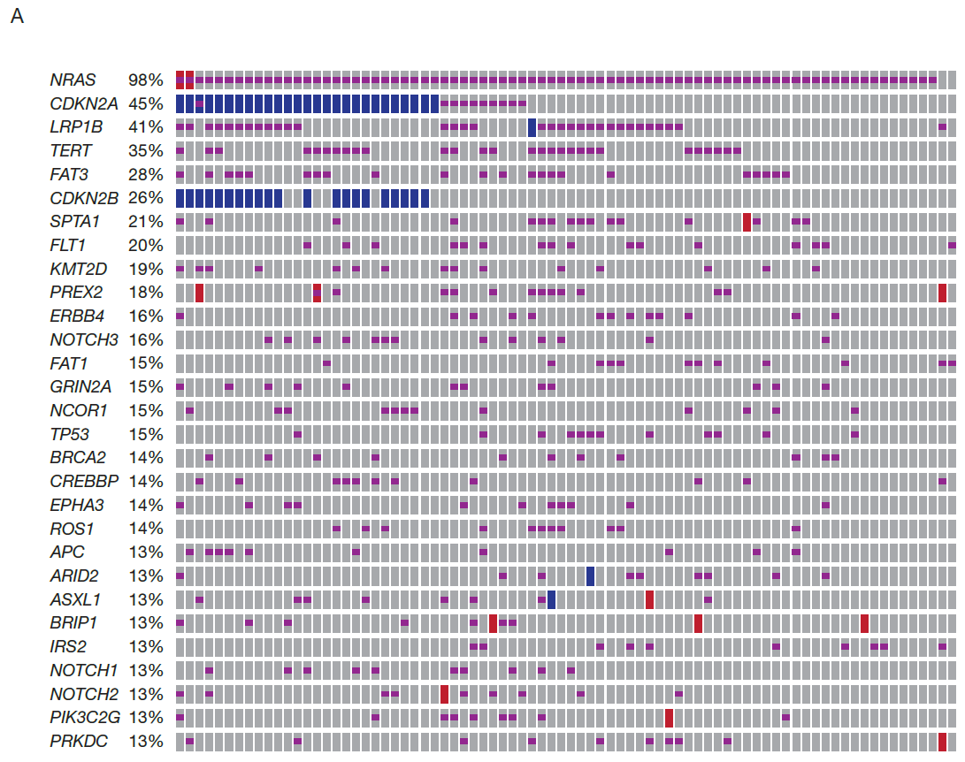
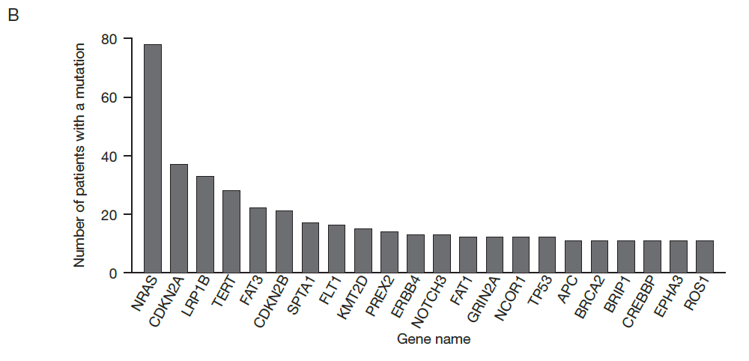
REFERENCE
- He Y, Zhou J, Ma S, Nie Y, Yue D, Jiang Q, et al. Multi-responsive "turn-on" nanocarriers for efficient site-specific gene delivery in vitro and in vivo. Adv Healthc Mater 2016;5:2799-812.

