Figure S4. Kaplan-Meier plots of progression-free survival and overall survival (Full analysis set)

Progression-free survival
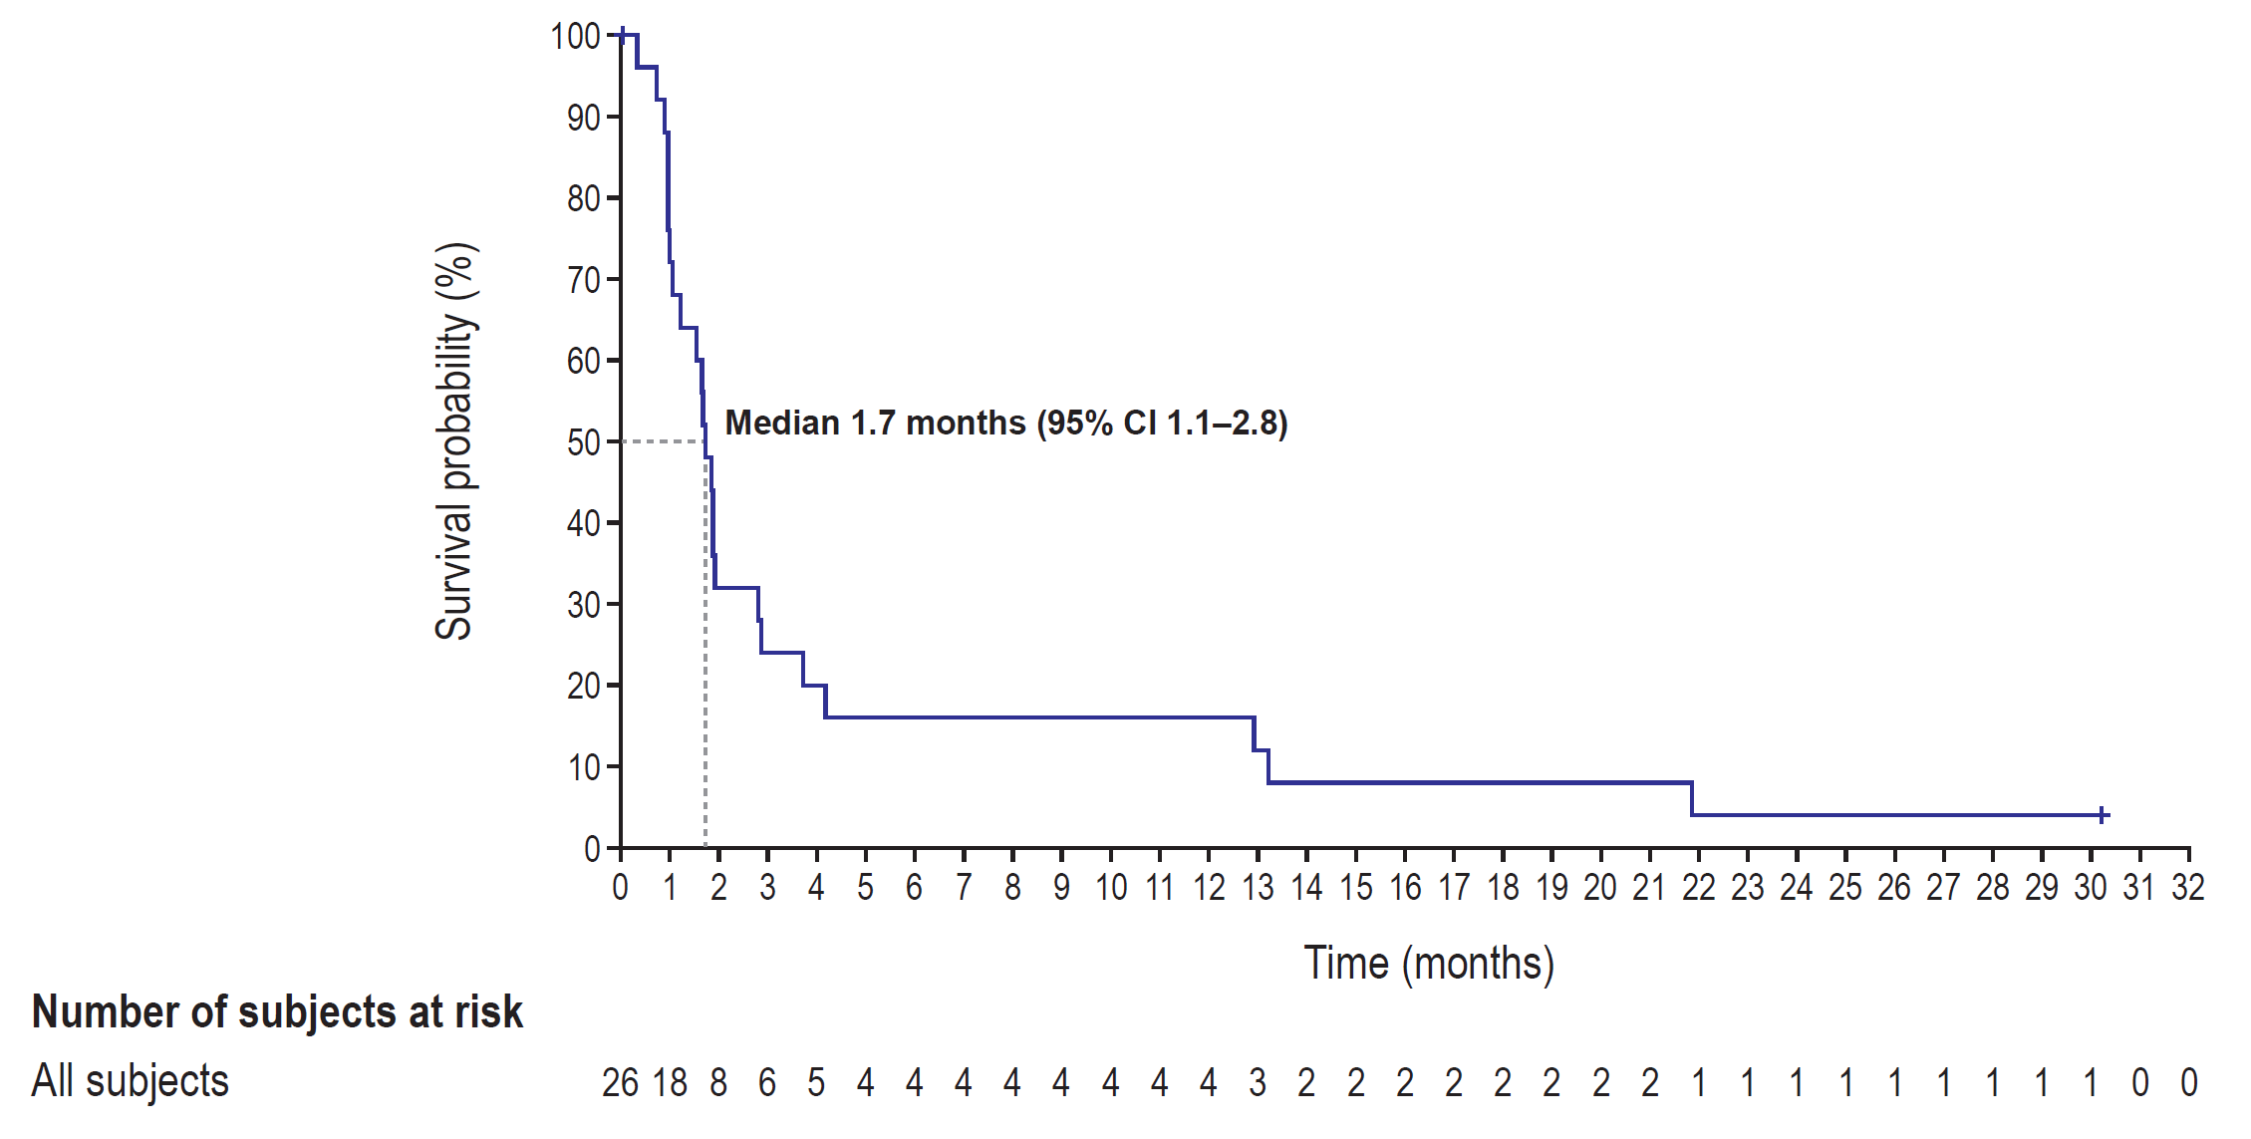

Overall survival
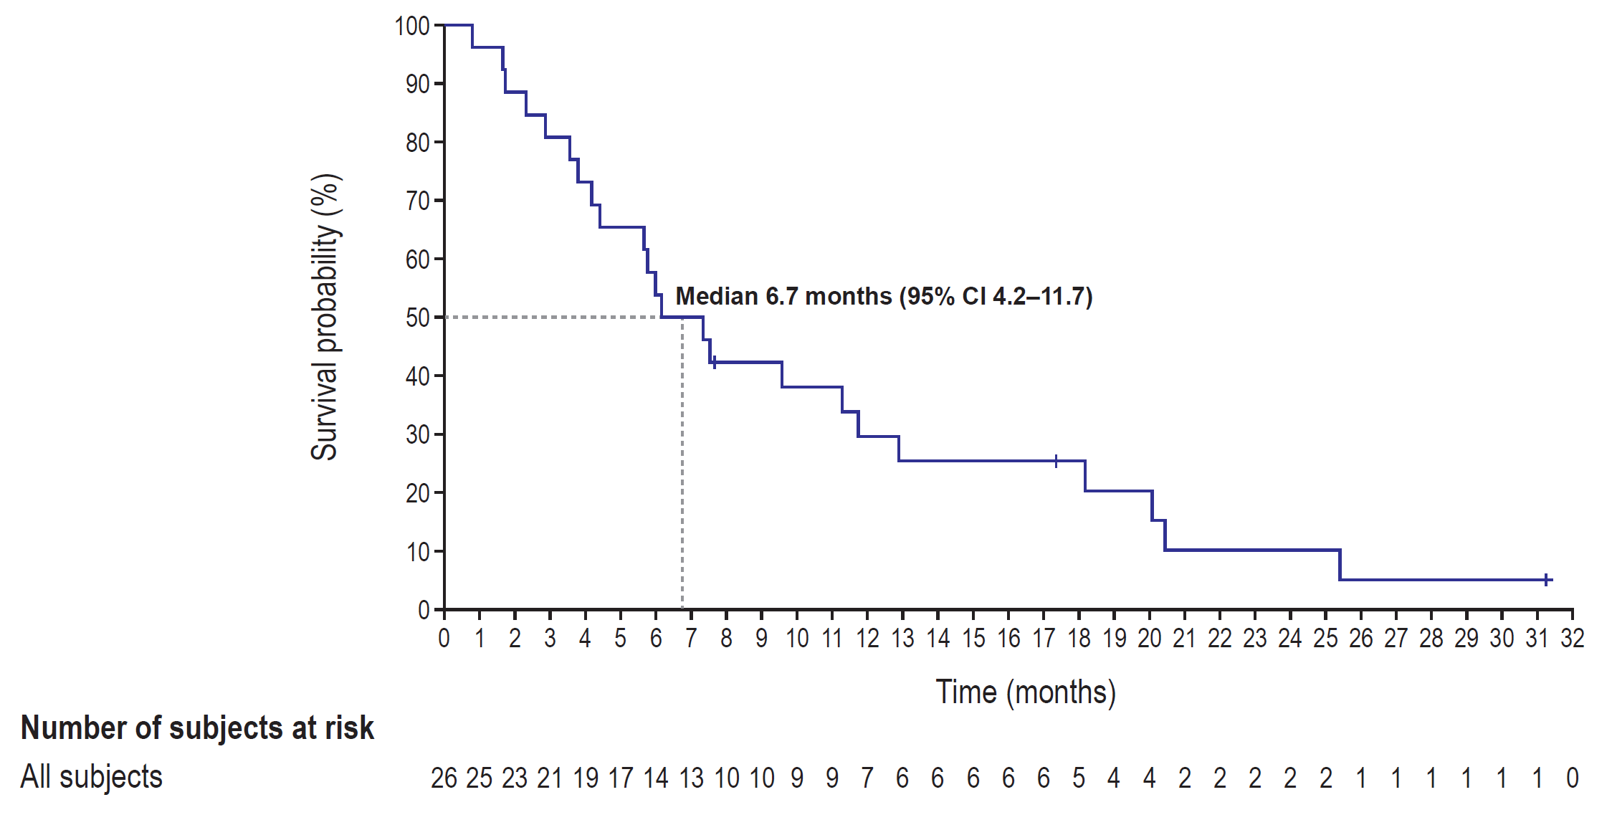

Abbreviation: CI, confidence interval

