Figure S3. Comprehensive gene profiling in archival tumor tissue from patients with tumor response assessments and sufficient tumor tissue for comprehensive genomic profiling (n = 16)
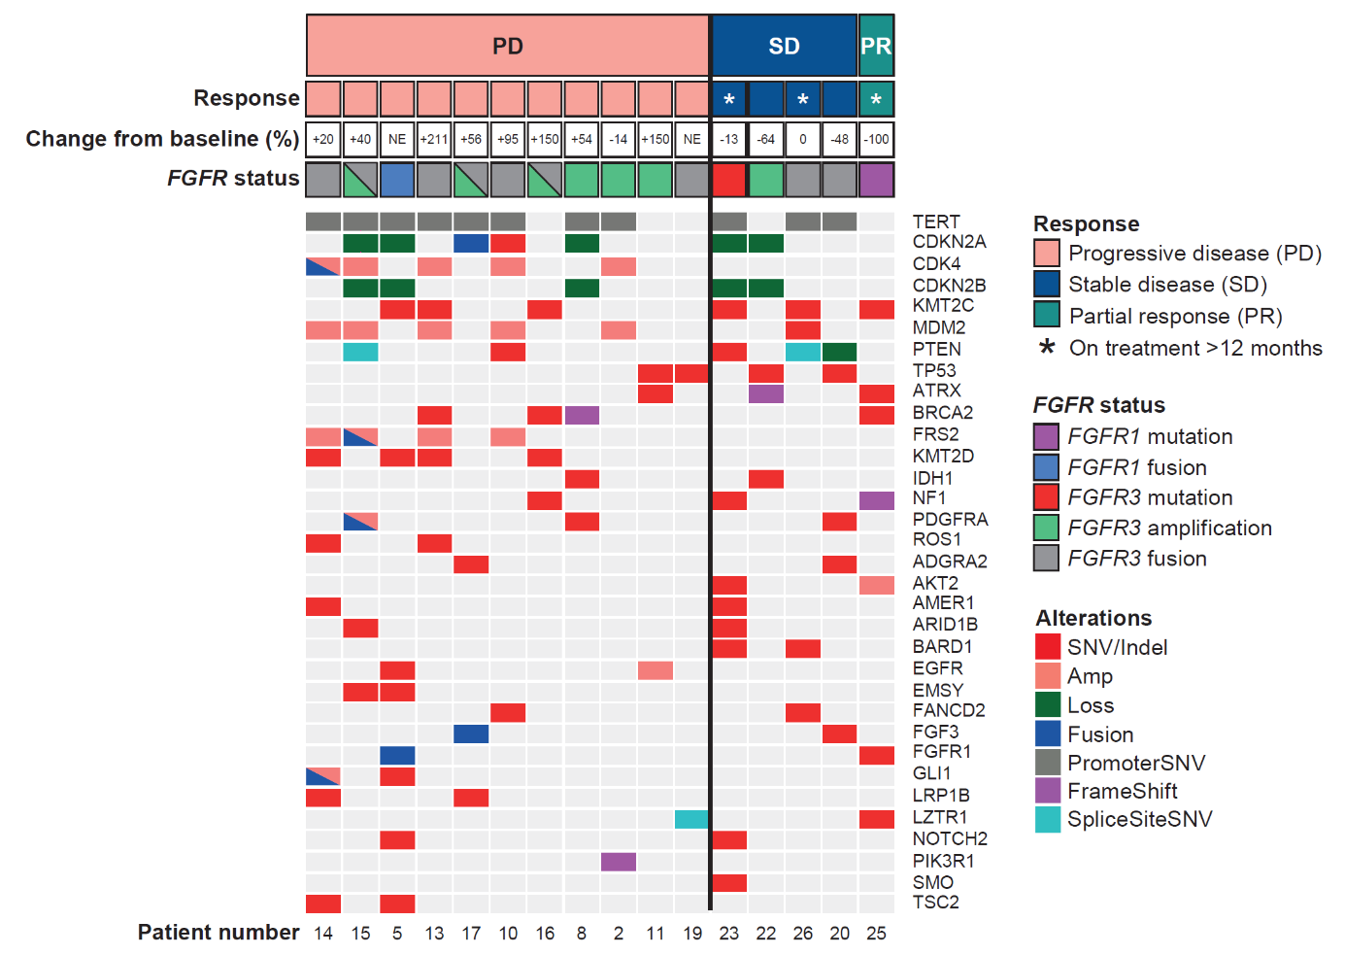
Note: FGFR status indicates results at screening.* Best response and change from baseline in tumor size (%) are reported per local investigator designation. Results of other gene analyses are obtained from centrally performed Next Generation Sequencing (by Foundation Medicine) among the 16 cases with available tissue.
ADGRA2, adhesion G protein-coupled receptor A2; AKT2, AKT serine/threonine kinase 2; AMER1, APC membrane recruitment protein 1; ARID1B, AT-rich interaction domain 1B; ATRX, α thalassemia/mental retardation syndrome X-linked; BARD1, BRCA1-associated RING domain 1; BRCA2, breast cancer gene 2; CDKN2A or B, cyclin-dependent kinase Inhibitor 2A or B; CDK4, cyclin-dependent kinase 4; EGFR, epidermal growth factor receptor; EMSY, BRCA2-interacting transcriptional repressor; FANCD2, FA complementation group D2; FGF3, fibroblast growth factor 3; FGFR, fibroblast growth factor receptor; FRS2, fibroblast growth factor receptor substrate 2; GLI1, GLI family zinc finger 1; IDH1, isocitrate dehydrogenase 1; KMT2C or D, lysine methyltransferase 2C or D; LRP1B, low-density lipoprotein receptor-related protein 1B; LZTR1, leucine zipper like transcription regulator 1; MDM2, mouse double minute 2 homolog; NE, not evaluable; NF1, neurofibromin 1; NOTCH1, notch homolog 1, translocation-associated; PDGFRA, platelet-derived growth factor receptor alpha; PIK3R1, phosphoinositide-3-kinase regulatory subunit 1; PD, progressive disease; PR, partial response; PTEN, phosphatase and tensin homolog; ROS1, c-ros oncogene 1; SMO, smoothened, frizzled class receptor; SD, stable disease; SNV, single-nucleotide variant; TERT, telomerase reverse transcriptase; TP53, tumor protein 53; TSC2; TSC complex subunit 2.
*Except case 16 (see Table S3)

