Supplementary figure S3:
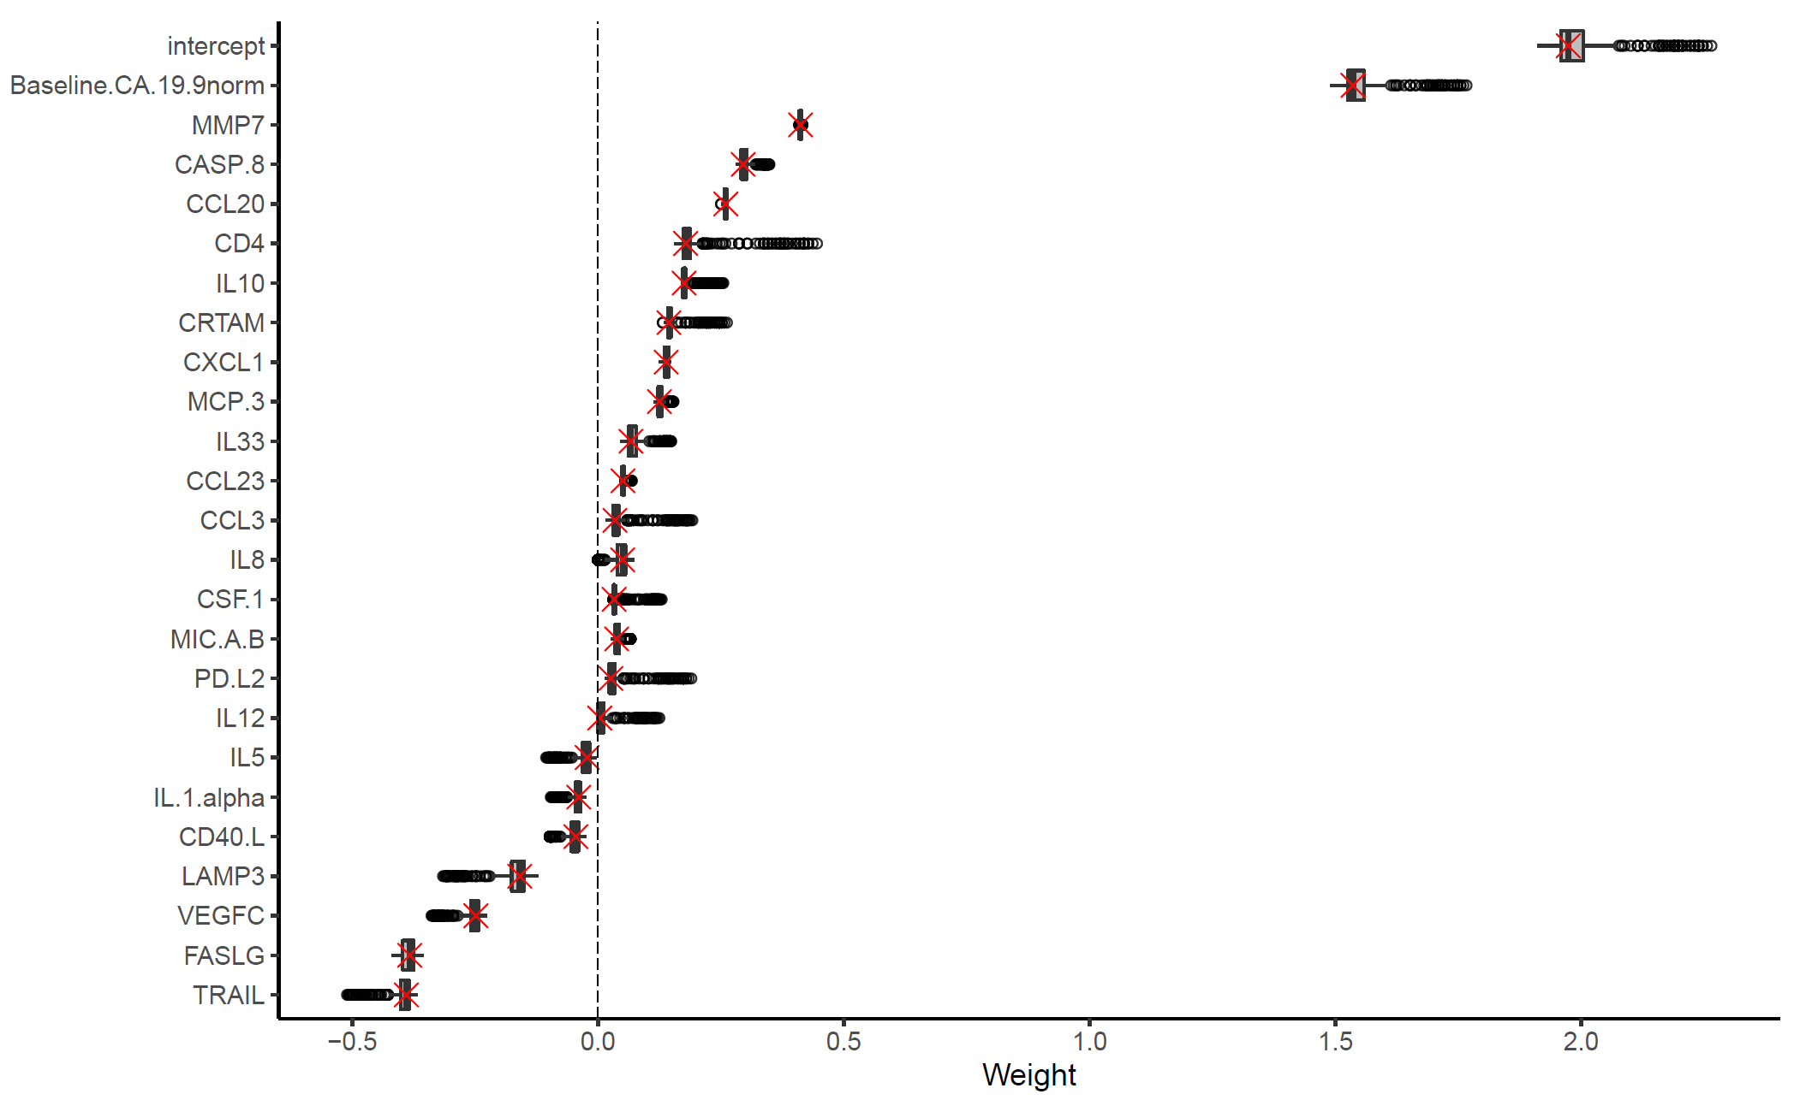
Box plots of the weights for the proteomic features contributing to the Index II. The range of values from 500 replicates of training in cross–validation is shown. Red crosses indicate the final weights used in the Index II. In the box plots, the midline represents the median, the two edges of the box represent the lower and upper interquartile range (IQR), upper whisker = min(max(x), Q3 + 1.5 × IQR) and lower whisker = max(min(x), Q1 − 1.5 × IQR).

