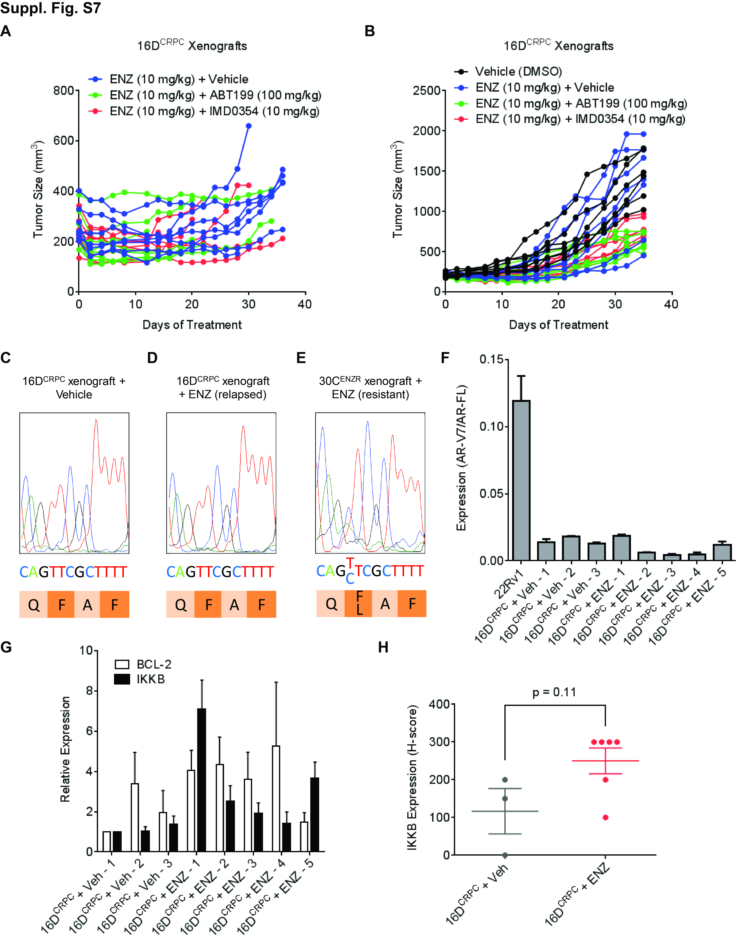
Supplementary Figure S7. Emergence of ENZ resistance can be prevented by BCL-2 or IKKB inhibitor in vivo and is associated with IKKB upregulation.
A. Tumor growth of 16D^{CRPC} xenografts with the treatment of vehicle control (DMSO), 100 mg/kg ABT199 or 10 mg/kg IMD0354, in combination with 10 mg/kg ENZ, when the tumor size exceeds 200 mm³. Individual animals are denoted.
B. Tumor growth of 16D^{CRPC} xenografts with the treatment of vehicle control (DMSO) or 10 mg/kg ENZ, when the tumor size exceeds 200 mm³. After the size of ENZ-treated tumor reaches 300 mm³, the mice are additionally treated with vehicle control (DMSO), 100 mg/kg ABT199 or 10 mg/kg IMD0354. Individual animals are denoted.
C~D. Representative sequencing results for AR point mutation F877L in 16D^{CRPC} xenografts collected at the endpoint with treatment of vehicle (C) or ENZ (D).
E. Representative sequencing results for AR point mutation F877L in 30C^{ENZR} xenografts collected at the endpoint with treatment of ENZ.
F. mRNA levels of AR-V7 in 16D^{CRPC} xenografts collected at the endpoint with treatment of vehicle (Veh) or ENZ. 22Rv1 used as AR-V7 positive control.
G. mRNA levels of BCL-2 and IKKB in 16D^{CRPC} xenografts collected at the endpoint with treatment of vehicle (Veh) or ENZ.
H. Expression (H-score) of cytoplasmic IKKB protein in 16D^{CRPC} xenografts collected at the endpoint with treatment of vehicle (Veh) or ENZ. p-value indicated.

