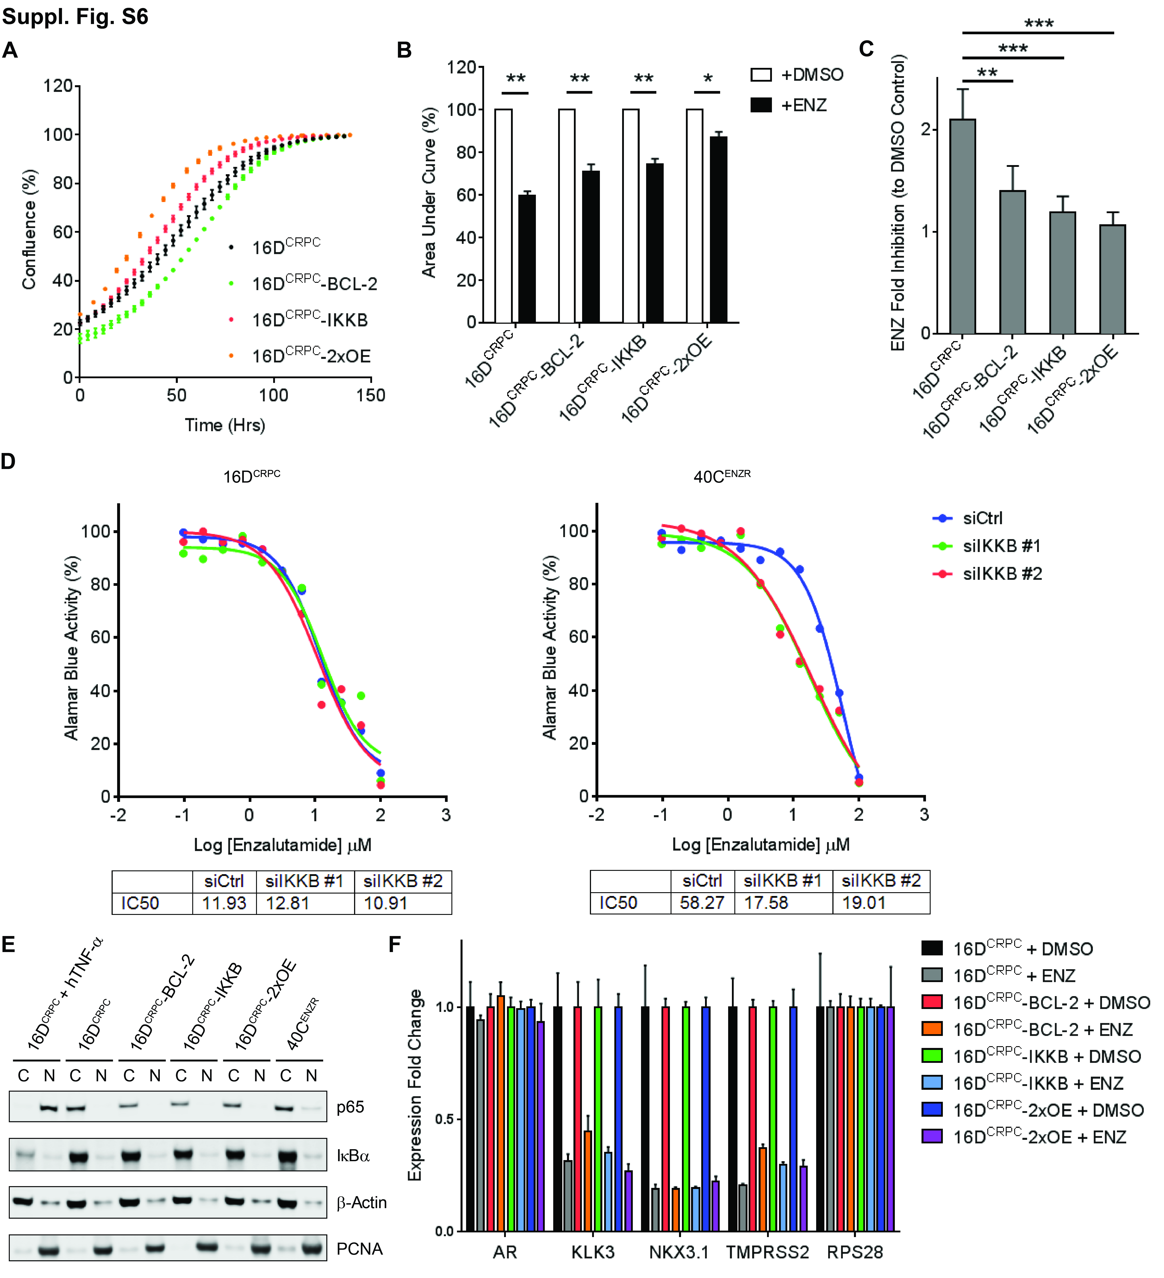
Supplementary Figure S6. 16D^{CRPC} cell line variants expressing BCL-2 and IKKB are resistant to ENZ.
A. Growth kinetics of 16D^{CRPC} cell line variants in complete media without ENZ.
B. Normalized Area Under Curve for the growth kinetics of 16D^{CRPC} cell line variants in the absence and presence of 20 μM ENZ. All ENZ-treated cells were normalized to DMSO controls within the same cell line variants. *, p < 0.05. **, p < 0.01.
C. ENZ fold inhibition of cell viability measured by Alamar Blue assays at last timepoint. All treated cell variants were normalized to DMSO controls within the same cell variant. **, p < 0.01. ***, p < 0.001.
D. Representative curve of cell viability of 16D^{CRPC} (left) and 40C^{ENZR} (right) cells after 6 days of growth in varying concentrations of ENZ in the presence of 20 nM negative control (siCtrl), siIKKB #1 or siIKKB #2, with IC50 values (μM) indicated at bottom.
E. Protein levels of nuclear p65 and cytoplasmic IκBα in 16D^{CRPC} cell line variants and 40C^{ENZR} cells (C: cytoplasmic. N: nuclear). 16D^{CRPC} cells treated by 30 ng/ml human tumor necrosis factor-alpha (hTNF-α) for 1 hour served as positive control of the activation of NF-κB pathway. β-Actin used as cytoplasmic loading control. PCNA used as nuclear loading control.
F. mRNA expression levels of AR, KLK3, NKX3.1 and TMPRSS2 in 16D^{CRPC} cell line variants after 6 days of growth in the presence of DMSO or 20 μM ENZ. All treated cell variants were normalized to DMSO controls within the same cell variant. RPS28 used as internal control.

