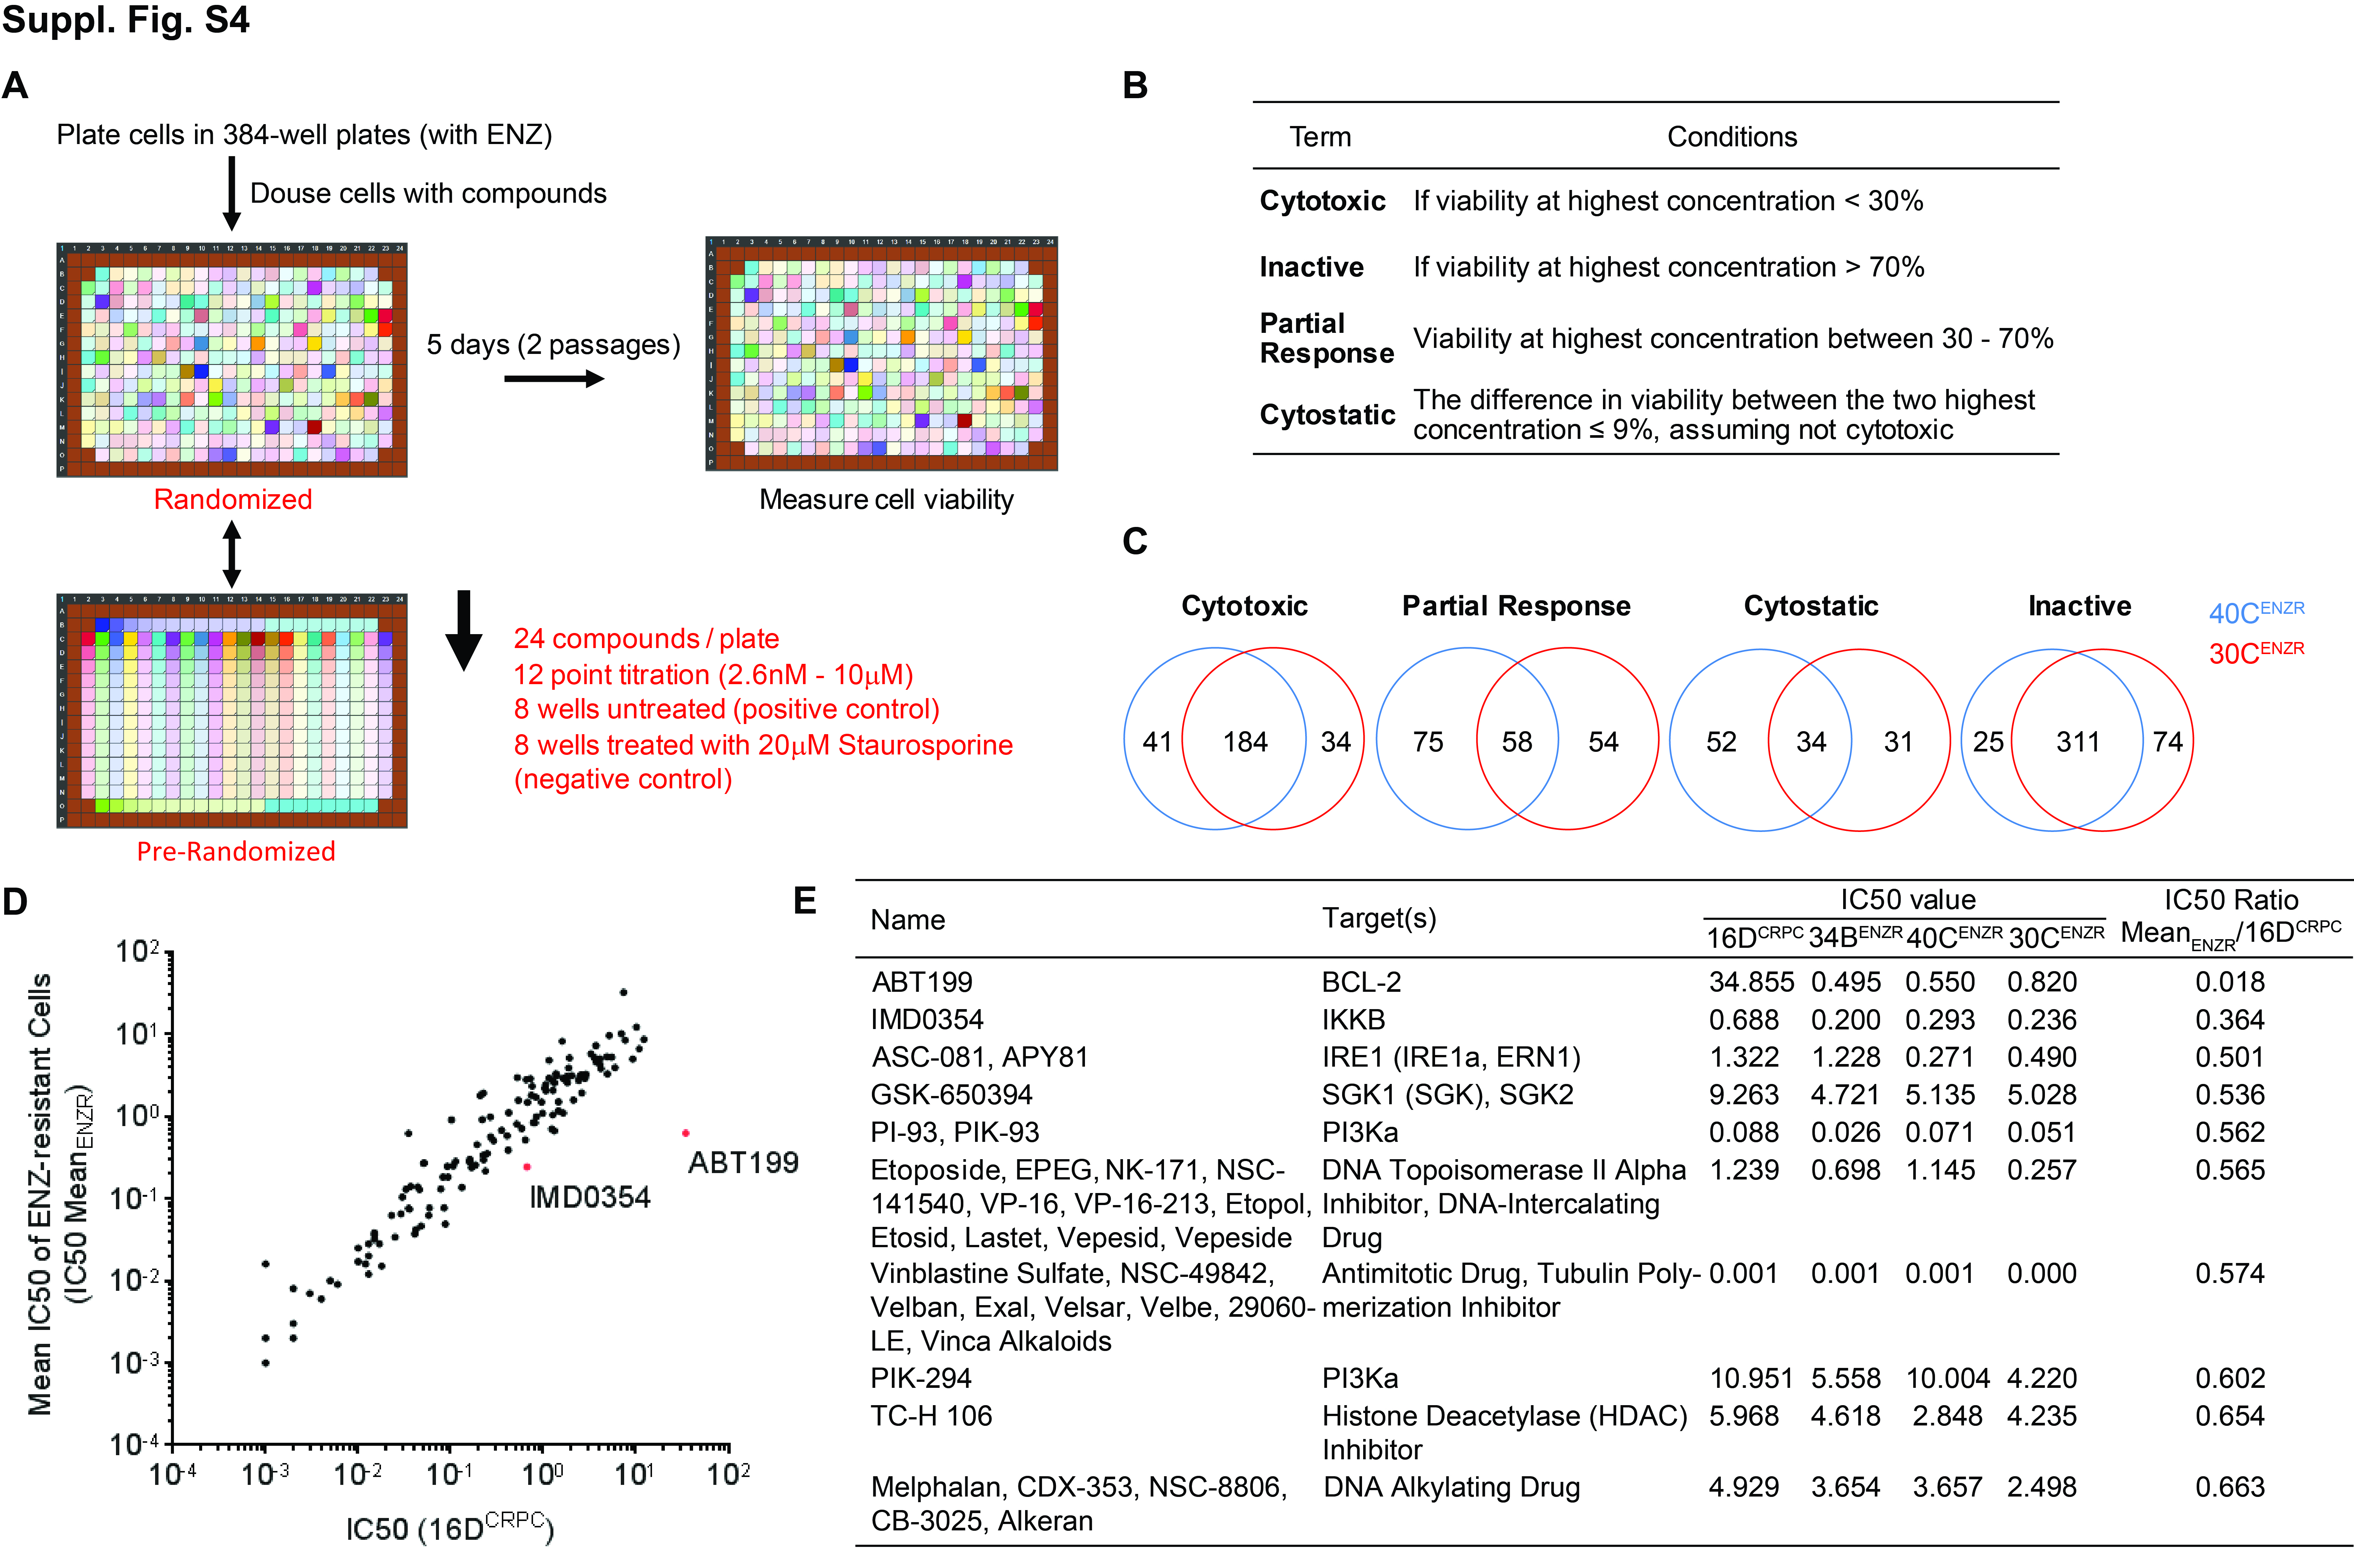
Supplementary Figure S4. Pharmacological screens identify BCL-2 and IKKB inhibitor that specifically targets ENZ-resistant cell lines.
A. Schematic overview of the randomized plate setting.
B. Definition of the four subsets of drug effects.
C. Summary of results for the initial drug screen performed in 40C^{ENZR} and 30C^{ENZR} cell lines. Numbers of compound are indicated.
D. Scatter graph showing the IC50 values of 16D^{CRPC} and the mean IC50 values of the three ENZ-resistant cell lines (IC50 Mean_{ENZR}) for the 138 compounds. ABT199 and IMD0354 are highlighted.
E. Summary of the top 10 compounds ranked by the IC50 ratio Mean_{ENZR}/16D^{CRPC}.

