SUPPLEMENTARY FIGURES

*DNA-based next-generation sequencing—163 were identified by MSK-IMPACT and 4 by Foundation One; $IHC, immunohistochemistry; §SRM-MS, selected reaction monitoring mass spectrometry

Supplementary Figure S1. Patient cohort by DNA, RNA, and protein testing. In this retrospective cohort, 168 patients with MET exon 14-altered lung cancers were identified. DNA-based (MSK-IMPACT and Foundation One) and RNA-based (MSK-Fusion) next-generation sequencing identified these alterations. MET protein expression was analyzed using MET immunohistochemistry and mass spectrometry.

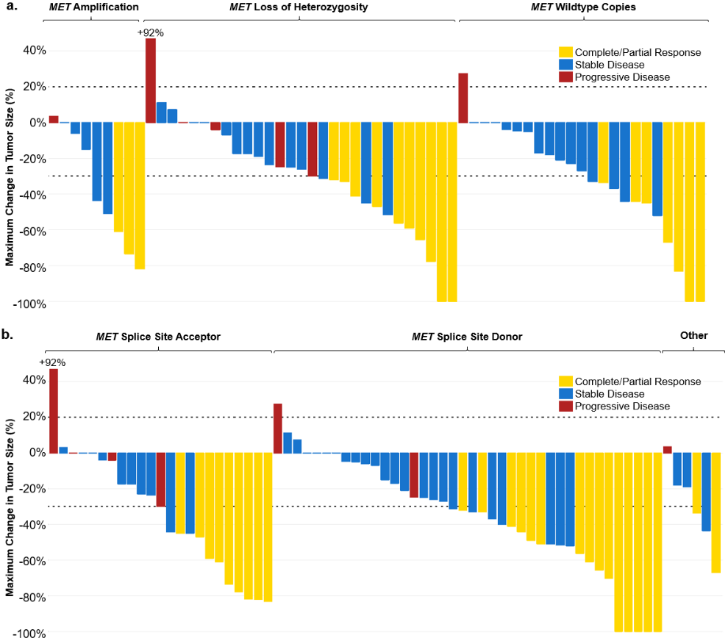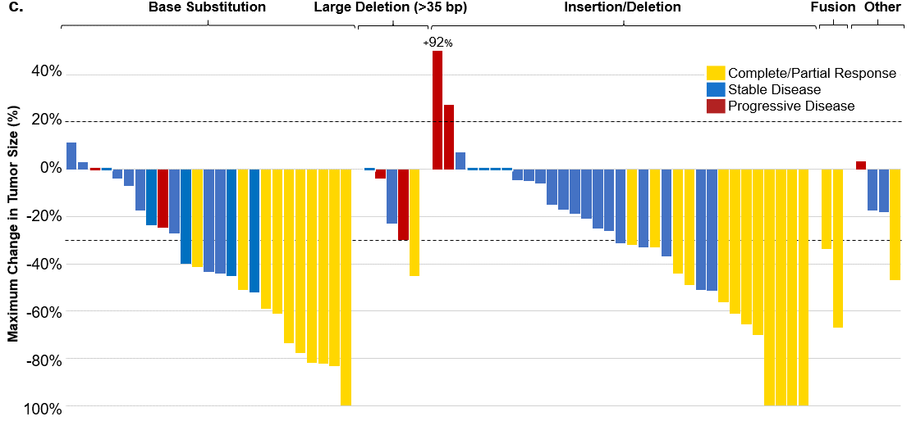

Supplementary Figure S2. Outcomes to MET tyrosine kinase inhibition (TKI) in patients with MET exon14-altered lung cancers. a, Responses to MET TKI by MET amplification, loss of heterozygosity, or wildtype copies. b, Responses to MET TKI by intron 13 acceptor (acceptor) or intron 14 donor (donor) status. c, Responses to MET TKI by MET mutation type (base substitution, insertion/deletion, large deletion or deletion >35 base pairs, MET fusion). Outcomes in all panels are from evaluable MET exon 14-altered lung cancers (N = 69).

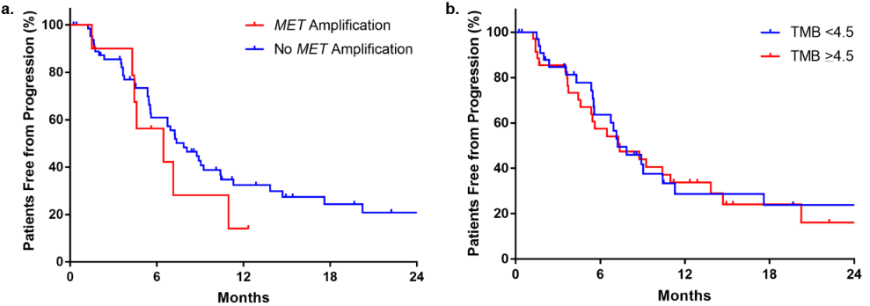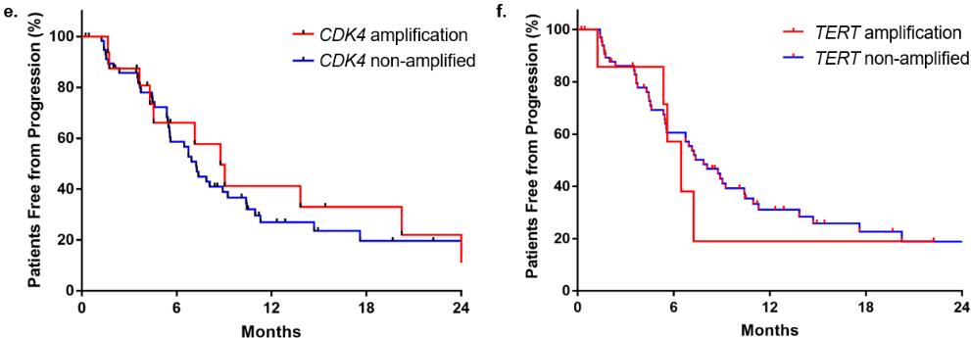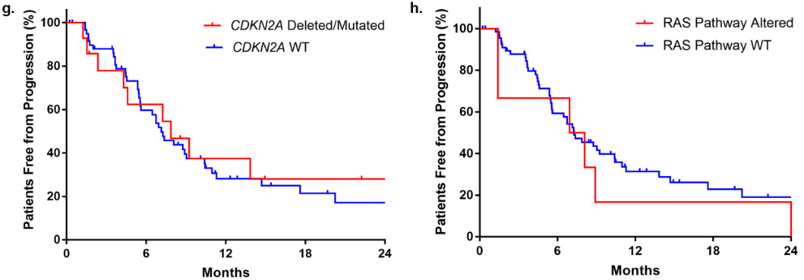
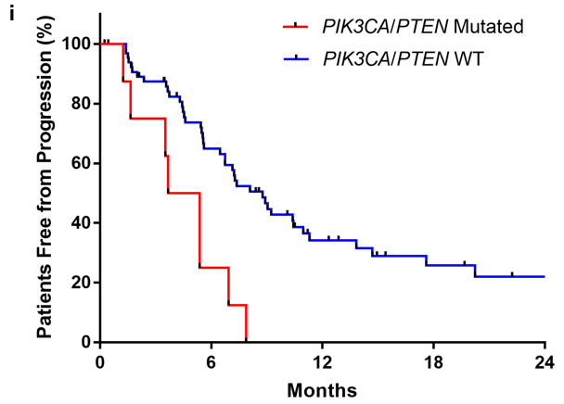
Supplementary Figure S3. Progression-free survival (PFS) by de novo concomitant mutations in MET exon14-altered lung cancers treated with MET TKI. a, For MET amplified (N = 10) and MET non-amplified (WT copies, copy neutral loss of heterozygosity, and heterozygous loss; N = 54) MET exon 14-altered lung cancers, median PFS was 6.5 months compared to 7.4 months (hazard ratio [HR] 1.5, 95% CI 0.6 to 3.9; P = 0.37), respectively. b, For TMB >4.5 mutations/megabase (N = 35) and TMB <4.5 (N = 35), median PFS was 7.4 months compared to 7.2 months (HR 0.9, 95% CI 0.5 to 1.7; P = 0.80). c, For TP53 mutated (N = 31) and TP53 WT (N = 44), median PFS was 5.6 months compared to 7.4 months (HR 1.3, 95% CI 0.7 to 2.3; P = 0.39). d, For MDM2 amplified (N = 21) and MDM2 non-amplified (N = 54), median PFS was 7.1 months compared to 7.4 months (HR 1.1, 95% CI 0.6 to 2.1; P = 0.79). e, For CDK4 amplified (N = 14) and CDK4 not amplified (N = 61), median PFS was 8.8 months compared to 7.3 months (HR 0.9, 95% CI 0.4 to 1.8; P = 0.92). f, For TERT amplified (N = 7) and TERT not amplified (N = 68), median PFS was 6.5 months compared to 7.9 months (HR 1.2, 95% CI 0.5 to 3.4; P = 0.64). h, For CDKN2A deleted/mutated (N = 14) and CDKN2A WT (N = 61), median PFS was 7.9 months compared to 7.1 months (HR 0.9, 95% CI 0.4 to 1.7; P = 0.17). h. For RAS pathway altered (N = 6) and RAS pathway WT (N = 69), median PFS was 7.5 months compared to 7.3 months (HR 0.6, 95% CI 0.2 to 1.7; P = 0.80). i, For PIK3CA/PTEN mutations (N = 8) compared to the wildtype group (N = 67), median PFS was 4.5 months vs 8.8 months, respectively (HR 9.3, 95% CI: 2.6 to 33; P = 0.0005). CI, confidence interval; WT, wildtype; TMB, tumor mutational burden.

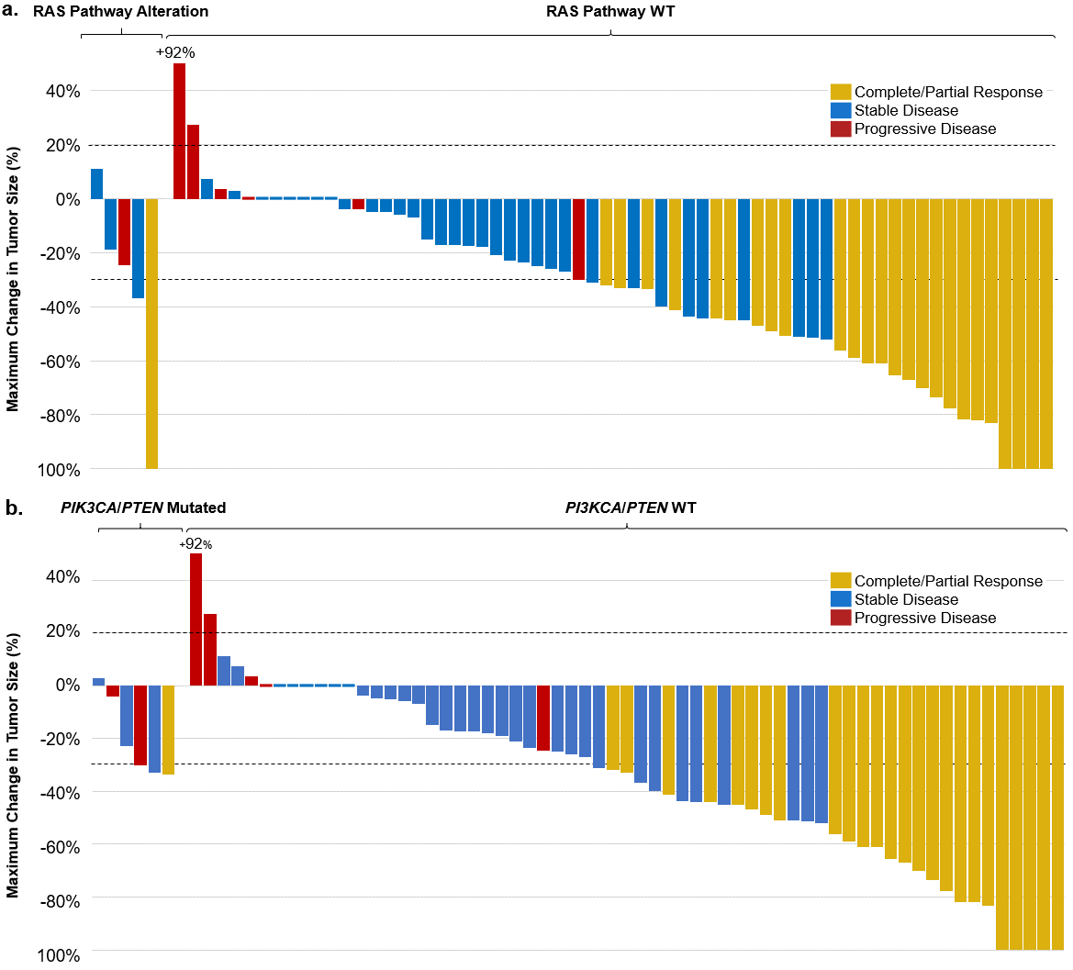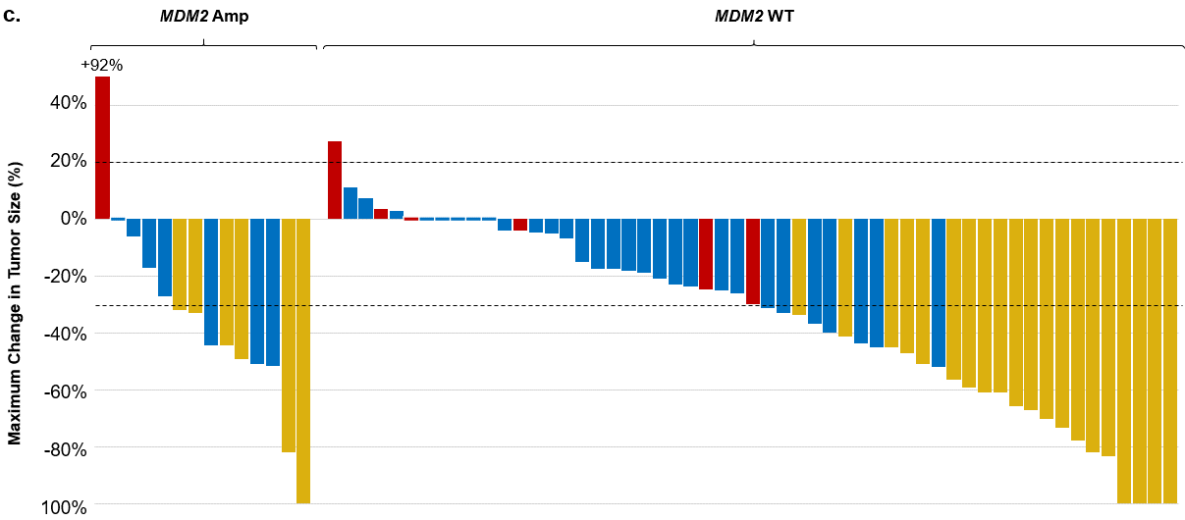

Supplementary Figure S4. Response rates and time on therapy to MET tyrosine kinase inhibition by de novo concomitant mutation. a, Responses to a MET tyrosine kinase inhibitor (TKI) in evaluable MET exon 14-altered lung cancers (N = 69) with and without a concomitant KRAS or NF1 mutation. b, Responses to a MET TKI in evaluable MET exon 14-altered lung cancers (N = 69) with and without a concomitant PIK3CA/PTEN mutation. c, Responses to a MET TKI in evaluable MET exon 14-altered lung cancers (N = 69) with and without concomitant MDM2 amplification.

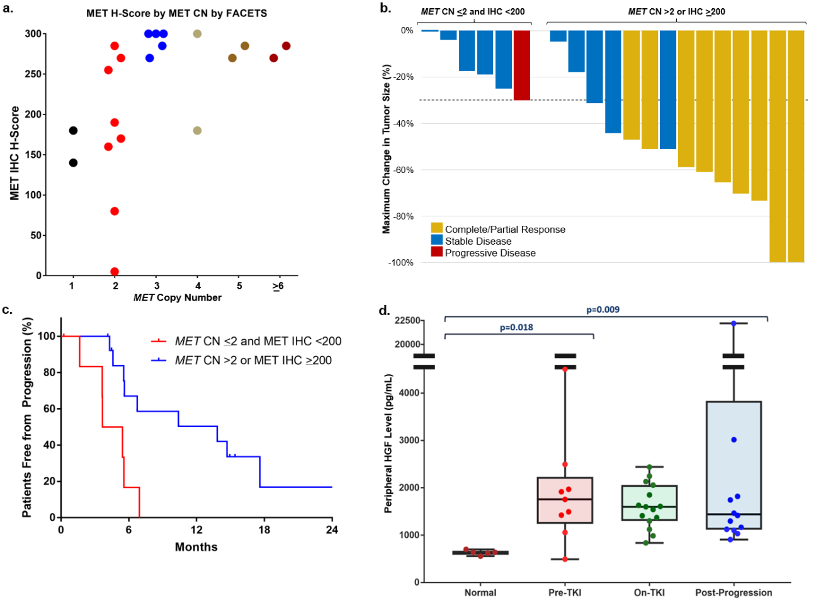

Supplementary Figure S5. Combining MET copy number and IHC further selects for response to MET tyrosine kinase inhibition. a, MET immunohistochemistry H-score appears to trend positively with MET copy number (CN) as determined by Fraction and Allele-Specific Copy Number Estimates from Tumor Sequencing (FACETS). b, MET exon 14-altered cases that were MET copy neutral with low MET expression (<200) or lost a mutated or wildtype MET allele (CN <2) were less likely to respond to MET TKI (0%, N = 0/6) than those that had MET CN >2 or MET IHC >200 (65%, 9/14; P = 0.0141). c, Median progression-free survival is also significantly longer in cases with MET CN >2 or MET IHC >200 (13.8 months, N = 14) compared to cases with MET CN <2 or IHC <200 (4.6 months; HR 10.5, 95% CI 2.3 to 47.8; P = 0.003). d, Peripheral hepatocyte growth factor (HGF) levels in 28 patients with MET exon14-altered lung cancers pre- (N = 9) on- (N = 15), and post-progression (N = 15, 3 points were out of range in the graph). HGF was elevated in patients treated with MET exon 14-altered lung cancers regardless of treatment with a MET TKI (P = 0.009) compared to normal healthy controls (N = 5). HGF levels did not differ across treatment phase (pre-TKI, on-TKI, post-progression; P = 0.91). Center line, median HGF level; box limits, upper and lower quartiles; whiskers, minimum and maximum HGF levels

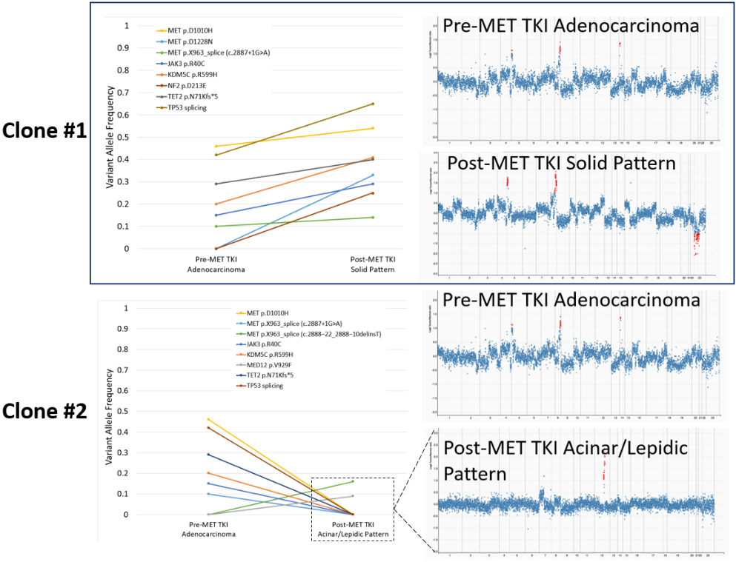

Supplementary Figure S6. Concomitant genomic mutations by MET expression and mechanisms of acquired resistance to MET tyrosine kinase inhibitor (TKI). On the left, clonal heterogeneity was detected in a post-progression wedge resection sample from one patient. Clone #1 had two MET exon 14 splice site mutations (c.3028G>C and c.2887+1G>A) and acquired a MET D1228N on-target mutation at progression. A new clone (clone #2) was detected at progression with a unique MET c.2888-22_2888-10delinsT exon 14 splice site mutation. Both of these clones had different histologies: clone #1 consisted of a predominantly solid pattern whereas clone #2 consisted of an acinar/lepidic pattern. On the right, the pattern of genomic alterations on next-generation sequencing for post-MET TKI clone #1 is similar to the pre-MET TKI pattern, whereas clone #2 is distinctly different. This supports that clone #2 is a new and separate clone. These findings likely represent two separate primary cancers with different MET exon 14-alterations in the acquired resistance setting.

Factors |  | N (%) | Responses  (ORR %) | p value | 95% CI | PFS (months) | p value | HR | 95% CI
MET Splice Site Region | Intron 14 donor | 40 (53%) | 15 (38%) | 1.00 | 24% to 53% | 10.4 | 0.03 | 0.5 | 0.2 to 0.9
 | Intron 13 acceptor | 23 (31%) | 9 (39%) |  | 22% to 59% | 5.5
 | NE | 12 (16%)
MET Mutation Type | Base substitution | 33 (44%) | 12 (36%) | 0.26 | 22% to 53% | 8.8 | 0.9
 | Insertion/  deletion | 25 (33%) | 10 (40%) |  | 23% to 59% | 10.4
 | Large deletion  (>35 bp) | 5 (7%) | 1 (20%) |  | 2% to 64% | 5.0
 | Fusion | 2 (3%) | 2 (100%) |  | 29% to 100% | 5.7
 | NE | 10 (13%)
Smoker | Current or Former | 37 (49%) | 17 (46%) | 0.14 | 31% to 61% | 8.1 | 0.51 | 0.8 | 0.5 to 1.5
 | Never | 32 (43%) | 9 (28%) |  | 15% to 46% | 6.5
 | NE | 6 (8%)
Sample Type | Primary | 40 (55%) | 11 (28%) | 0.05 | 18% to 40% | 6.9 | 0.30 | 1.4 | 0.8 to 2.4
 | Metastasis | 29 (45%) | 15 (51%) |  | 34% to 69% | 8.8
 | NE | 6 (8%)
Prior Chemotherapy | Yes | 35 (47%) | 14 (40%) | 0.80 | 26% to 56% | 7.4 | 0.80 | 0.9 | 0.5 to 1.6
 | No | 34 (45%) | 12 (35%) |  | 21% to 52% | 7.2
 | NE | 6 (8%)
Prior Chemotherapy (Crizotinib Only) | Yes | 29 (44%) | 12 (41%) | 0.79 | 25% to 59% | 7.9 | 0.55 | 0.9 | 0.5 to 1.6
 | No | 31 (47%) | 11 (36%) |  | 21% to 53% | 7.3
 | NE | 6 (9%)
MET TKI | Crizotinib | 66 (89%) | 23 (38%) | 1.00 | 25% to 45% | 7.2 | 0.26 | 1.8 | 0.8 to 4.0
 | Tepotinib | 8 (11%) | 3 (38%) |  | 13% to 70% | 17.6
Age | <75 years old | 39 (52%) | 13 (33%) | 0.45 | 21% to 49% | 7.1 | 0.12 | 1.6 | 0.9 to 2.8
 | >75 years old | 30 (40%) | 13 (43%) |  | 27% to 61% | 10.4
 | NE | 6 (8%)
Karnofsky Performance Status | <70 | 7 (9%) | 57% | 0.42 | 24% to 84% | 10.4 | 0.9 | 1.0 | 0.4 to 2.3
 | >70 | 56 (75%) | 38% |  | 26% to 51% | 7.2
 | NE | 12 (16%)
RAS Pathway Alterations | Yes | 5 (7%) | 1 (20%) | 0.64 | 2% to 64% | 7.5 | 0.36 | 0.6 | 0.2 to 1.7
 | No | 64 (85%) | 25 (39%) |  | 28% to 51% | 7.3
 | NE | 6 (8%)
PIK3CA/PTEN Alterations | Yes | 8 (11%) | 1 (13%) | 0.24 | 0% to 49% | 4.5 | 0.0005 | 9.3 | 2.6 to 33
 | No | 61 (81%) | 25 (41%) |  | 30% to 54% | 8.8
 | NE | 6 (8%)
TP53 Mutations | Yes | 29 (39%) | 12 (41%) | 1.00 | 25% to 59% | 5.6 | 0.39 | 1.3 | 0.7 to 2.3
 | No | 40 (53%) | 14 (35%) |  | 22% to 51% | 7.4
 | NE | 6 (8%)
MDM2 Amplification | Yes | 20 (27%) | 6 (30%) | 0.59 | 14% to 52% | 7.1 | 0.79 | 1.1 | 0.6 to 2.1
 | No | 49 (65%) | 20 (41%) |  | 28% to 55% | 7.4
 | NE | 6 (8%)
TERT Amplification | Yes | 7 (9%) | 4 (57%) | 0.41 | 25% to 81% | 6.5 | 0.64 | 1.2 | 0.5 to 3.4
 | No | 62 (83%) | 22 (35%) |  | 25% to 48% | 7.9
 | NE | 6 (8%)
CDK4 Amplification | Yes | 13 (17%) | 4 (31%) | 0.75 | 12% to 58% | 8.8 | 0.92 | 0.9 | 0.4 to 1.8
 | No | 56 (75%) | 22 (39%) |  | 28% to 52% | 7.3
 | NE | 6 (8%)
CDKN2A Mutation or Deletion | Yes | 14 (19%) | 8 (57%) | 0.12 | 33% to 79% | 7.9 | 0.17 | 0.9 | 0.4 to 1.7
 | No | 55 (73%) | 18 (33%) |  | 22% to 46% | 7.1
 | NE | 6 (8%)
Pre-TKI Plasma HGF | Above Median* | 3 (4%) | 3 (100%) | 1.00 | 38% to 100% | 6.7 | NE | NE | NE
 | Below Median* | 3 (4%) | 2 (67%) |  | 20% to 94% | NE
 | NE | 69 (92%)
Percentages may not add up to 100% due to rounding. ORR, objective response rate; PFS, progression-free survival; HR, hazard ratio; CI, confidence interval; WT, wildtype; bp, base pair(s); CN LOH, copy neutral loss of heterozygosity; mut, mutations; Mb, megabase; HGF, hepatocyte growth factor; *, median plasma HGF 1861 pg/mL; NE, not evaluable; TKI, tyrosine kinase inhibitor; NE, not evaluable (no evaluable biomarker and/or not RECIST-evaluable)

Supplementary Table S1. Objective Response and Progression-Free Survival by Tumor Mutational Burden and Other Clinicopathologic and Co-mutational Characteristics.

 | MET IHC H-score <200 | MET IHC H-score >200
Age, median (range) | 79 years (60 – 88 years) | 74 years (56 – 91 years)
Karnofsky Performance Status, N (%)  >70  <70  NE | 6 (67%)  2 (22%)  1 (11%) | 12 (92%)  0 (0%)  1 (8%)
Cigarette smoking, N (%)  Never  Former or Current | 5 (55%)  4 (44%) | 5 (63%)  8 (38%)
Prior Chemotherapy, N (%)  Yes  No | 3 (33%)  6 (66%) | 6 (46%)  7 (54%)
MET TKI, N (%)  Crizotinib  Tepotinib | 7 (78%)  2 (22%) | 11 (85%)  2 (15%)
MET Zygosity, N (%)  WT Copies  CN LOH  Heterozygous loss  Amplification  NE | 3 (33%)  3 (33%)  2 (22%)  0  1 (11%) | 3 (23%)  5 (38%)  0 (0%)  2 (15%)  3 (23%)
Percentages may not add up to 100% due to rounding. NE, not evaluable; CN LOH, copy neutral loss of heterozygosity

Supplementary Table S2. Clinicopathologic features of patients with advanced MET exon 14-altered lung cancers with MET IHC performed

MET IHC  H-score | Concomitant de novo Mutations | MET acceptor or donor | MET Copy Number | Best Response | Progression-free Survival
0 | PTEN p.R74Lfs*2 | Intron 13 acceptor | 2 | PD (-30%) | 1.6 months
80 | No | Intron 13 acceptor | 2 | SD (-4%) | 5.4 months
100 | KRAS G12A | Intron 14 donor | NA | PR (-100%) | 8.1 months
140 | PIK3CA E545K & HGF amp | Intron 13 acceptor | 1 | SD (-17%) | 3.7 months
160 | No | Intron 14 donor | 2 | SD (-25%) | 3.7 months
170 | No | Intron 14 donor | 2 | NA | 0.2 month
180 | KRAS G12C & PIK3CA E545K | NA | 1 | SD (-19%) | 6.9 months
180 | No | Intron 14 donor | 4 | PR (-100%) | 13.8 months
190 | No | Intron 13 acceptor | 2 | SD (0%) | 5.6 months
Tumors that were MET low expressing were more likely to have a concomitant mutation in the PIK3CA/PTEN or RAS pathway (44%; N = 9) than tumors that were MET high expressing (0%; N = 13) (P = 0.017). HGF, hepatocyte growth factor; PD, progressive disease; SD, stable disease; PR, partial response.

Supplementary Table S3. Concomitant mutations, objective responses, and survival outcomes for patients with low MET expression.

eMETHODS

DNA- and RNA-based Next-generation Sequencing
Tumor nucleic-acid testing was performed using targeted sequencing of DNA using MSK-IMPACT or Foundation One (Foundation Medicine, Cambridge, MA)¹. Targeted NGS sequencing of tumor RNA was performed using an anchored multiplex polymerase chain reaction (MSK Solid Fusion Panel, NY, NY, USA)².
Clonality and Zygosity Analyses
Samples sequenced by MSK-IMPACT were analyzed for zygosity using FACETS³. Mutations called by the MSK-IMPACT pipeline were annotated for cancer cell fraction (CCF) using FACETS-suite⁴; variants were classified as clonal if the lower-bound CCF was > 80%. MET zygosity was labelled as high amplification if > 6 total copies. Focal amplifications were called if the MET copy number was > 6 and > 3 more than the calculated copies of chromosome 7q. For other genetic alterations, amplification was defined as >2.0-fold change and deletion was defined as < -2.0-fold change.
Protein Expression Evaluation
Protein expression of pre-TKI tumor samples was performed using a targeted selected reaction monitoring-mass spectrometry panel (SRM-MS) as previously described⁵. In brief, tissues from sectioned formalin-fixed paraffin-embedded (FFPE) blocks were placed onto DIRECTOR microdissection slides. These were then deparaffinized and stained with hematoxylin. Tumors were then microdissected and solubilized to tryptic peptides. These peptides were then analyzed with TSQ Quantiva triple-quadrupole mass spectrometers (Thermo Scientific, San Jose, CA, USA). Standardization for quantification and quality control for MET were previously reported. Positive MET expression by SRM-MS was previously established to >150 amol/μL⁵.
Peripheral hepatocyte growth factor (HGF) Measurement
Peripheral blood was collected from select patients pre-, on-, and post-progression of a MET TKI and plasma was separated and frozen at -80℃ until further evaluation. Healthy control human plasma from five subjects was obtained from the New York Blood Center, aliquoted into individual cryovials, and frozen at -80℃ until further evaluation. Peripheral HGF levels from each patient with available sample were quantified with an HGF ELISA kit (SHG00B, R&D Systems, Minneapolis, MN, USA)⁶. The data was normalized such that the mean level of five healthy control plasma samples were kept equivalent across experiments.
Statistics
Fisher’s exact test was used to compare overall response rate between groups. P-value for progression-free survival was determined using the log-rank test. P-values < 0.05 were considered significant. Hazard ratios and confidence intervals were generated using the Mantel-Haenszel test. Mann-Whitney test was used to compare differences between two group, Kruskal-Wallis was used to compare differences between three or more groups. Statistical analyses were performed with Prism 7 (GraphPad Software).
Supplementary Table 1. Clinicopathologic features of patients with advanced MET exon 14-altered lung cancers.

Supplementary References
1. Cheng, D.T., et al. Memorial Sloan Kettering-Integrated Mutation Profiling of Actionable Cancer Targets (MSK-IMPACT): A Hybridization Capture-Based Next-Generation Sequencing Clinical Assay for Solid Tumor Molecular Oncology. J Mol Diagn 17, 251-264 (2015).
2. Benayed, R., et al. High Yield of RNA Sequencing for Targetable Kinase Fusions in Lung Adenocarcinomas with No Mitogenic Driver Alteration Detected by DNA Sequencing and Low Tumor Mutation Burden. Clinical cancer research : an official journal of the American Association for Cancer Research 25, 4712-4722 (2019).
3. Shen, R. & Seshan, V.E. FACETS: allele-specific copy number and clonal heterogeneity analysis tool for high-throughput DNA sequencing. Nucleic Acids Res 44, e131 (2016).
4. Bielski, C.M., et al. Widespread Selection for Oncogenic Mutant Allele Imbalance in Cancer. Cancer cell 34, 852-862 e854 (2018).
5. Catenacci, D.V., et al. Absolute quantitation of Met using mass spectrometry for clinical application: assay precision, stability, and correlation with MET gene amplification in FFPE tumor tissue. PloS one 9, e100586 (2014).
6. Llovet, J.M., et al. Plasma biomarkers as predictors of outcome in patients with advanced hepatocellular carcinoma. Clinical cancer research : an official journal of the American Association for Cancer Research 18, 2290-2300 (2012).

