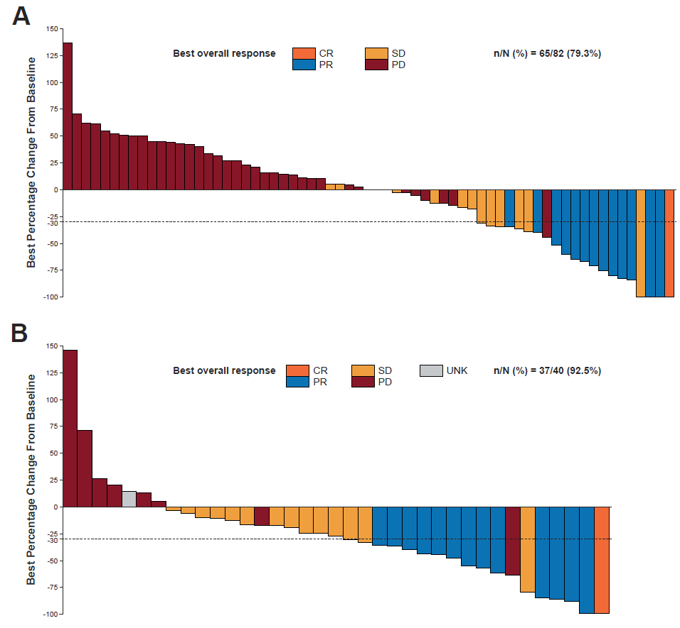
Supplemental Figure S3. Best percentage change from baseline in sum of diameters of target lesions for patients treated with spartalizumab (A) and chemotherapy (B)

CR, complete response; PD, progressive disease; PR, partial response; SD, stable disease; UNK, unknown.

