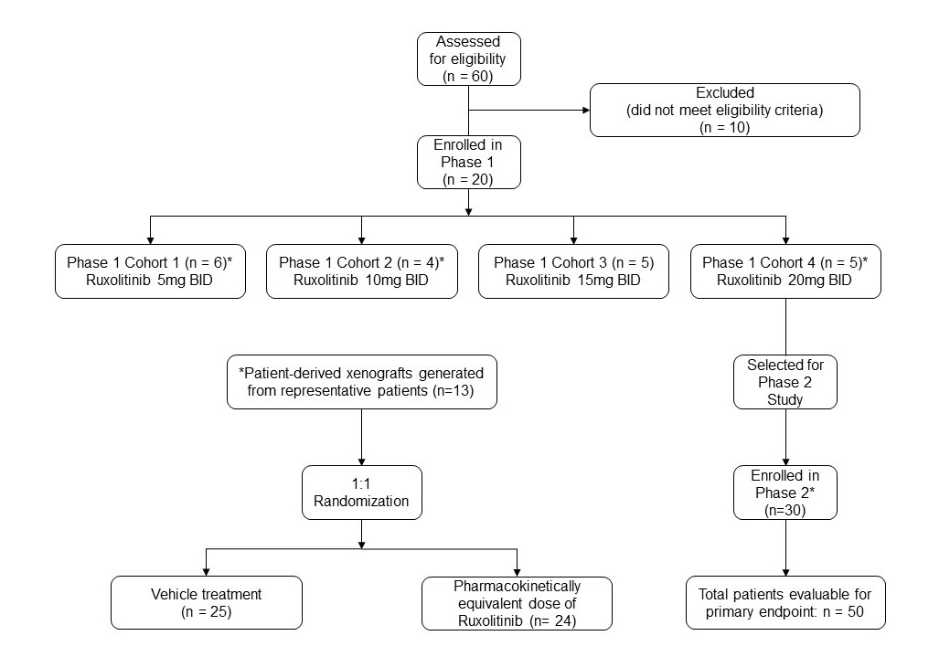

**Supplementary Figure S1. Study design.** The phase 1 portion of the study followed a dose escalation, rolling six design. Based on dose-limiting toxicities, ruxolitinib 20mg taken twice daily was selected as the phase 2 dose. *Patient-derived xenograft models were generated from 13 representative patients treated in both phase 1 and phase 2, with 49 xenograft mice successfully created and included in final analyses.