**OX40 Agonist BMS-986178 Alone or in Combination With Nivolumab and/or Ipilimumab in Patients With Advanced Solid Tumors**

Martin Gutierrez, et al

**Supplementary Data**

* **Table S1**
* **Figure S1**
* **Figure S2**
* **Additional patient eligibility criteria**
* **Sample size determinations**

**Supplementary Table S1. Immunogenicity in patients treated with BMS-986178 and nivolumab and/or ipilimumab**

|  |  |  |  |  |  |
| --- | --- | --- | --- | --- | --- |
|  | **Monotherapy** | **Combination Therapy** | | | |
|  | **Part 1A** | **Part 2A** | | **Part 3A** | |
|  | **BMS-986178 Q2W**  **(n = 20)** | **BMS-986178 + NIVO Q2W**  **(n = 43)** | | **BMS-986178 + IPI Q3W**  **(n = 35)** | |
| ADAs assessed | BMS-986178 | BMS-986178 | NIVO | BMS-986178 | IPI |
| Patients assessed, n | 12 | 30 | 34 | 26 | 29 |
| Baseline ADA positive, n (%) | 0 | 1 (3) | 3 (9) | 0 | 4 (14) |
| ADA positive, n (%) | 1 (8) | 8 (27) | 2 (6) | 11 (42) | 2 (7) |
| Persistent positive, n (%) | 0 | 0 | 0 | 0 | 0 |
| Only last sample positive, n (%) | 1 (8) | 2 (7) | 0 | 9 (35) | 1 (3) |
| Other positive, n (%) | 0 | 6 (20) | 2 (6) | 2 (8) | 1 (3) |
| ADA negative, n (%) | 11 (92) | 22 (73) | 32 (94) | 15 (58) | 27 (93) |

Baseline ADA positive: a patient with baseline ADA-positive sample; ADA positive: a patient with ≥ 1 ADA-positive sample relative to baseline (ADA negative at baseline or ADA titer ≥ 4-fold than baseline positive titer) at any time after initiation of treatment; persistent positive (PP): ADA-positive sample at ≥ 2 consecutive time points, where the first and last ADA-positive samples are ≥ 16 weeks apart; other positive: not PP but some ADA-positive samples, with the last sample being negative; ADA negative: a patient with no ADA-positive sample after initiation of treatment. The sensitivity curve for the BMS-986178 ADA was run between 25,000 ng/mL – 0 ng/mL (5-fold dilutions) of PC and the sensitivity of the assay was 8 ng/mL.

IPI, ipilimumab; NIVO, nivolumab.

**Figure S1. Dose-related exposure of BMS-986178 alone and in combination with nivolumab or ipilimumab. Panel A** shows dose-exposure pharmacokinetic analysis of BMS-986178 alone or in combination with nivolumab or ipilimumab. Each point represents cycle 1 AUC for each participant; the line represents the linear regression line. **Panel B** shows normalized AUC of soluble OX40 vs dose. AUC, area under the curve.

A.

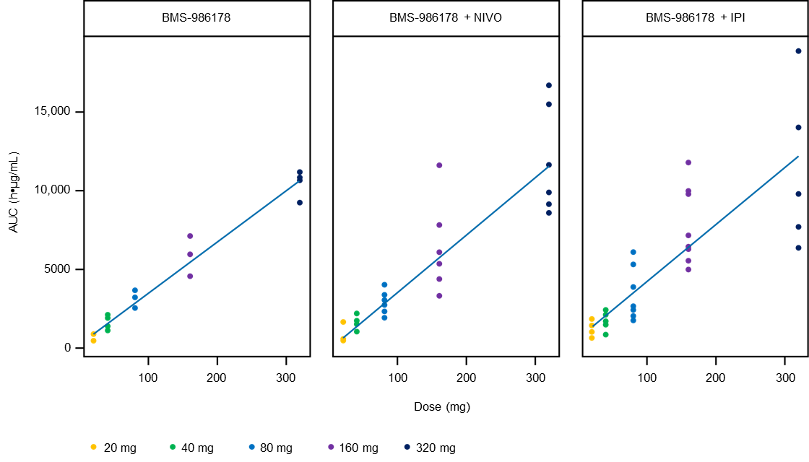

**B.**



**Figure S2. PD-L1 modulation in patients treated with BMS-986178 in combination with nivolumab or ipilimumab.** Change in PD-L1 expression was analyzed by immunohistochemistry in patients treated with BMS-986178 plus nivolumab (n = 62), BMS-986178 plus ipilimumab (n = 37), and BMS-986178 plus nivolumab and ipilimumab (n = 15). Individual plots show values at screening vs on treatment.

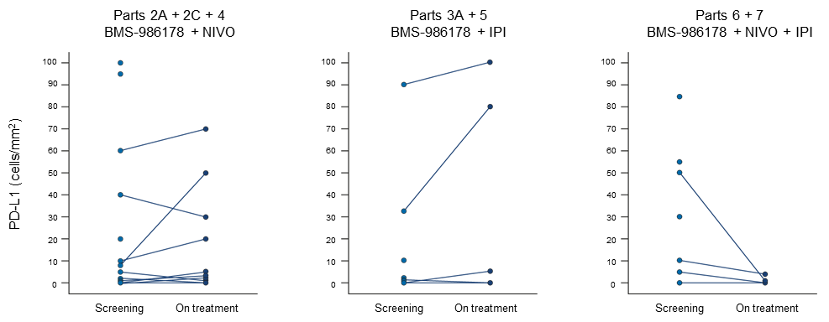

**Additional patient eligibility criteria**

In the dose-escalation, dose-exploration, and safety cohorts (parts 1A, 2A, 3A, 4, 5, 6A, 7A), eligible patients had progressed on ≥ 1 prior therapy in the advanced, recurrent, or metastatic setting. Patients with the following tumors were enrolled in the dose-escalation and -exploration cohorts (parts 1A, 2A, 3A, 4, and 5): melanoma, non-small cell lung cancer (NSCLC), head and neck cancer (restricted to squamous cell carcinoma), transitional cell carcinoma of the genitourinary tract, RCC, pancreatic adenocarcinoma, colorectal cancer (CRC), cervical cancer, triple-negative breast cancer (TNBC), adenocarcinoma of the endometrium, ovarian cancer (OC), prostate adenocarcinoma, hepatocellular cancer (Child-Pugh A only), small cell lung cancer, gastric and gastroesophageal junction cancer, and thyroid cancer.

In the safety cohort (part 6A), patients with histologically confirmed RCC with clear-cell component who received ≥ 1 prior systemic treatment in the advanced or metastatic setting were enrolled. In the safety cohort (part 7A), eligible patients had histological or cytological confirmation of NSCLC with advanced squamous or nonsquamous histology with ≥ 1 prior systemic treatment for NSCLC.

Patients enrolled in the dose-exploration cohort (part 8) had histologically or cytologically confirmed bladder cancer. Patients were required to be immunotherapy treatment naive, have received or refused 1 prior platinum-based therapy for metastatic or locally advanced unresectable disease, and be within 12 months of perioperative treatment with a platinum agent in the setting of cystectomy.

In the dose-expansion cohorts, eligible patients had histologically or cytologically confirmed bladder cancer (part 2C). Patients must have been offered and/or received or refused 1 prior platinum-based therapy for the treatment of metastatic or locally advanced unresectable disease and had < 2 prior systemic therapies. In part 6B, patients with histologically confirmed advanced or metastasized RCC with a clear-cell component were enrolled. No prior systemic therapy for RCC was permitted, with the following exception: 1 prior adjuvant or neoadjuvant therapy for completely resectable RCC if such therapy did not include an agent that targets VEGF or VEGF receptors and if recurrence occurred ≥ 6 months after the last dose of adjuvant or neoadjuvant therapy. In part 7B, prior adjuvant or neoadjuvant chemotherapy (last administration ≥ 6 months prior to enrollment) and prior definitive chemoradiation for locally advanced disease (last administration ≥ 6 months prior to enrollment) were permitted.

**Sample size determinations**

Because this was a phase 1 dose-escalation trial, the sample size for each dose-escalation cohort depended on observed toxicity and posterior inference. Approximately 30 patients were expected to be treated during each dose-escalation part (BMS-986178 monotherapy [part 1A], BMS-986178 in combination with nivolumab [part 2A], and BMS-986178 in combination with ipilimumab [part 3A]), for a combined total of approximately 90 patients in parts 1A, 2A, and 3A. Initially, approximately 3 patients were treated at the starting dose levels of BMS-986178 or BMS-986178 in combination with nivolumab or ipilimumab. Additional cohorts of approximately 3 evaluable patients were treated at recommended dose levels per Bayesian-Copula logistic regression model recommendations during the dose escalation phase. At least 6 patients evaluable for dose-limiting toxicities were treated at the maximum tolerated dose; at most, 12 were to be treated at each dose level. This limit was set to avoid instances in which the model could recommend adding patients indefinitely to a specific dose level due to uncertainty in the tolerability profile. Escalation by > 1 dose level (dose skipping) was not permitted.

As in any dose-escalation study, the exact number of patients in the dose escalation could not be predicted. However, different estimates with the prespecified parameters of the dose-escalation design under various scenarios were made. A maximum of 30 patients was prespecified as one of the simulation parameters (assuming approximately 6 patients per dose level). The simulation in the protocol used combination therapy as an illustration (containing 5 dose levels for BMS-986178 and a fixed dose level for nivolumab [240 mg]). The simulation estimated a total of 15 to 21 patients on average under different scenarios. Note that in the actual clinical trial, dose skipping was not permitted, and the clinical team could override Bayesian-Copula logistic regression model dose recommendations based on the totality of data (clinical safety data along with available pharmacokinetic [PK] and pharmacodynamic [PD] data).

Cohort expansion: The purpose of cohort expansion was to gather additional safety, tolerability, preliminary efficacy, PK, and PD information regarding BMS-986178 alone or in combination with nivolumab and/or ipilimumab.

In general, the estimated sample size for parts 2B, 2C, 2D, 3B, 6B, and 7B for the expansion phase was guided by Simon 2-stage design, which is based on target response rates (target objective response rate [ORR]) and the ability to identify a signal for such clinical response that is above the standard of care (historical ORR). Enrollment of patients at the end of stage 1 continued while the initial efficacy evaluation was ongoing. Decisions regarding continuing or not continuing enrollment of a specific arm were to be based on a combination of model guidance, clinical judgment on the totality of data (clinical safety, PK, PD, and efficacy), and communication between the sponsor and investigators. It was not the intent of the investigators to use Simon 2-stage design for formal hypothesis testing for the following reasons:

* At an early stage, the sponsor intended to explore primary antitumor activity as proof of confidence. According to the exploratory nature of an early-phase design, the sample size was not large enough to clearly define the patient population. Meanwhile, there were no control arms planned as a comparison.
* In immuno-oncology, it is known that response rate alone does not reflect all potential clinical benefits. Factors such as duration, depth, and delay of response could become evident as potential benefits according to the nature of immunotherapy.
* Safety was still the primary objective of the study; if there was evidence of accumulated toxicity in a dose cohort, the cohort would be discontinued.

The Simon 2-stage design was to be used as a guide for the disease-restricted expansion cohorts in parts 2B, 2C, 2D, 3B, 6B, and 7B. The total sample size for each expansion cohort was calculated to provide a reasonable false-positive rate (FPR) and false-negative rate (FNR) based on assumptions of true (target) and historical ORRs for each indication. Approximately 12 patients with CRC and OC, 10 with TNBC, 17 with cervical cancer, and 28 with RCC and NSCLC were to be treated in stage 1 for an initial evaluation of efficacy. This was to inform potential early decisions and guide planning/operations or early termination after taking into consideration additional data (eg, duration of response and/or stable disease and safety). If the true response rate was 10% for CRC and OC, the study had a 66% probability of early termination of the cohort. If the true response rate was 25% in patients with BC, the study had a 53% probability of early termination of the cohort. If the true response rate was 20% in patients with cervical cancer, the study had a 55% probability of early termination of the cohort. If the true response rate was 40% in patients with RCC and NSCLC, the study had a 55% probability of early termination of the cohorts.

For an expansion cohort of 35 patients with CRC and OC with an assumed true response rate of 30%, there was a 94% chance of observing ≥ 7 responses (in other words, the FNR was 6%). If the true response rate was only 10% rather than 30%, there was a 6% chance of observing ≥ 7 responses in 35 patients (in other words, the FPR was 6%). If 7 responses were observed (eg, 20% observed response rate), the lower bound of the 80% CI for the ORR was 11% (higher than the historical ORR of 10%). The CI was calculated using the Clopper-Pearson method.

For an expansion cohort of 27 patients with BC with an assumed true response rate of 50%, there was an 88% chance of observing ≥ 11 responses (in other words, the FNR was 12%). If the true response rate was only 25% rather than 50%, there was a 5% chance of observing ≥ 11 responses in 27 patients (in other words, the FPR was 5%). If 11 responses were observed (eg, 41% observed response rate), the lower limit of the 80% CI for the ORR was 28% (higher than the historical ORR of 25%). The CI was calculated using the Clopper-Pearson method.

For an expansion cohort of 37 patients with cervical cancer with an assumed true response rate of 40%, there was an 87% chance of observing ≥ 12 responses (in other words, the FNR was 13%). If the true response rate was only 20% rather than 40%, there was a 5% chance of observing ≥ 12 responses in 37 patients (in other words, the FPR was 5%). If 12 responses were observed (eg, 32% observed response rate), the lower limit of the 80% CI for the ORR was 22% (higher than the historical ORR of 20%). The CI was calculated using the Clopper-Pearson method.