Supplementary figure 1. Top 1% significantly enriched gene sets, in tumors of women and men

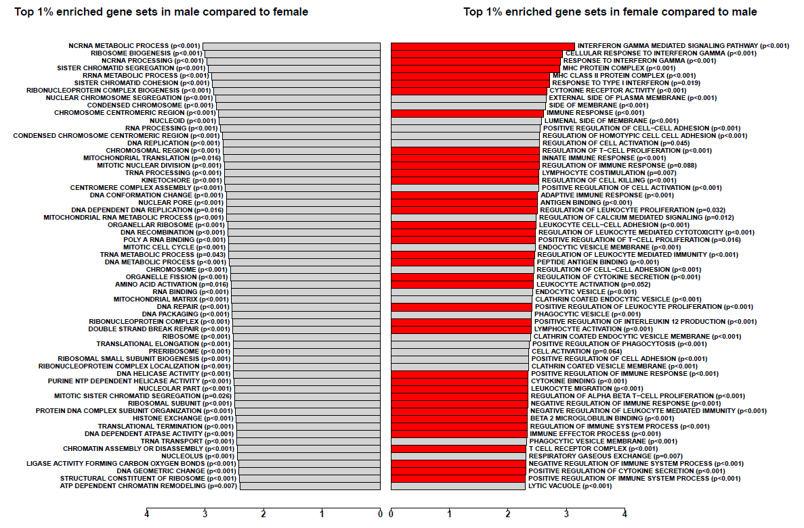
Normalized Enriched Score (NES)

