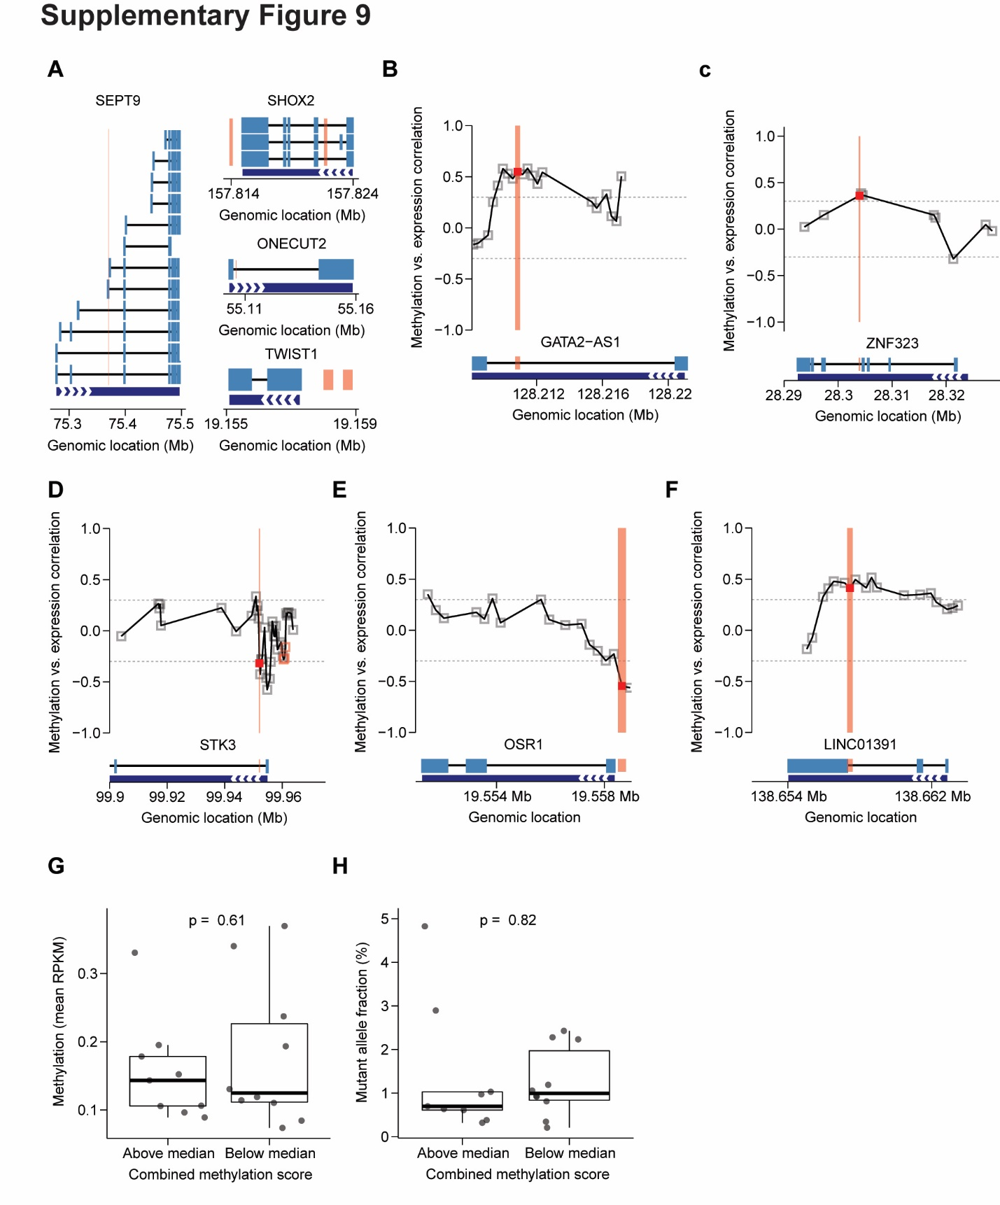
Figure S9. Identification of regions of potential functional relevance and clinical utility (related to Figure 5). A) Genome-track of genes currently targeted by commercially available liquid biopsy tests that also displayed hypermethylation in HNSCC primary tumors (TCGA) and HNSCC patient plasma (this study); location of the overlapping 300-bp windows are indicated by red bars. Thick blue bars denote exons, and thin blue bars denote introns. Multiple transcripts are shown (UCSC IDs). Bottom dark blue bar with arrows denotes the direction of transcription for the specified gene. B-F) Prognostic methylated regions associated with RNA expression in the 5 genes displayed in Figure 5D: (B) GATA2-AS1, (C) ZNF323, (D), STK3, (E) OSR1, (F) LINC01391. Boxes denote 300-bp regions overlapping with hm450k probes. Y-axis: Correlation (Spearman’s R) between methylation within a particular 300-bp region and RNA expression among HNSCC primary tumors from TCGA (n = 520). A meaningful association was defined as an absolute R value ≥ 0.3 (denoted by horizontal dashed grey lines). 300-bp regions that were prognostic for disease-specific survival in TCGA are denoted with a red outline. Prognostic regions which were further associated with RNA expression are denoted as solid red and with a red vertical bar. G,F) Welch’s two-sided t-test evaluating the relationship of methylation associated with ctDNA abundance (i.e. mean methylation across all 941 HNSCC hyper-DMRs) (G) or mutant allele fraction of mutations identified by CAPP-Seq (F) between ctDNA-positive patients by both assays (n = 19) above and below the median combined methylation score (CMS). Black bar: median mean methylation. Box: interquartile range (IQR) of mean methylation values. Whisker: most extreme value within quartile ±1.5 IQR of mean methylation values.

