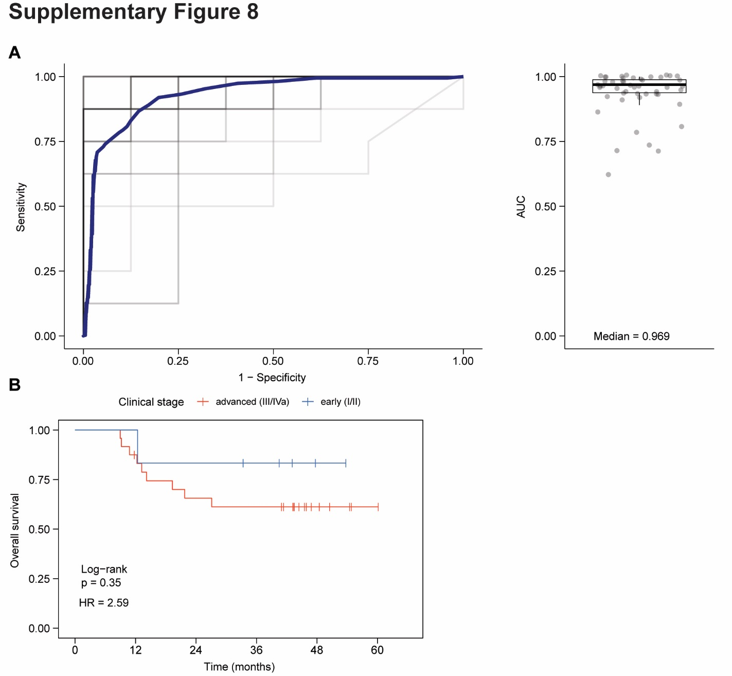
Figure S8. Cross-validation of CAPP-Seq informed differential methylation analysis of cfMeDIP-seq profiles for identification of ctDNA-derived methylation reflective of ctDNA abundance. A) To perform cross-validation, patients with detectable ctDNA by CAPP-Seq and healthy controls were randomly placed within training and testing sets (60/40 split). Hyper-DMRs were identified in the training set as previously described in Figure 3 and applied to the test set. Within the test set, mean methylation (RPKMs) across the identified hyper-DMRs were compared between HNSCC and healthy controls. This process was repeated for a total of 50 replicates. Left: Receiver Operator Characteristics (ROC) curves across all 50 replicates. Blue line: average ROC curve. Positive detection of ctDNA was defined as mean methylation above the healthy controls. Right: Calculated area under the curve (AUC) for all 50 replicates. Black bar: median AUC. Box: interquartile range (IQR) of AUC values. Whisker: most extreme value within quartile ±1.5 IQR of AUC values. B) Kaplan-Meier analysis depicting overall survival. Patients were stratified based on diagnosis of early stage (stage I-II) or locoregionally advanced stage (stage III-IVA) disease.

