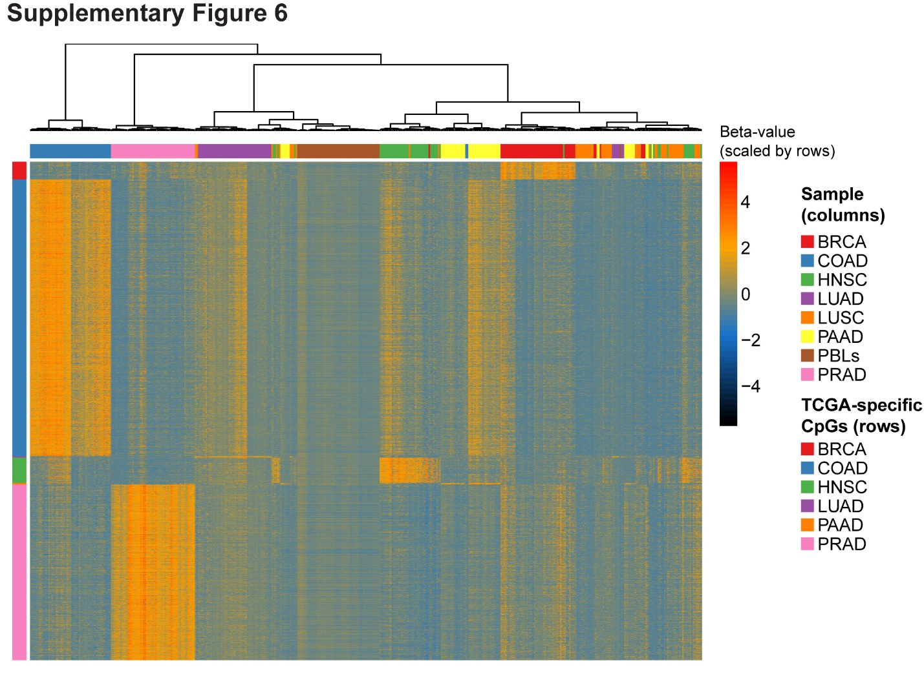
Figure S6. Hierarchical clustering of 385 TCGA primary tumors (55 per TCGA study) and 55 PBLs supervised using 5,677 cancer-specific differentially methylated cytosines. Columns: sample type, meaning either one of 8 TCGA studies (BRCA: breast cancer; COAD: colon adenocarcinoma; HNSC: head and neck squamous cell carcinoma; LUAD: lung adenocarcinoma; LUSC: lung squamous cell carcinoma; PAAD: pancreatic adenocarcinoma; PRAD: prostate adenocarcinoma) or 55 PBLs from this study. 363,943 CpGs were examined for differential methylation analysis. Rows: 5,677 differentially methylated cytosines specific to 6/7 TCGA studies (BRCA: 200; COAD: 3153; LUAD: 15; LUSC: 0; HNSC: 290; PAAD: 18; PRAD: 2001). TCGA studies with sufficient site-specific differentially methylated cytosines (n ≥ 50).

