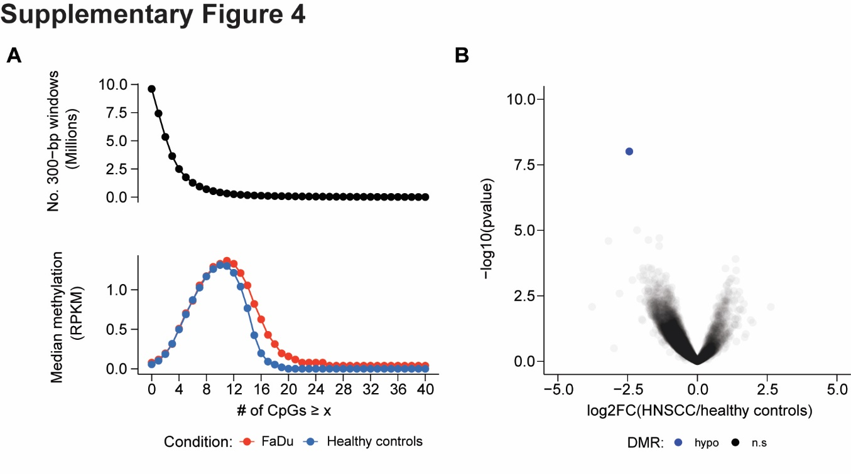
Figure S4. Identification of informative genomic regions (related to Figure 3B, 3C). A) (Top) Number of 300-bp windows with >= CpGs. (Bottom) Median read count of methylated DNA fragments in reads per kilobase per million mapped reads (RPKM) for 9,603,454 300-bp non-overlapping bins with ≥ varying minimum numbers of CpGs. Values calculated on chromosomes 1–22. B) We compared MeDIP-seq profiles from 30 HNSCC patient PBLs to 20 risk-matched healthy control PBLs within the 99,994 PBL-depleted windows for each sample. This procedure identified a single control-associated region of cfDNA methylation. (Right) Volcano plot of 49,358 genomic regions, each with >20 reads across all samples, displaying -log₁₀ p-value of differential methylation against log₂ fold change of relative methylation (RPKMs) from healthy controls to HNSCC patients. Grey: regions without significant differential methylation (false discovery rate ≥10%). Blue: 1 hypomethylated 300-bp regions, with significantly lower methylation in the HNSCC cohort compared to healthy controls.

