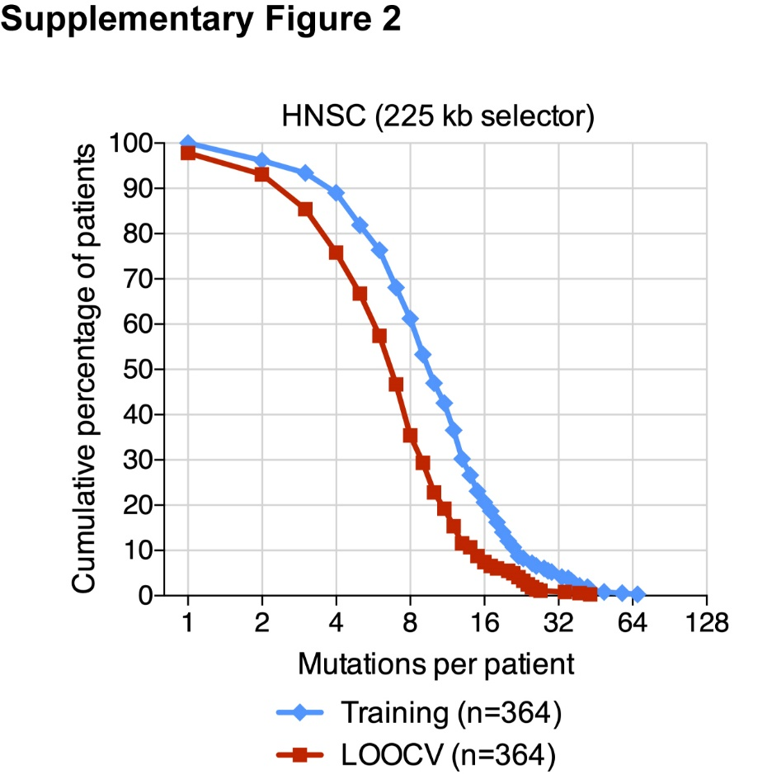
Figure S2. Coverage of HNSCC CAPP-Seq selector. Analysis of the number of mutations per HNSCC patient covered by the CAPP-Seq selector assessed either among 364 patients in the HNSC TCGA cohort (Training; blue diamonds) or using leave-one-out cross-validation (LOOCV; red squares).

