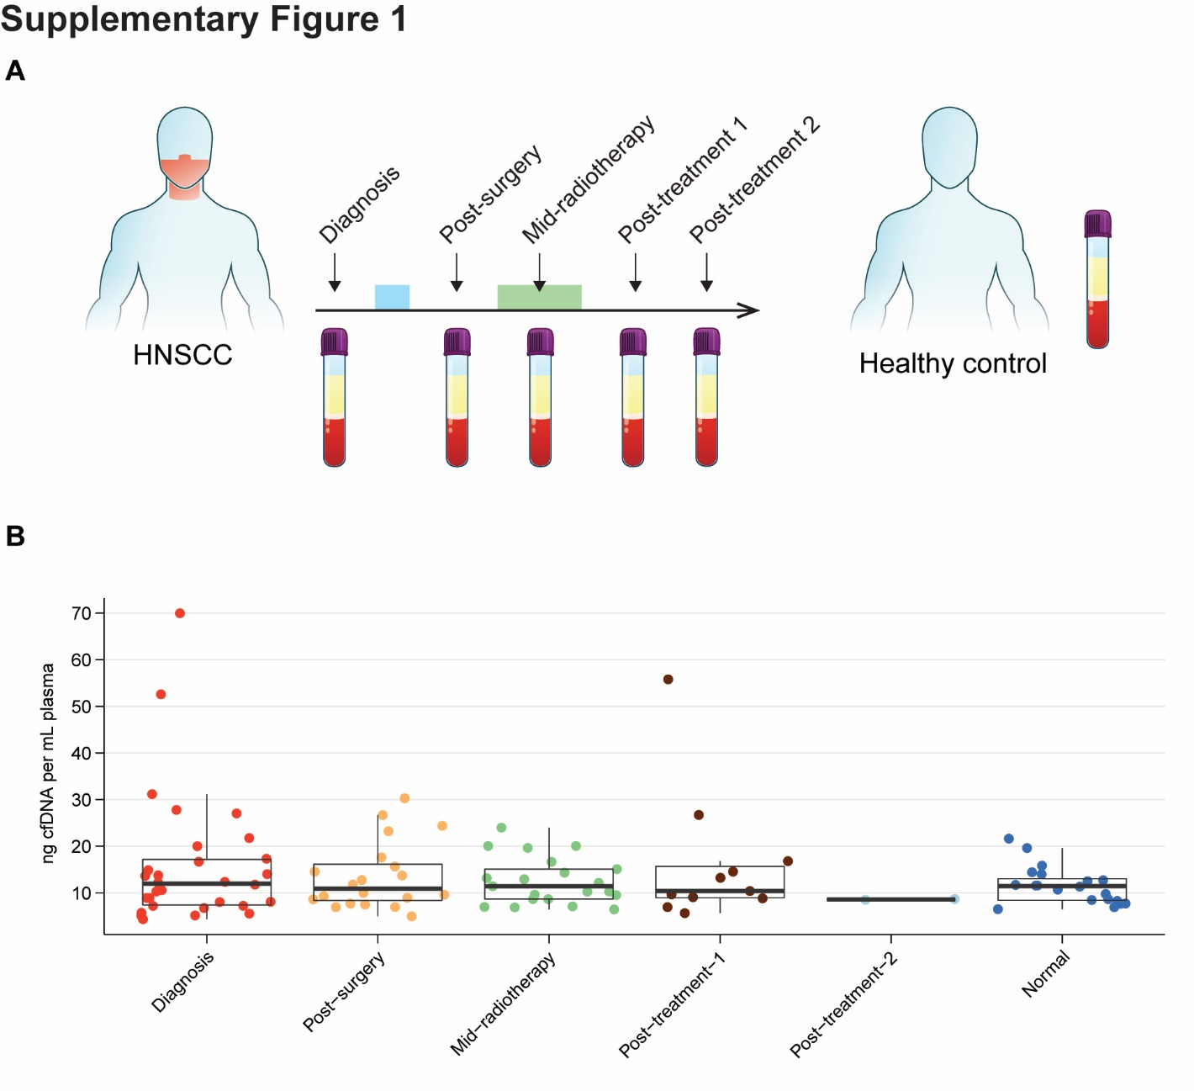 Figure S1. Sample characteristics of isolated cell-free DNA from HNSCC and healthy controls. A) Schematic defining timepoints of blood isolation. B) cfDNA yields (ng per mL of plasma) across timepoints for HNSCC patients as well as healthy controls (i.e., “Normal”).

