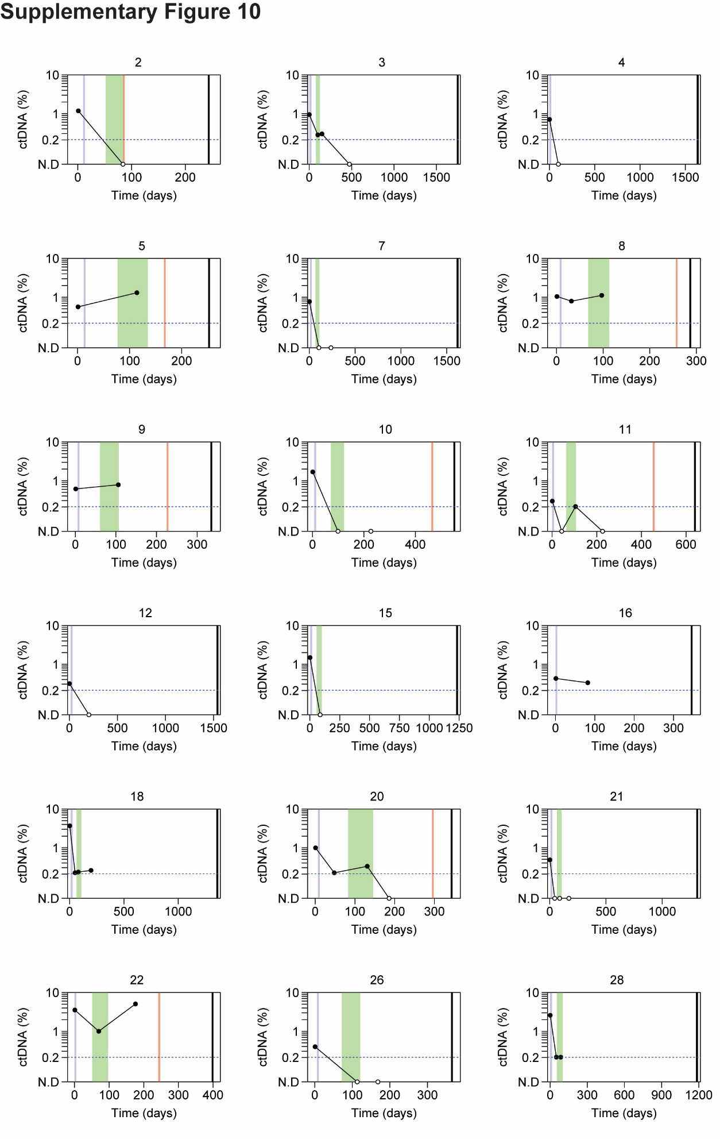
Figure S10. Extension of Figure 6A. Changes in ctDNA abundance by cfMeDIP-seq throughout treatment for HNSCC patients with detectable ctDNA at diagnosis by CAPP-Seq and cfMeDIP-seq (n = 18). Patient identifiers are provided above each subplot. Mean methylation of the hypermethylated regions (n = 941, Figure 3d) were used to estimate ctDNA percentage. To estimate ctDNA, a linear model was fitted between the mean methylation (fragments between 100 – 150-bp) of the 941 hypermethylated regions by cfMeDIP-seq and the mutant allele fraction of ctDNA-derived mutations by CAPP-Seq, across HNSCC plasma samples at diagnosis (n = 30) (Figure 5a). The lower limit of detection was determined by the maximum methylation observed across healthy controls (n = 20); post-diagnosis HNSCC samples below the lower limit of detection were denoted as not detected (N.D). Dashed horizontal blue line: lower limit of detection. Solid vertical blue line: date of surgery. Shaded vertical green area: duration of radiotherapy. Solid vertical red line: date of relapse. Solid vertical black line: Last clinical follow-up.

