Figure S2: Kaplan-Meier estimates of overall survival by the DeepPET-OPSCC risk category, evaluated in the entire cohort with known HPV status

A HPV+ B HPV–
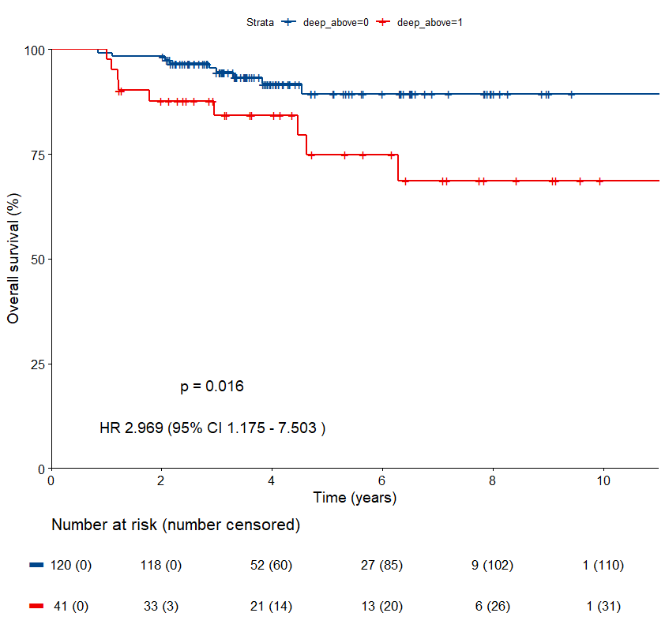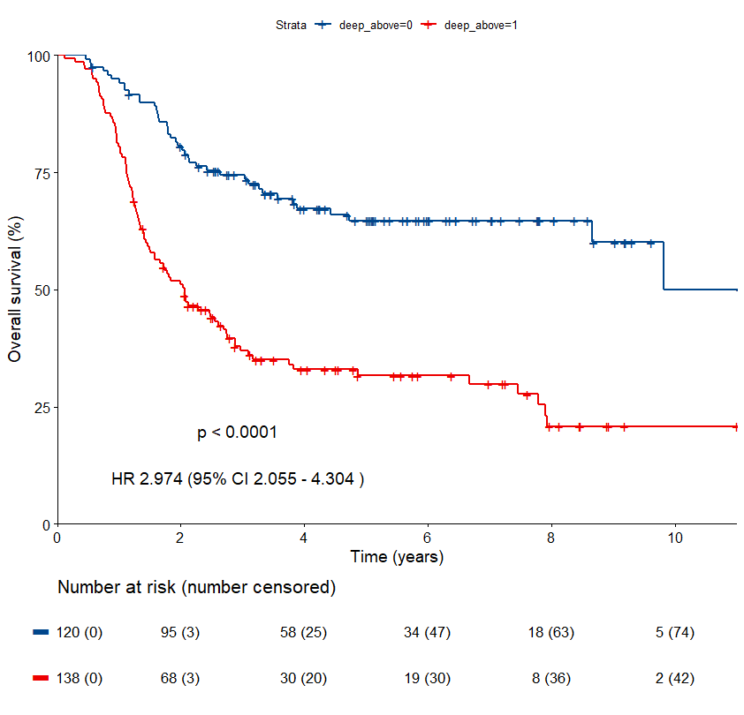
Low-risk group
High-risk group
High-risk group
Low-risk group

