Figure S14: Scatter plots of the relationship between SUVmax/MTV and DeepPET-OPSCC scores in the entire cohort with known HPV status (n=419).

A Scatter plots of MTV and DeepPET-OPSCC scores B Scatter plots of SUV_{max} and DeepPET-OPSCC scores
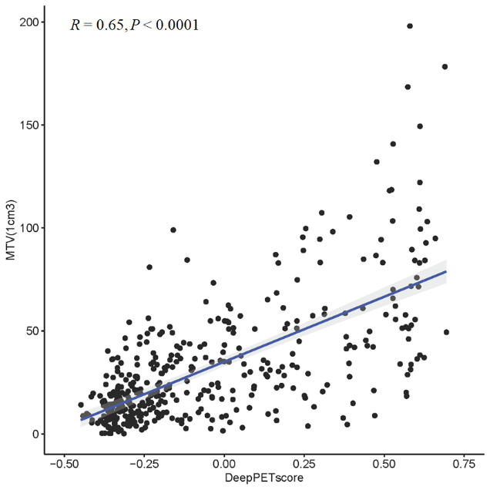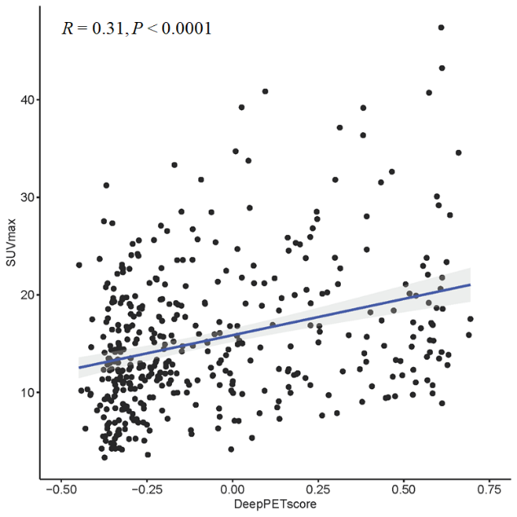

C Scatter plots of SUV_{max} and MTV
