# Figure S10: Kaplan-Meier estimates of overall survival by the DeepPET-OPSCC risk category with three groups defined by tertiles of the risk scores in the discovery cohort

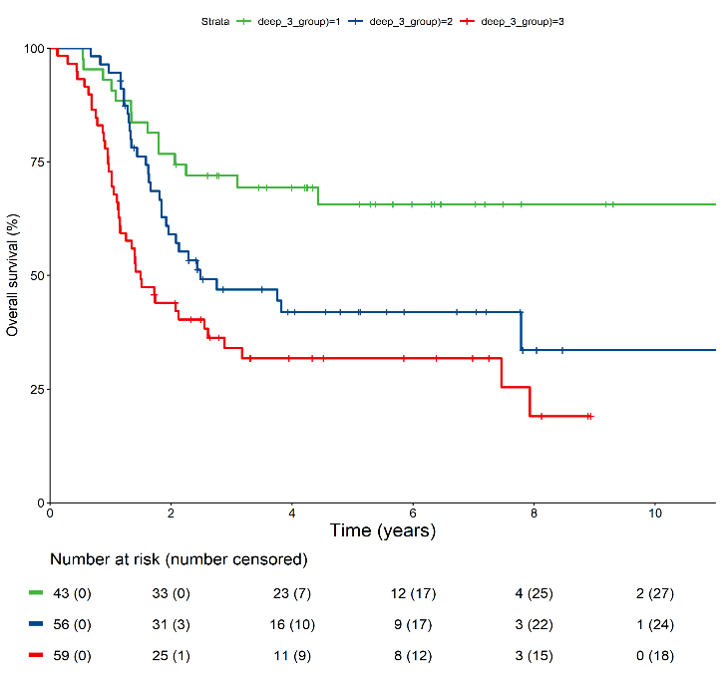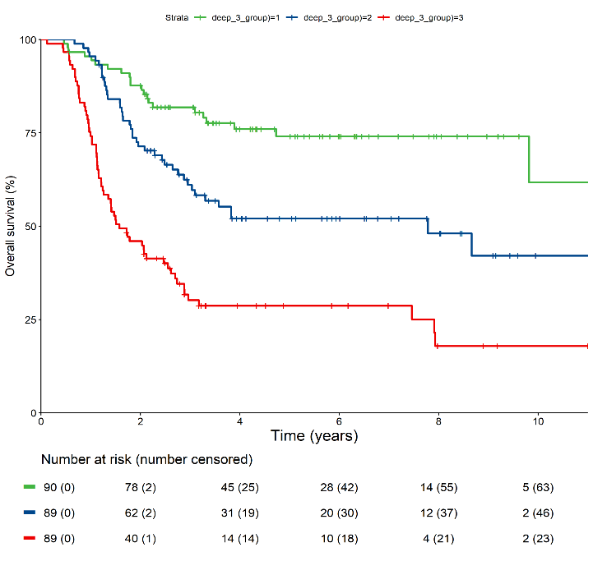

Low-risk group, ref

High-risk group, HR=5.07 (95% CI 3.11–8.26)

Medium-risk group, HR=2.15 (95% CI 1.28–3.62)

*P < 0.001*

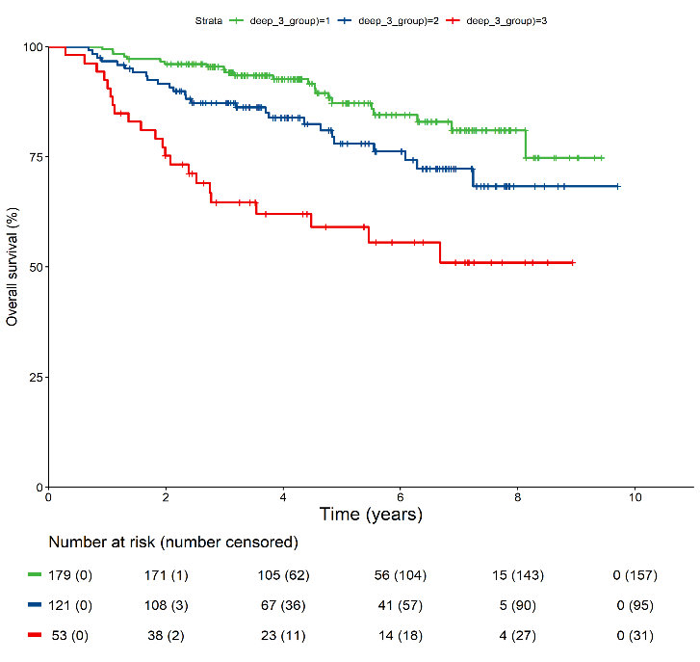

Low-risk group, ref

High-risk group, HR=4.16 (95% CI 2.30–7.51)

Medium-risk group, HR=1.84 (95% CI 1.04–3.25)

*P < 0.001*

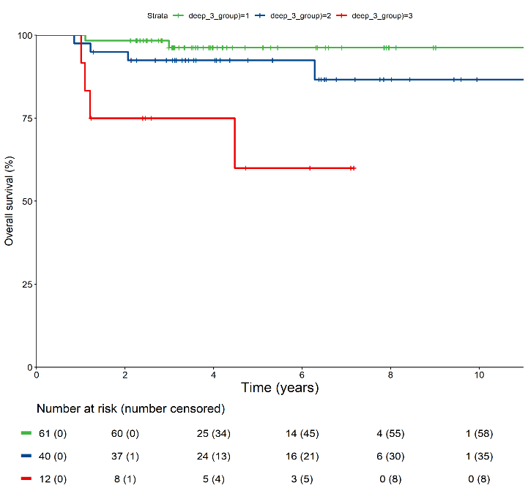

Low-risk group, ref

High-risk group, HR=12.08 (95% CI 2.20–66.31)

Medium-risk group, HR=2.80 (95% CI 0.51–15.37)

*P = 0.0016*

Low-risk group, ref

High-risk group, HR=3.30 (95% CI 1.80–6.08)

Medium-risk group, HR=1.99 (95% CI 1.06–3.76)

*P < 0.001*

**A Discovery cohort**

**B TCIA test cohort**

**C HPV+ and cTNM IVA in entire cohort**

**D HPV– and cTNM IVA in entire cohort**