Figure S6: Kaplan-Meier estimates of overall survival by the DeepPET-OPSCC risk category, evaluated in cT stages of the entire HPV– cohort

A HPV– and cT1-3 B HPV– and cT4a
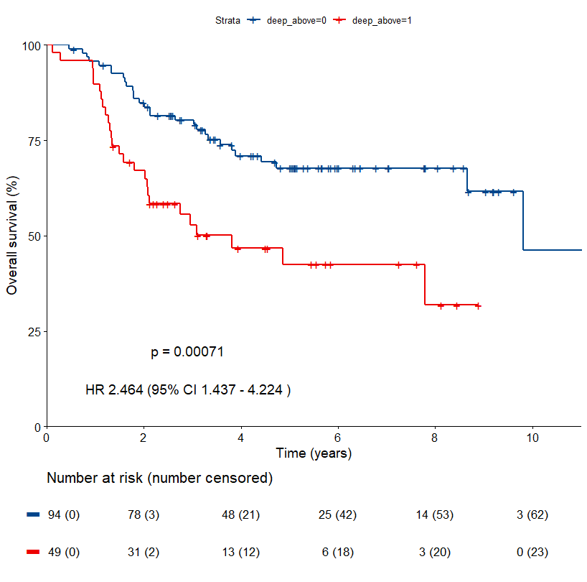 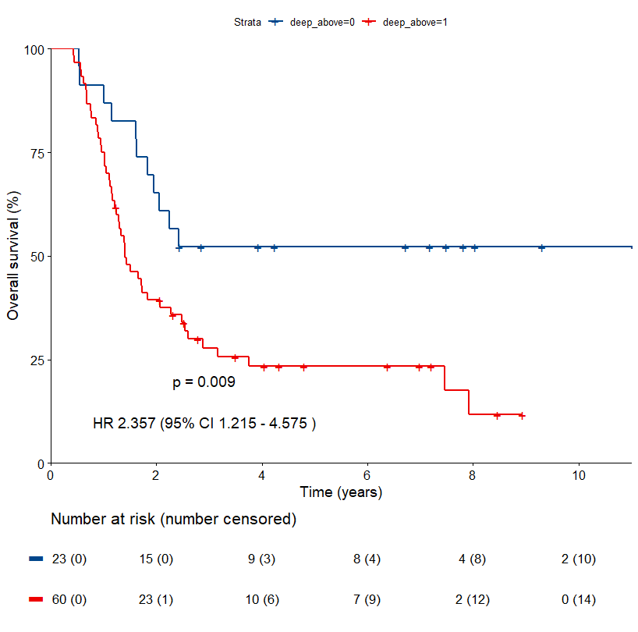 C HPV– and cT4b
Low-risk group
High-risk group
Low-risk group
High-risk group
High-risk group
Low-risk group
