Figure S5: Kaplan-Meier estimates of overall survival by the DeepPET-OPSCC risk category, evaluated in cTNM stages of the entire HPV+ cohort

A HPV+ and cTNM I-III
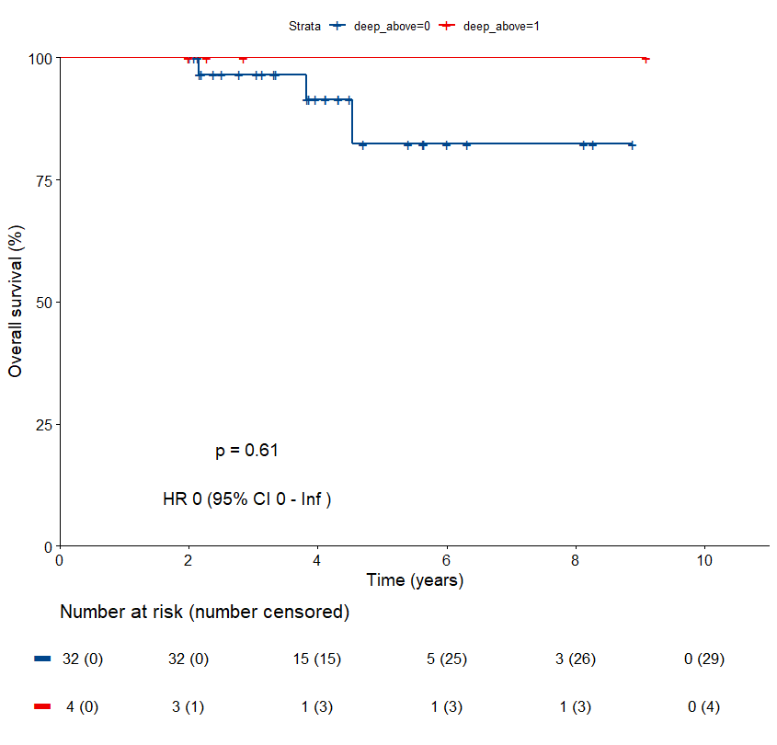
Low-risk group
High-risk group

