Supplementary material

All adverse events 2
EORTC-QLQ-C30 questionnaires 3
Dosimetry results of target lesions and organs at risk 4
PSMA-PET/CT SUV and size of all the lesions during each cycle 5
PSMA-PET maximum intensity projections (MIP) before and after ¹⁷⁷Lu-PSMA 8
Inclusion and exclusion criteria 10
Study Flowchart 11
Labeling and purification of PSMA-617 with ¹⁷⁷Lu 12

All adverse events
Adverse event | Grade I-II | Grade III-IV | Grade I-II attributed to ¹⁷⁷Lu-PSMA* | Grade ≥III attributed to ¹⁷⁷Lu-PSMA*
Fatigue | 7 (70%) | 0 | 7 (70%) | 0
Nausea | 3 (30%) | 0 | 3 (30%) | 0
Xerostomia | 2 (20%) | 0 | 2 (20%) | 0
Rash | 2 (20%) | 0 | 1 (10%) | 0
Pain | 1 (10%) | 0 | 1 (10%) | 0
Hypertension# | 9 (90%) | 1 | 0 | 0
Fever | 2 (20%) | 0 | 0 | 0
Abdominal pain | 2 (20%) | 0 | 0 | 0
Hypokalemia | 1 (10%) | 0 | 0 | 0
Dyspepsia | 1(10%) | 0 | 0 | 0
Hypotension# | 1 (10%) | 0 | 0 | 0
Rectal hemorrhage# | 2 (20%) | 0 | 0 | 0
Hematuria# | 1 (10%) | 0 | 0 | 0
Headache | 1 (10%) | 0 | 0 | 0
Vomiting | 1 (10%) | 0 | 0 | 0
Cough | 1 (10%) | 0 | 0 | 0
Data are n (%). *Possibly, probably, or definitely according to the CTCAE v4.03. # These toxicities were already present prior to the study inclusion.

EORTC-QLQ-C30 questionnaires

 | BASELINE | CYCLE 1 WEEK 4 | CYCLE 1 WEEK 8 | CYCLE 2 WEEK 4 | CYCLE 2 WEEK 8 | CYCLE 2 MONTH 3 | CYCLE 2 MONTH 6
Global health status | 83 (67-100) | 78 (42-100) | 73 (25-100) | 76 (33-100) | 76 (25-100) | 78 (33-100) | 90 (50-100)
Functional scales:
Physical functioning | 96 (67-100) | 94 (53-100) | 96 (60-100) | 96 (60-100) | 97 (67-100) | 96 (67-100) | 99 (93-100)
Role functioning | 93 (67-100) | 93 (50-100) | 97 (67-100) | 94 (67-100) | 97 (67-100) | 97 (67-100) | 100 (100-100)
Emotional functioning | 81 (58-100) | 89 (67-100) | 93 (83-100) | 94 (75-100) | 94 (75-100) | 95 (83-100) | 90 (67-100)
Cognitive functioning | 100 (100-100) | 98 (83-100) | 100 (100-100) | 98 (83-100) | 100 (100-100) | 100 (100-100) | 98 (83-100)
Social functioning | 93 (67-100) | 97 (83-100) | 98 (83-100) | 100 (100-100) | 98 (83-100) | 100 (100-100) | 98 (83-100)
Symptom scales and items:
Fatigue | 13 (0-44) | 17 (0-44) | 11 (0-33) | 14 (0-22) | 8 (0-22) | 4 (0-22) | 5 (0-33)
Nausea and vomiting | 2 (0-17) | 3 (0-17) | 3 (0-33) | 0 (0-0) | 0 (0-0) | 0 (0-0) | 0 (0-0)
Pain | 5 (0-50) | 8 (0-67) | 7 (0-50) | 2 (0-17) | 2 (0-17) | 8 (0-67) | 2 (0-17)
Dyspnoea | 3 (0-33) | 3 (0-33) | 3 (0-33) | 4 (0-33) | 0 (0-0) | 0 (0-0) | 0 (0-0)
Insomnia | 17 (0-33) | 13 (0-33) | 7 (0-33) | 15 (0-33) | 10 (0-33) | 7 (0-33) | 11 (0-33)
Appetite loss | 0 (0-0) | 3 (0-33) | 0 (0-0) | 0 (0-0) | 0 (0-0) | 0 (0-0) | 0 (0-0)
Constipation | 3 (0-33) | 3 (0-33) | 0 (0-0) | 0 (0-0) | 0 (0-0) | 0 (0-0) | 4 (0-33)
Diarrhoea | 3 (0-33) | 3 (0-33) | 0 (0-0) | 7 (0-33) | 7 (0-33) | 3 (0-33) | 4 (0-33)
Financial difficulties | 0 (0-0) | 0 (0-0) | 0 (0-0) | 0 (0-0) | 0 (0-0) | 0 (0-0) | 0 (0-0)
Data are mean scores (range). EORTC = European Organization for Research and Treatment of Cancer

Dosimetry results of target lesions and organs at risk
Patient # | Salivary glands | Kidneys | Liver | Bone Marrow | Target lesion cycle one | Target lesion cycle Two
1 | 0.41 | 0.34 | 0.08 | 0.01 | 1.51 | *
2 | 0.23 | 0.66 | 0.09 | 0.02 | 1.57 | 0.87
3 | 0.60 | 0.61 | 0.11 | 0.01 | 1.14 | 1.30
4 | 0.49 | 0.36 | 0.07 | 0.01 | 0.87 | 0.65
5 | 0.34 | 0.64 | 0.12 | 0.02 | 1.02 | 2.40
6 | 0.66 | 0.36 | 0.09 | 0.02 | 2.96 | 2.32
7 | 0.21 | 0.50 | 0.09 | 0.02 | 1.55 | 1.82
8 | 0.44 | 0.46 | 0.08 | 0.02 | 8.89 | 3.53
9 | 0.33 | 0.53 | 0.10 | 0.01 | 3.91 | 3.80
10 | 0.14 | 0.48 | 0.09 | 0.02 | 1.62 | 1.12
Mean dose: | 0.39 ± 0.17 | 0.49 ± 0.11 | 0.09 ± 0.01 | 0.02 ± 0.00 | 2.51 ± 2.43 | 1.78 ± 1.24
Doses to organs and lesions in Gy/GBq from both cycles of ¹⁷⁷Lu-PSMA. No organ specific threshold level was reached. *The target lesion was not visible anymore on the second cycle SPECT/CT scans.

PSMA-PET/CT SUV and size of all the lesions during each cycle
Patient # | Location | Baseline | C1W8 | C2W12 | C2W24
1 | Lymph node, SUVmax (mm) | 11.5 (10) | 4.0 (3.2) | 1.3 (0) | 1.6 (0)
 | Liver, SUVmean | 2.4 | 1.7 | 3.7 | 4
 | Salivary glands, SUVmean | 15.6 | 15.2 | 13.5 | 18.2
2 | Bone, SUVmax | 9.3 (*) | 16.2 (*) | 19.8 (*) | 21.9 (*)
 | Bone, SUVmax | 31.3 (*) | 43.7 (*) | 28.6 (*) | 29.3 (*)
 | Bone, SUVmax | 5.4 (*) | 11.5 (*) | 7.4 (*) | 9.8 (*)
 | Bone, SUVmax | 7.6 (*) | 11.6 (*) | 9.8 (*) | 9 (*)
 | Liver, SUVmean | 4.2 | 5.5 | 5.2 | 6.3
 | Salivary glands, SUVmean | 10.7 | 12.6 | 11.1 | 12
3 | Lymph node, SUVmax (mm) | 44.7 (11.3) | 34.5 (10.7) | 21.4 (9.1) | 36.5 (9.5)
 | Lymph node, SUVmax (mm) | 6.8 (7.4) | 5.8 (5.1) | 3.2 (3.1) | 10.9 (4.8)
 | Lymph node, SUVmax (mm) | 14.8 (6.0) | 9.2 (5.1) | 4.4 (3.7) | 1.3 (3.8)
 | Lymph node, SUVmax (mm) | 5.4 (4.3) | 4.7 (3.4) | 1.4 (2.3) | 1.3 (0)
 | Liver, SUVmean | 5.6 | 4.4 | 5.2 | 4.2
 | Salivary glands, SUVmean | 11.3 | 10.4 | 14.5 | 15.4
4 | Lymph node, SUVmax (mm) | 12.2 (12.5) | 17.5 (12.5) | 17.2 (12.5) | .
 | Bone, SUVmax | 36.3 (*) | 26.3 (*) | 27.5 (*) | .
 | Lymph node, SUVmax (mm) | 7.8 (8) | 11.3 (8) | 12.7 (6) | .
 | Bone, SUVmax | 14.8 (*) | 27.0 (*) | 30.5 (*) | .
 | Bone, SUVmax | 20.8 (*) | 23.7 (*) | 26.3 (*) | .
 | Bone, SUVmax | 17.1 (*) | 18.5 (*) | 15.5 (*) | .
 | Bone, SUVmax | 21.5 (*) | 18 (*) | 16 (*) | .
 | Lymph node, SUVmax (mm) | 12.3 (5.2) | 7.6 (6.0) | 12.3 (6.2) | .
 | Lymph node, SUVmax (mm) | 14 (6.7) | 13.0 (7.3) | 14 (7.7) | .
 | Liver, SUVmean | 6.4 | 5.1 | 5.6 | .
 | Salivary glands, SUVmean | 13.8 | 14 | 13.1 | .
5 | Lymph node, SUVmax (mm) | 12.5 (6.8) | 17.3 (6.6) | 6 (5.3) | 6.1 (5.4)
 | Lymph node, SUVmax (mm) | 8.1 (5.9) | 8.3 (4.9) | 3.7 (4.3) | 3.3 (3.8)
 | Lymph node, SUVmax (mm) | 22.8 (10.9) | 18 (9.1) | 11 (6.9) | 7.1 (6.1)
 | Lymph node, SUVmax (mm) | 11.8 (10.4) | 11 (7.8) | 8 (5.4) | 6.7 (4.8)
 | Lymph node, SUVmax (mm) | 9.6 (4.9) | 6.5 (5.4) | 4.3 (4) | 3.1 (3.8)
 | Liver, SUVmean | 5.4 | 5.6 | 4.4 | 5
 | Salivary glands, SUVmean | 4.4 | 16.8 | 7.6 | 8.3
6 | Lymph node, SUVmax (mm) | 11.8 (7.9) | 20.8 (7.4) | 11.8 (5.6) | 6.8 (4.2)
 | Lymph node, SUVmax (mm) | 4.5 (6.4) | 6.5 (6.1) | 3.5 (2.6) | 2.7 (2.6)
 | Lymph node, SUVmax (mm) | 5.0 (10.3) | 5.4 (9.6) | 3.2 (6.0) | 3.1 (3.2)
 | Lymph node, SUVmax (mm) | 3.6 (6.4) | 9.7 (6.2) | 3 (4.7) | 2.8 (4.3)
 | Liver, SUVmean | 4.5 | 3 | 5.1 | 4.3
 | Salivary glands, SUVmean | 17.1 | 13.4 | 12.1 | 11.6
7 | Lymph node, SUVmax (mm) | 10.7 (11) | 5.9 (10.5) | 2.6 (9.1) | 2.5 (8.6)
 | Lymph node, SUVmax (mm) | 6.5 (5.9) | 5.6 (5.5) | 4.8 (3.5) | 4.7 (2.6)
 | Lymph node, SUVmax (mm) | 3.5 (7) | 2.3 (7.2) | 1.8 (6.2) | 2 (4.9)
 | Bone, SUVmax | 3.5 | 5.6 (*) | 5.2 (*) | 9.7 (*)
 | Bone, SUVmax | 2 | 2.7 (*) | 2.2 (*) | 10.4 (*)
 | Liver, SUVmean | 4.7 | 6.3 | 5.7 | 4.5
 | Salivary glands, SUVmean | 3.9 | 6.4 | 7.6 | 6.2
8 | Lymph node, SUVmax (mm) | 23 (11.6) | 24.2 (11.4) | 9 (4.7) | 6.6 (4)
 | Lymph node, SUVmax (mm) | 33.4 (10.9) | 16.9 (10.3) | 3.3 (5.4) | 3.7 (4.1)
 | Lymph node, SUVmax (mm) | 10.8 (6.4) | 8.1 (6) | 4.7 (4) | 2.6 (0)
 | Liver, SUVmean | 5.4 | 5.7 | 4.6 | 4.6
 | Salivary glands, SUVmean | 11.5 | 9.8 | 6.5 | 8.6
9 | Lymph node, SUVmax (mm) | 44.4 (9.8) | 33.4 (7.8) | 11.3 (5.3) | 6.1 (4.4)
 | Lymph node, SUVmax (mm) | 7.4 (5.7) | 5.5 (4.6) | 2.5 (3.9) | 2 (0)
 | Lymph node, SUVmax (mm) | 8.2 (4.2) | 4.7 (4.5) | 2.4 (3.3) | 2.4 (0)
 | Lymph node, SUVmax (mm) | 6.9 (4.2) | 7.3 (3.5) | 2.1 (2.8) | 2.4 (0)
 | Liver, SUVmean | 5.4 | 4.3 | 4.3 | 6
 | Salivary glands, SUVmean | 8.1 | 8.2 | 7.8 | 6.5
10 | Bone, SUVmax | 20.3 (*) | 29.0 (*) | 18.9 (*) | 16 (*)
 | Lymph node, SUVmax (mm) | 5.7 (4.6) | 6.2 (2.6) | 6.5 (2.9) | 4.6 (2.9)
 | Lymph node, SUVmax (mm) | 27.2 (6.1) | 21.5 (4.6) | 18.8 (4.6) | 10.2 (4.1)
 | Bone, SUVmax | 3.2 (*) | 2.7 (*) | 2.7 (*) | 22 (*)
 | Bone, SUVmax | 2.6 (*) | 2.3 (*) | 3.2 (*) | 9.7 (*)
 | Bone, SUVmax | 1.7 (*) | 2 (*) | 2.8 (*) | 5.5 (*)
 | Bone, SUVmax | 2.2 (*) | 1.6 (*) | 1.8 (*) | 5.5 (*)
 | Liver, SUVmean | 7.1 | 7.1 | 5.1 | 5.8
 | Salivary glands, SUVmean | 7.4 | 7 | 7.4 | 6.6

Data are standard uptake values from the ⁶⁸Ga-PSMA-11-PET/CT scans. The target lesions are highlighted in bold. In between brackets is the size of soft tissue metastases on diagnostic CT in mm. The size of bone metastases was not be evaluated (*). A red box indicates radiographic tumor increment over the baseline scan (e.g. higher SUV_{max}), while a green box shows a radiographic response (e.g. smaller tumor size or lower SUV_{max}). The prior SUV_{max} of ’new’ metastases on a subsequent scan are highlighted in yellow.
SUV was recorded with a 30 mm ROI. To measure the average liver and salivary gland uptake, a 30 mm ROI was placed in the upper right section of the liver and right mandibular gland. Patient #4 was removed from the study after 21 weeks because of disease progression.
PET = positron emission tomography; PSMA = prostate-specific membrane antigen; ROI = regions of interest; SUV = standardized uptake value;

PSMA-PET maximum intensity projections (MIP) before and after ¹⁷⁷Lu-PSMA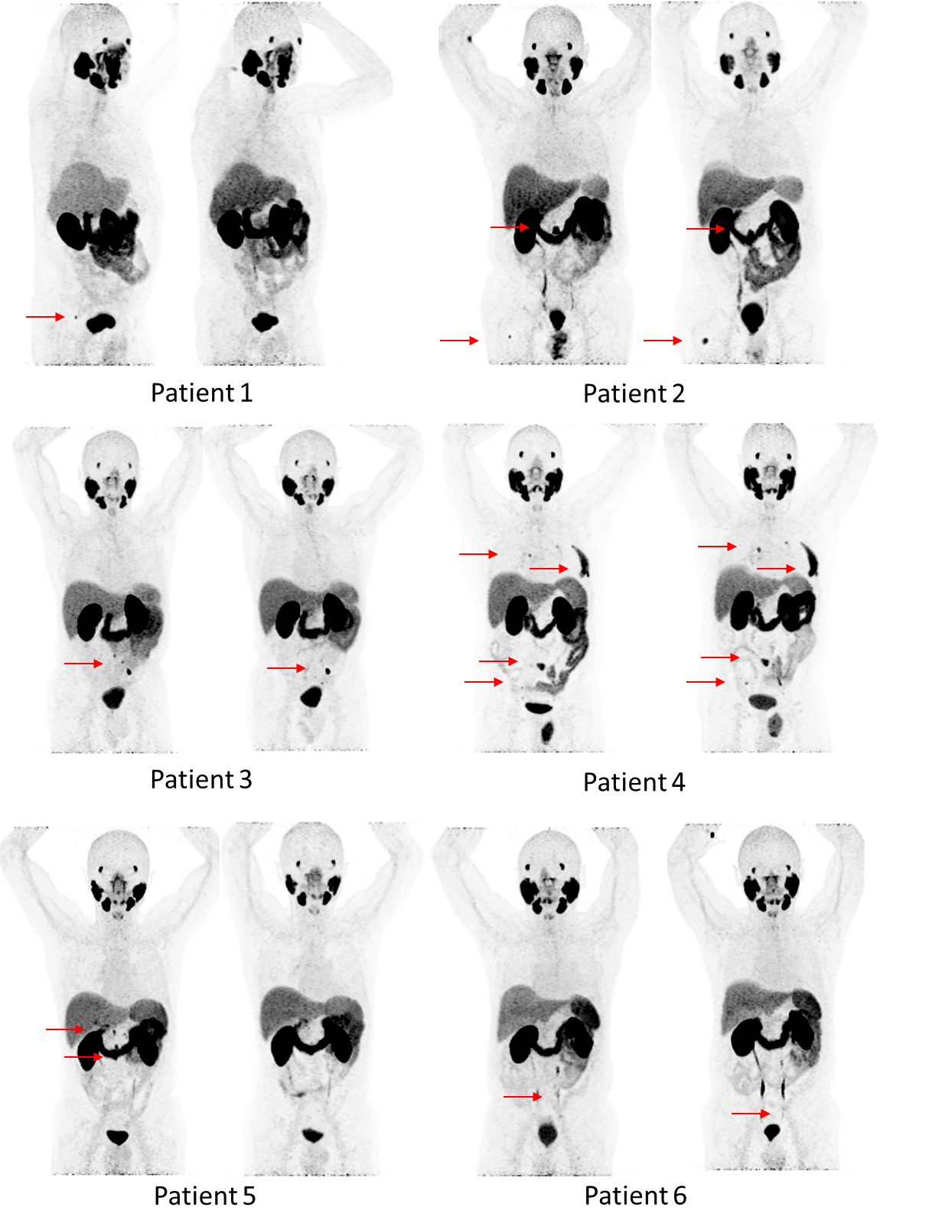
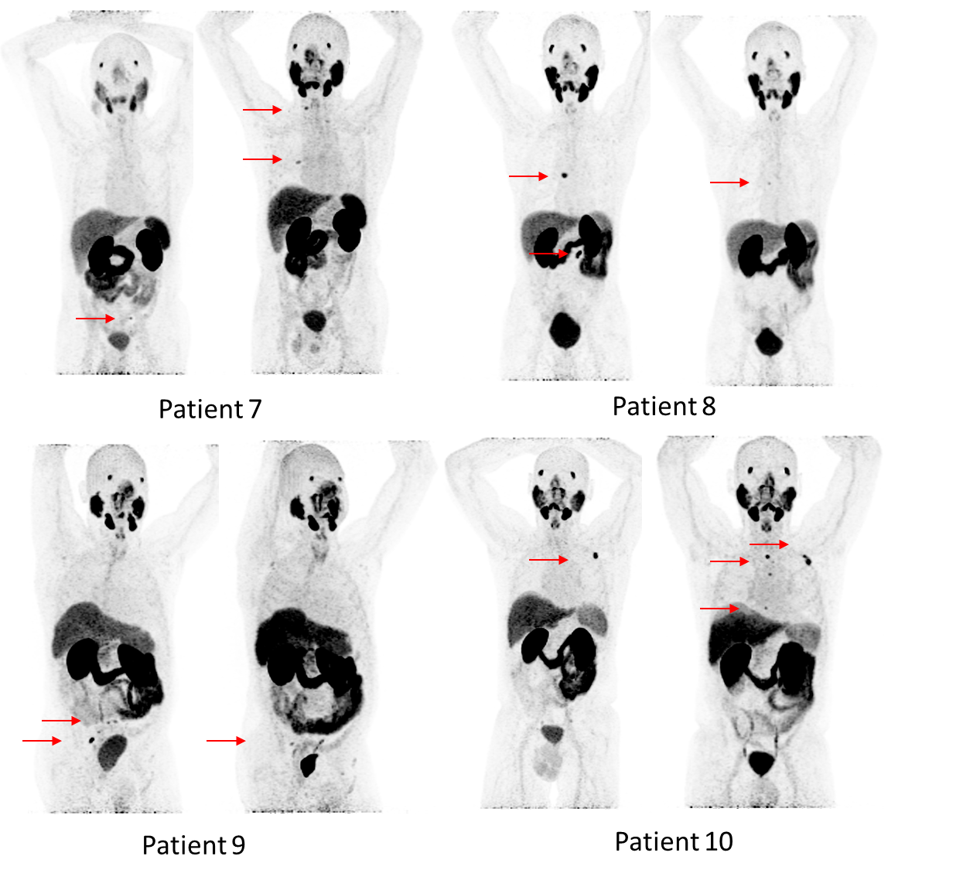

The left sided MIPs are from the baseline or EOS ⁶⁸Ga-PSMA-11 PET/CT (PSMA-PET) scan and the right sided are from the six months post cycle two PSMA-PET. The right sided MIP of patient #4 is the PSMA-PET of week 12 after cycle two.
MIP = maximum intensity projection; PET = positron emission tomography; PSMA = prostate-specific membrane antigen

Inclusion and exclusion criteria
Inclusion criteria
- Histological proven adenocarcinoma of the prostate
- Age > 50 years
- Prior local therapy for prostate cancer
- Biochemical recurrence or clinical progression after local therapy (PSA > 0.2 μg/l)
- PSA doubling time < 6 months
- ⁶⁸Ga-PSMA-11-PET/CT positive metastases in bones and/or lymph nodes: ≥1, maximally 10 metastases (at least 1 lesion with a lesion size of ≥1 cm to enable adequate dosimetry studies)
- Local treatment for oligometastases with radiotherapy or surgery appears to be no option anymore (due to prior treatment or the location of the metastatic lesions)
- No prior hormonal therapy or chemotherapy; testosterone > 1.7 nmol/l. (Exception: local prostate cancer treated with local radiotherapy plus adjuvant ADT; these patients need to have stopped ADT at least 3 months before inclusion)
- No visceral metastases
- White blood cells > 3.5 x 10⁹/l
- Platelet count > 150 x 10⁹/l
- Hemoglobin > 6 mmol/l
- AST, ALT < 3 x ULN
- MDRD-GFR ≥ 60 ml/min
- Signed informed consent

Exclusion criteria
- No detectable lesions on the ⁶⁸Ga-PSMA-11-PET/CT with an uptake level below the liver uptake.
- A known subtype other than prostate adenocarcinoma
- Any medical condition present that in the opinion of the investigator will affect patients’ clinical status when participating in this trial.
- Prior hip replacement surgery potentially influencing performance of ⁶⁸Ga-PSMA-11-PET/CT and nano-MRI
- Contra-indication for MRI imaging (claustrophobia, implanted electric and electronic devices (heart pacemakers, insulin pumps, implanted hearing aids, neurostimulators), intracranial metal clips, metallic bodies in the eye)
- Contra-indication for glucagon or Buscopan (allergy to hyoscine or any other ingredients of this medication, allergy to other atropinics (e.g. atropine, scopolamine), myasthenia gravis, enlarged colon, glaucoma or obstructive prostatic hypertrophy)
ADT = androgen deprivation therapy; ALT = alanine aminotransferase; AST = aspartate aminotransferase; MDRD-GFR = modification of diet in renal disease study [formula to estimate glomerular filtration rate]; PSA = prostate-specific antigen; PSMA = prostate-specific membrane antigen; ULN = upper limit of normal.

Study Flowchart
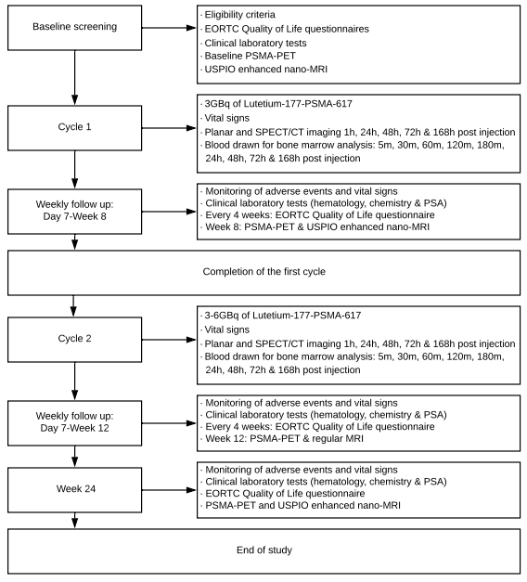

Labeling and purification of PSMA-617 with ¹⁷⁷Lu
¹⁷⁷LuCl₃ was obtained from ITG (Garching, Germany). GMP-grade PSMA-617 was obtained from ABX (Radeberg, Germany). The radiolabeling of PSMA-617 was performed on GRP synthesis module (Scintomics, Fürstenfeldbruck, Germany) using sterile and GMP-grade SC-105 kits. In brief, 4 mg gentisic acid and the PSMA-617 peptide were dissolved in 500 μL WFI and added to the reaction vessel. After addition of the ¹⁷⁷LuCl₃ in sodium acetate buffer and ascorbic acid the reaction was incubated at 100 °C for 20 minutes. After cooling down, the product was diluted to 16.5 ml with saline/DTPA to which 0.9 ml ethanol has been added. The radioactive solution was filtered through a 0.22 μm filter (Millex GV. Merck, Amsterdam, The Netherlands) and dispensed into a closed glass type I container. Microbiological monitoring in class C was performed during synthesis, filtration and dispensing. Assembling of the dispensing and filtration system was performed in a class A isolator with a class B airlock (in a class C background). The radiolabeled PSMA-617 was measured for total radioactivity in a calibrated activity dose calibrator prior to injection and injected within 6 hours after radiolabeling.

