**Supplemental Data**

**Figure S1.** Progression-free survival (PFS) in each cohort. Kaplan-Meier estimates of PFS from the **A,** initial (n=15) and **B,** expansion (n=20) cohorts. Six-month and 12-month landmarks are shown in **A** and 6-month landmarks are shown in **B**.

1. **Initial Cohort (n = 15)**

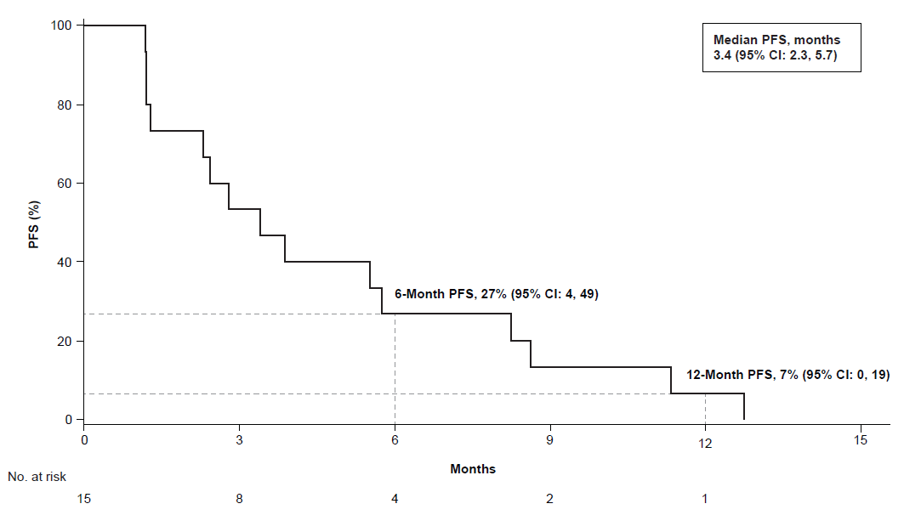

1. **Expansion Cohort (n = 20)**

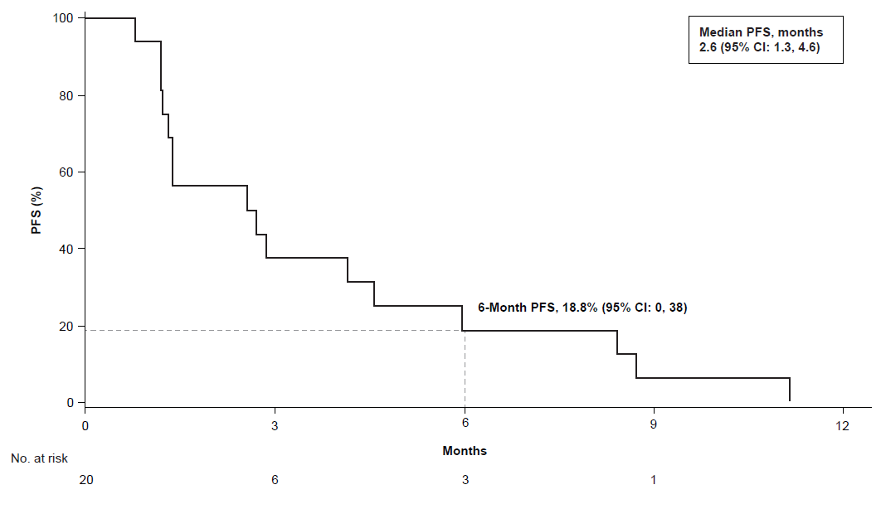

**Figure S2.** Overall survival in each cohort. Kaplan-Meier estimates of OS from the **A,** initial (n=15) and **B,** expansion (n=20) cohorts. Twelve-month and 24-month landmarks are shown in **A** and 12-month landmark is shown in **B**. OS, overall survival.

1. **OS for Initial Cohort (n = 15)**

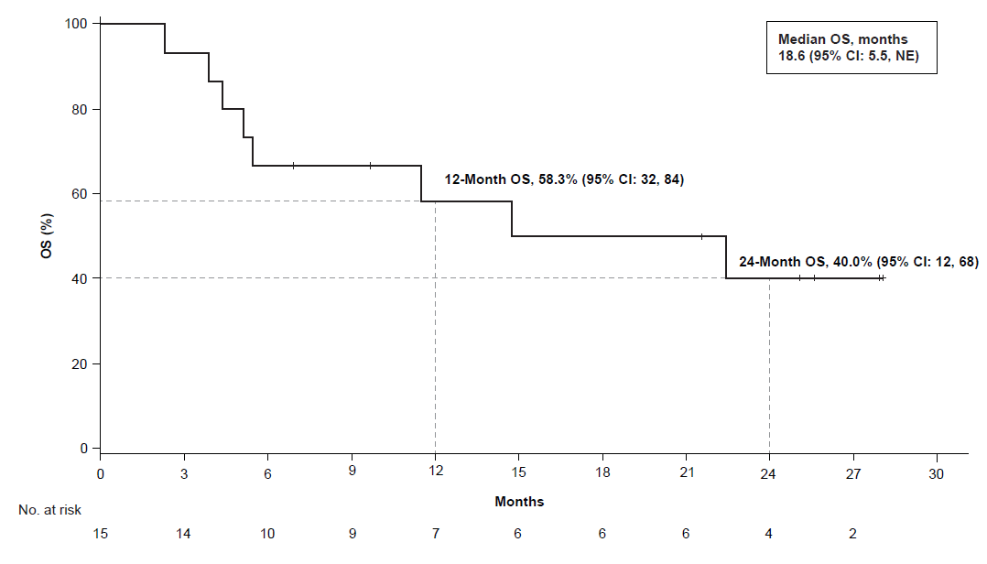

1. **OS for Expansion Cohort (n = 20)**

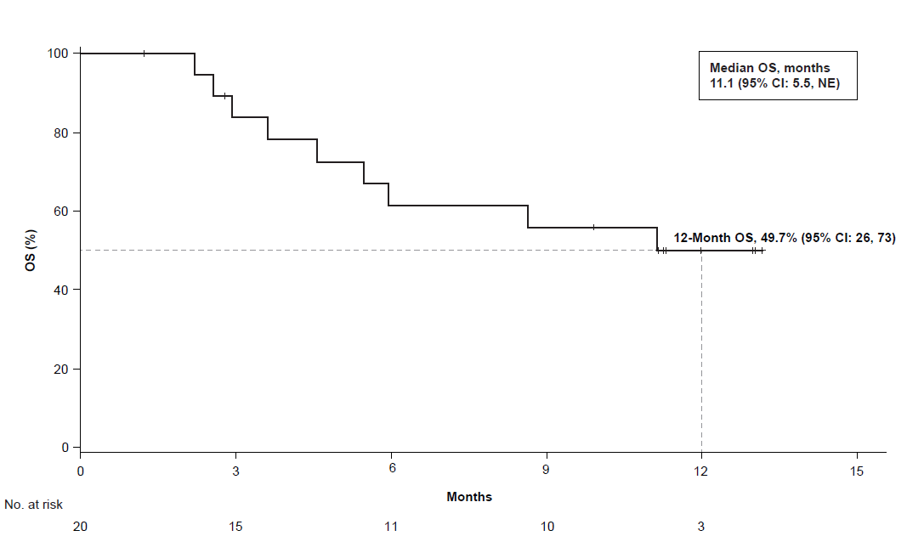

**Figure S3.** FMI oncoprint. A full oncoprint is shown for patient samples evaluated by FMI for known/likely gene alterations. FMI, Foundation Medicine Inc; HRD, homologous recombination deficiency; ND, not detected. Patient 9 had a known/likely *BRCA2* alteration and was HRD+. Patient 20 had an *ATM* alteration, thus was also HRD+.

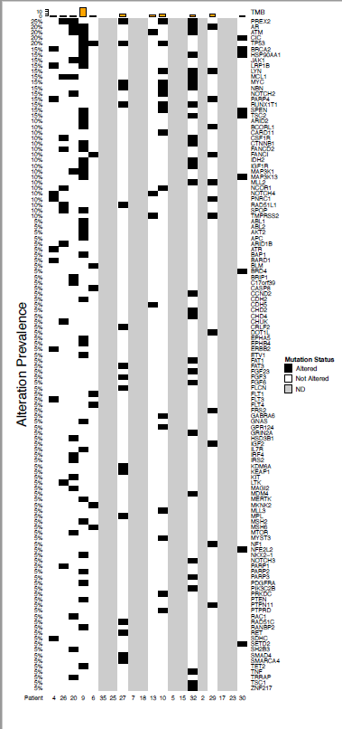

**Figure S4.** Case report 1. **A,** Patient characteristics from case report 1 (patient 31). **B,** CT scan at baseline and after 2 months of atezolizumab treatment. **C,** Pretreatment and on-treatment biomarker expression by IHC (PD-L1 and CD8). **D,** Frequency of TCR clones in PBMC samples collected at baseline (x-axis) and on-treatment (y-axis). AR, androgen receptor; CT, computed tomography; DDR, DNA damage response; IC, tumor-infiltrating immune cells; IHC, immunohistochemistry; MSI-H, microsatellite instability-high; PBMC, peripheral blood mononuclear cell; PC, prostate cancer; PD-L1, programmed death-ligand 1; PSA, prostate-specific antigen; TC, tumor cells; TMB, tumor mutational burden; TCR, T-cell receptor; Tx, treatment.

**Patient characteristics**

|  |  |
| --- | --- |
| **Case report 1** |  |
| Age | 63 years |
| Diagnosis | Metastatic adenocarcinoma of the prostate (2014) |
| Prior therapy | Bicalutamide (March 2014-April 2015)  Enzalutamide (April 28, 2015-May 27, 2016; radiographic progression)  No prior PC surgeries or radiotherapies |
| Enrolled in PCD4989g | June 2016 |
| Clinical status at enrollment | Retroperitoneal, iliac, and subclavicular lymph node metastasis  PSA of 12 ng/mL |
| Initial biomarker status | PD-L1 IC0/TC0  Low CD8 expression (0.02%)  Per local analysis of screening tissue:  High TMB (30 mut/Mb)  DDR mutations including germline *BRCA2* (E49*) mutations  MMR deficiency owing to *MSH2* and *MSH6* loss  *TP53* mutation (tumor suppressor, Y236D), *MYC* amplification (proto-oncogene)  TMPRSS2-ERG (EST fusion)  *AR* mutation (W742C) |
| Biomarker status after treatment with atezolizumab | Increase in PD-L1 expression (IC3/TC1)  Infiltration of CD8 to a previously desert tumor (2.89%)  Clonal expansion of novel CD8 clones in the periphery |

**Radiographic response**

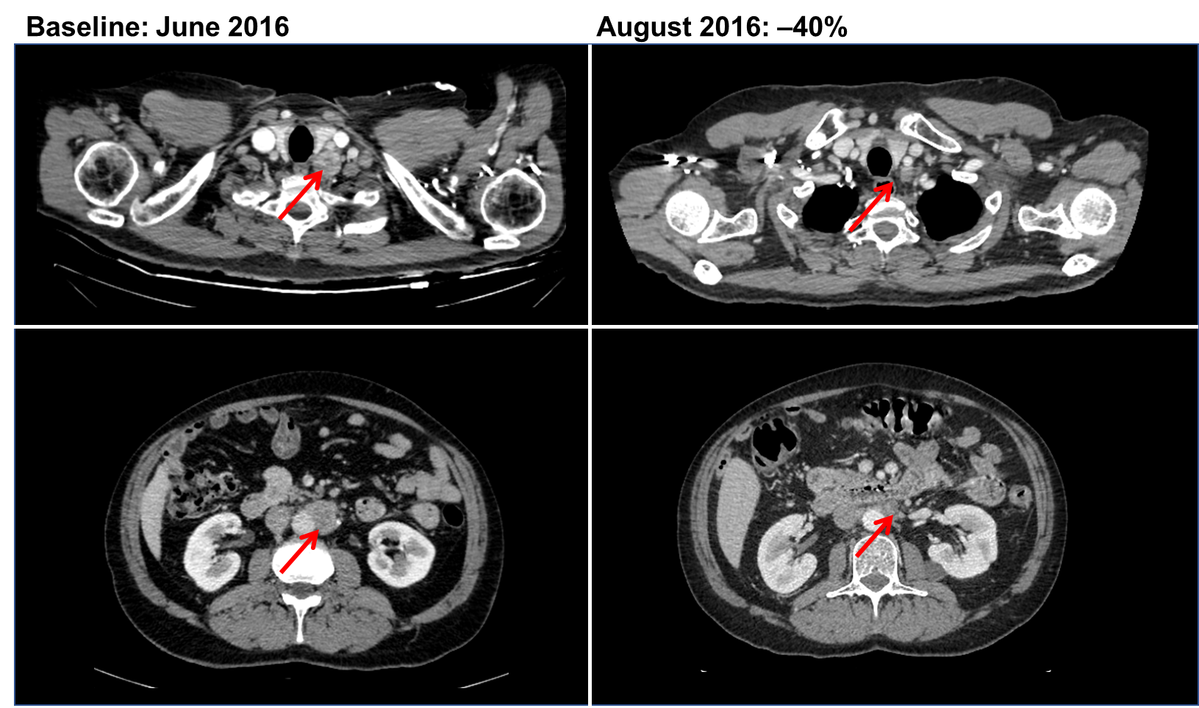

**Pretreatment and on-treatment biomarker expression**

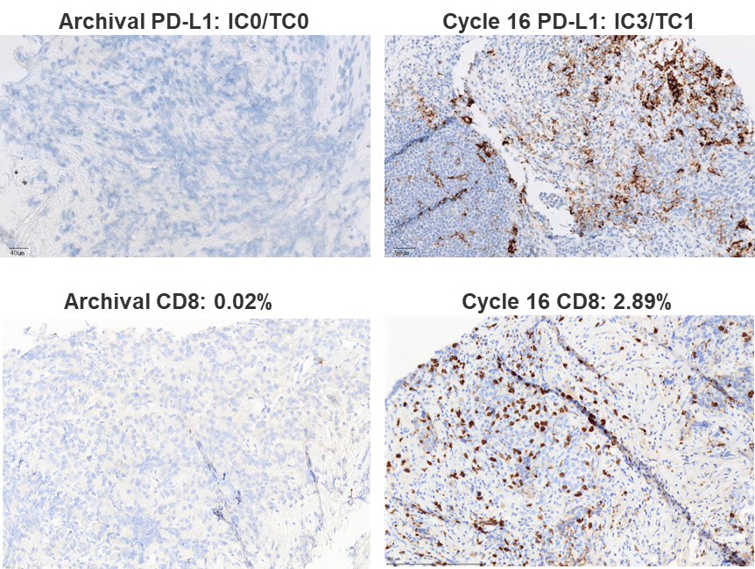

**TCR sequencing**

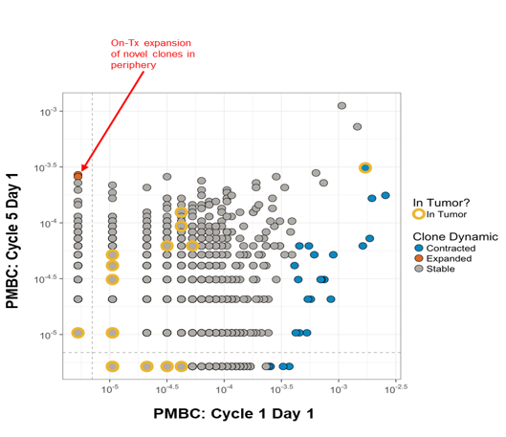

**Figure S5.** Case report 2. **A,** Patient characteristics from case report 2 (patient 32). **B,** CT scan at baseline and after 8 cycles of atezolizumab treatment. **C,** Pretreatment and on-treatment biomarker expression by IHC (PD-L1 and CD8). **D,** RNA expression by Fluidigm analysis at baseline and on-treatment. **E,** The frequency of TCR clones in PBMC samples collected at baseline (x-axis) and on-treatment (y-axis) are shown, with Clone Dynamics and presence in associated tumor at that same time point. Expansion of T-cell clones found in both the periphery and uniquely in the on-treatment tumor sample are highlighted, following treatment with atezolizumab, that were absent in the archival tumor and baseline PBMC. CT, computed tomography; DDR, DNA damage response; IC, tumor-infiltrating immune cells; MSS, microsatellite stable; PBMC, peripheral blood mononuclear cell; PD-L1, programmed death-ligand 1; PSA, prostate-specific antigen; TC, tumor cells; TCR, T-cell receptor, TMB, tumor mutational burden.

**Patient characteristics**

|  |  |
| --- | --- |
| **Case report 2** |  |
| Age | 56 years |
| Diagnosis | Primary prostate adenocarcinoma (2011)  Metastatic diagnosis (2013) |
| Prior therapy | Bicalutamide + leuprolide (lymphadenopathy)  Sipuleucel-T (lymph node enlargement)  Docetaxel (8 cycles, PSA progression and pain)  Abiraterone (8 months, lymph node enlargement),  Enzalutamide (2 months, lymph node enlargement)  Radiation to retroperitoneal and mediastinal lymph node (February 2014)  Radiation to pelvic lymph node (January 2015) |
| Enrolled in PCD4989g | February 2015 |
| Clinical status at enrollment | Lymph node, kidney, pelvis, abdomen and left adrenal metastasis  PSA of 35 ng/mL |
| Initial biomarker status | PD-L1 IC0/TC0  CD8 0.39%  MSS  Relatively low TMB of 2.61  DDR mutation (*ATM* mutation of unknown significance) |
| Biomarker status after treatment with atezolizumab | PD-L1 IC1/TC1  Increased CD8 to 16.78%  Significant expansion of TCR clones in the tumor and periphery shown from PBMC  Increase in immune-related genes by Fluidigm |

**Radiographic response**

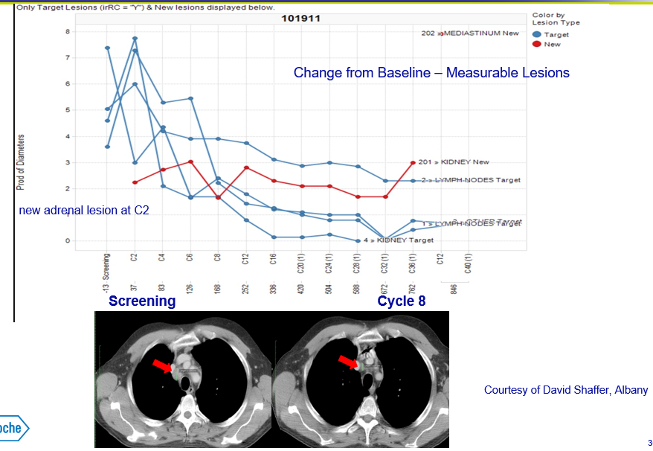

**Pretreatment and on-treatment biomarker expression**

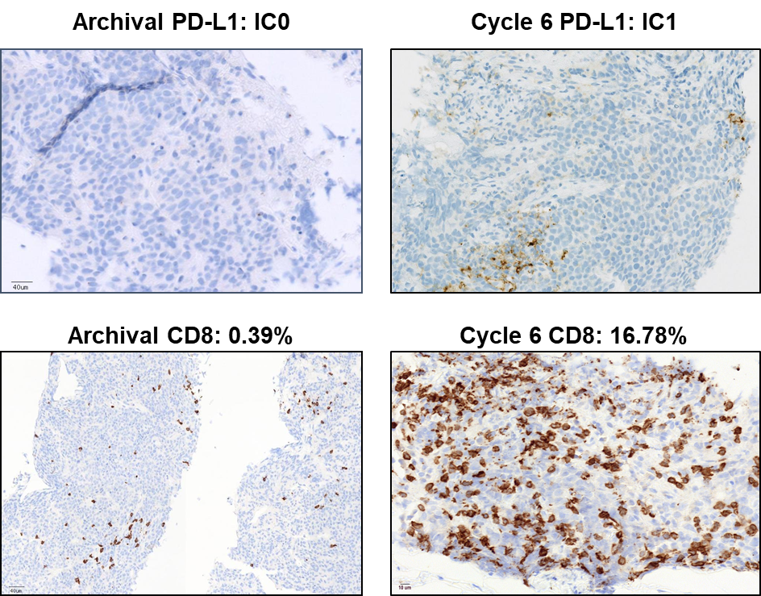

**RNA expression analysis using Fluidigm**



**TCR sequencing**

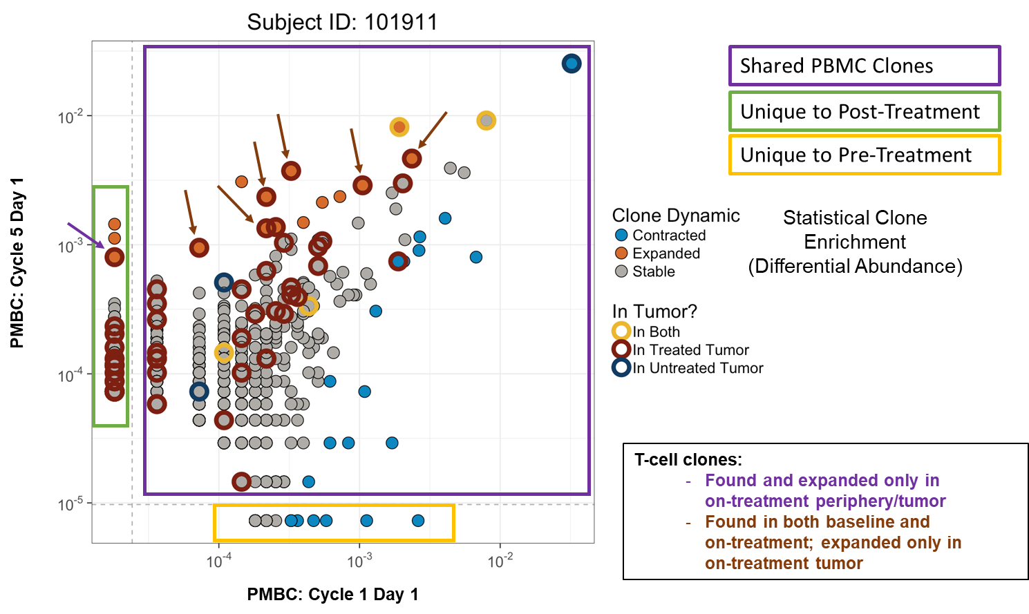

**Table S1.** Safety summary

|  |  |
| --- | --- |
| Total No. of patients with ≥1 AE, n (%) | |
| TRAEs | |
| Any grade AE | 21 (60.0) |
| Grade 3/4 AE | 4 (11.4) a |
| Serious AE | 1 (2.9)b |
| AE leading to dose interruption | 4 (11.4) c |
| AE leading to withdrawal from treatment | 1 (2.9) d |
| AESIs | |
| Any AESI | 9 (25.7)e |
| Grade 3/4 AESI | 1 (2.9)f |

AE, adverse event; AESI, adverse events of special interest; ALT, alanine aminotransferase; AST, aspartate aminotransferase, TRAE, treatment-related adverse event.

a Four patients had grade 3/4 TRAEs (1 with hypercalcemia, hypokalemia, hypophosphatemia, bone marrow infiltration, and anemia; 1 with spinal cord compression and lethargy; 1 with hypertension; 1 with hyponatremia).  
b One patient had 2 serious TRAEs (spinal cord compression and pyrexia).  
c Four patients had TRAEs leading to dose interruption (1 with dyspnea, 1 with rash; 1 with decreased appetite, fatigue, and vomiting; and 1 with increased ALT, increased AST, and increased alkaline phosphate).  
d Palmar-plantar erythrodysesthesia.  
e Neuropathy peripheral, hypothyroidism, increased ALT, increased AST, increased bilirubin, hypothyroidism, eczema, rash, and uveitis.  
f Increased ALT.

**Table S2.** Confirmed objective response rate per investigator in patients with measurable diseasea

|  |  |  |  |  |
| --- | --- | --- | --- | --- |
|  | Per RECIST 1.1  (n=25) | | Per irRC  (n=25) | |
|  | **n (%)** | **95% CI** | **n (%)** | **95% CI** |
| Partial response | 1 (4%)b | 0.1, 20.4 | 2 (8%)c | 0.7, 19.2 |
| Stable disease | 7 (28%) | 12.1, 49.4 | 8 (32%) | 10.4, 40.1 |
| Progressive disease | 15 (60%) | 38.7, 78.9 | 12 (48%) | 19.1, 52.2 |
| Missing/NEd | 2 (8%) | – | 3 (12%) | – |
| Stable disease ≥ 24 weeks | 5 (20%) | – | 5 (20%) | – |

NE, not evaluable; PR, partial response.

a Of 35 patients, 25 had measurable disease at baseline per RECIST 1.1. No patients had a complete response per RECIST 1.1 or irRC.

b Median duration of response was 7.2 months; patient had confirmed PR during cycle 2 of atezolizumab.

c Median duration of response was 10.6 months; patients had confirmed PR during cycles 2 and 16 of atezolizumab.

d Patients were classified as missing or NE if they had no postbaseline response assessments or all postbaseline response assessments were NE or <6 weeks from baseline. One additional patient was NE per irRC at baseline.

**Table S3.** Genes with no known/likely alterations by FMI in BEP

|  |  |  |  |  |  |  |  |
| --- | --- | --- | --- | --- | --- | --- | --- |
|  |  |  |  |  |  |  |  |
| *ACVR1B* | *CD79A* | *EPHA6* | *FH* | *JAK3* | *NTRK1* | *RAD50* | *STAT4* |
| *AKT1* | *CD79B* | *EPHA7* | *FOXL2* | *JUN* | *NTRK2* | *RAD51* | *STK11* |
| *AKT3* | *CDC73* | *EPHB1* | *FOXP1* | *KDM5A* | *NTRK3* | *RAD51D (RAD51L3)* | *SUFU* |
| *ALK* | *CDH1* | *EPHB6* | *FUBP1* | *KDM5C* | *NUDT1* | *RAD52* | *SYK* |
| *ALOX12B* | *CDH20* | *ERBB3* | *GALNT12* | *KDR* | *NUP93* | *RAD54L* | *TAF1* |
| *AMER1 (FAM123B)* | *CDK12* | *ERBB4* | *GATA1* | *KEL* | *PAK3* | *RAF1* | *TBX3* |
| *APCDD1* | *CDK4* | *ERCC4* | *GATA2* | *KLHL6* | *PAK7* | *RARA* | *TEK* |
| *ARAF* | *CDK6* | *ERG* | *GATA3* | *KMT2A (MLL)* | *PALB2* | *RB1* | *TERC* |
| *ARFRP1* | *CDK8* | *ERRFI1* | *GATA4* | *KRAS* | *PARK2* | *RBM10* | *TERT(promoter only)* |
| *ARID1A* | *CDKN1A* | *ESR1* | *GATA6* | *LMO1* | *PAX5* | *REL* | *TGFBR2* |
| *ASXL1* | *CDKN1B* | *ETV4* | *GEN1* | *LRP6* | *PBRM1* | *RICTOR* | *TIPARP* |
| *ATRX* | *CDKN2A* | *ETV5* | *GLI1* | *LZTR1* | *PDCD1LG2* | *RNF43* | *TNFAIP3* |
| *AURKA* | *CDKN2B* | *ETV6* | *GNA11* | *MAP2K1* | *PDGFRB* | *ROS1* | *TNFRSF14* |
| *AURKB* | *CDKN2C* | *EWSR1* | *GNA13* | *MAP2K2* | *PDK1* | *RPA1* | *TNKS* |
| *AXIN1* | *CEBPA* | *EZH2* | *GNAQ* | *MAP2K4* | *PHLPP2* | *RPTOR* | *TNKS2* |
| *AXL* | *CHEK1* | *FAM175A* | *GREM1* | *MDM2* | *PIK3C2G* | *RSPO2* | *TOP1* |
| *BACH1* | *CHEK2* | *FAM46C* | *GRM3* | *MED12* | *PIK3C3* | *RUNX1* | *TOP2A* |
| *BCL2* | *CRBN* | *FANCA* | *GSK3B* | *MEF2B* | *PIK3CA* | *SDHA* | *TP53BP1* |
| *BCL2A1* | *CREBBP* | *FANCC* | *H3F3A* | *MEN1* | *PIK3CB* | *SDHB* | *TSHR* |
| *BCL2L1* | *CRKL* | *FANCE* | *HGF* | *MET* | *PIK3CG* | *SDHD* | *TYRO3* |
| *BCL2L2* | *CTCF* | *FANCF* | *HLA-A* | *MITF* | *PIK3R1* | *SF3B1* | *U2AF1* |
| *BCL6* | *CTNNA1* | *FANCG* | *HLA-B* | *MKNK1* | *PIK3R2* | *SLIT2* | *VEGFA* |
| *BCOR* | *CUL3* | *FANCL* | *HLA-C* | *MLH1* | *PLCG2* | *SMAD2* | *VHL* |
| *BCR* | *CUL4A* | *FANCM* | *HNF1A* | *MRE11A* | *PMS2* | *SMAD3* | *WISP3* |
| *BMPR1A* | *CUL4B* | *FAS* | *HOXB13* | *MST1R* | *POLD1* | *SMARCB1* | *WT1* |
| *BRAF* | *CYLD* | *FBXW7* | *HRAS* | *MUTYH* | *POLE* | *SMARCD1* | *XPO1* |
| *BRCA1* | *CYP17A1* | *FGF10* | *IDH1* | *MYB* | *PPARG* | *SMO* | *XRCC2* |
| *BTG1* | *DAXX* | *FGF12* | *IGF1* | *MYCL (MYCL1)* | *PPP2R1A* | *SNCAIP* | *XRCC3* |
| *BTK* | *DDR1* | *FGF14* | *IGF2R* | *MYCN* | *PRDM1* | *SOCS1* | *ZBTB2* |
| *C11orf30 (EMSY)* | *DDR2* | *FGF19* | *IKBKE* | *MYD88* | *PRKAR1A* | *SOX10* | *ZNF703* |
| *CBFB* | *DICER1* | *FGF4* | *IKZF1* | *NF2* | *PRKCI* | *SOX9* | *ZNRF3* |
| *CBL* | *DIS3* | *FGF7* | *INHBA* | *NFKBIA* | *PRSS1* | *SPTA1* |  |
| *CCND1* | *DNMT3A* | *FGFR1* | *INPP4B* | *NOTCH1* | *PRSS8* | *SOX2* |  |
| *CCND3* | *EGFR* | *FGFR2* | *INSR* | *NPM1* | *PTCH1* | *SRC* |  |
| *CCNE1* | *EPHA3* | *FGFR4* | *JAK2* | *NRAS* | *PTCH2* | *STAG2* |  |
| *CD274* | *EP300* | *FGFR3* | *IRF2* | *NSD1* | *QKI* | *STAT3* |  |