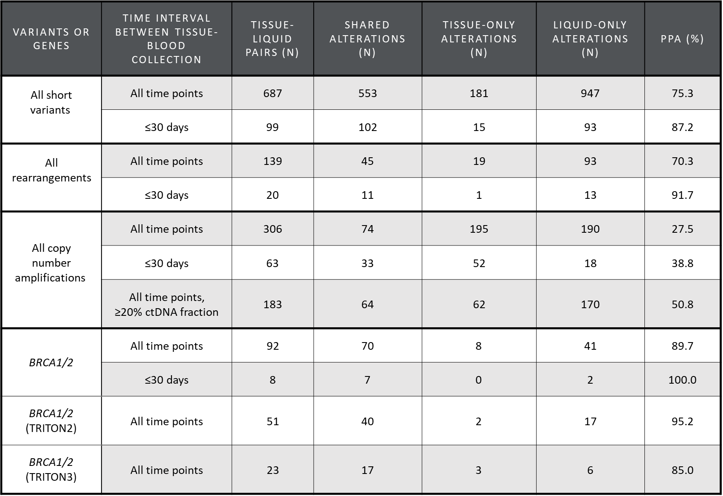

Table S3. Positive percent agreement (PPA) between patient-matched cancer tissue and liquid biopsies. Short variants, rearrangements, and copy number alterations considered separately. PPA of BRCA1/2 includes short variants and rearrangements also presented. PPA = shared alterations / (shared alterations + tissue only alterations).

