Figure S2.
Treatment-free interval, duration of therapy, duration of response, and subsequent systemic therapy in all patients with sRCC and I/P-risk disease and confirmed response (A, complete responders; B, partial responders).
Bar indicates time on treatment/treatment-free interval (TFI).
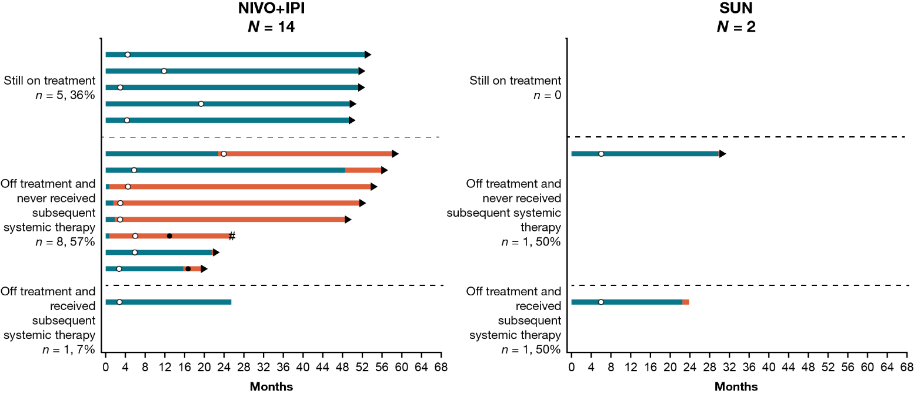
A)

B)
