Figure S1.
Post hoc identification of patients with sRCC in CheckMate214.
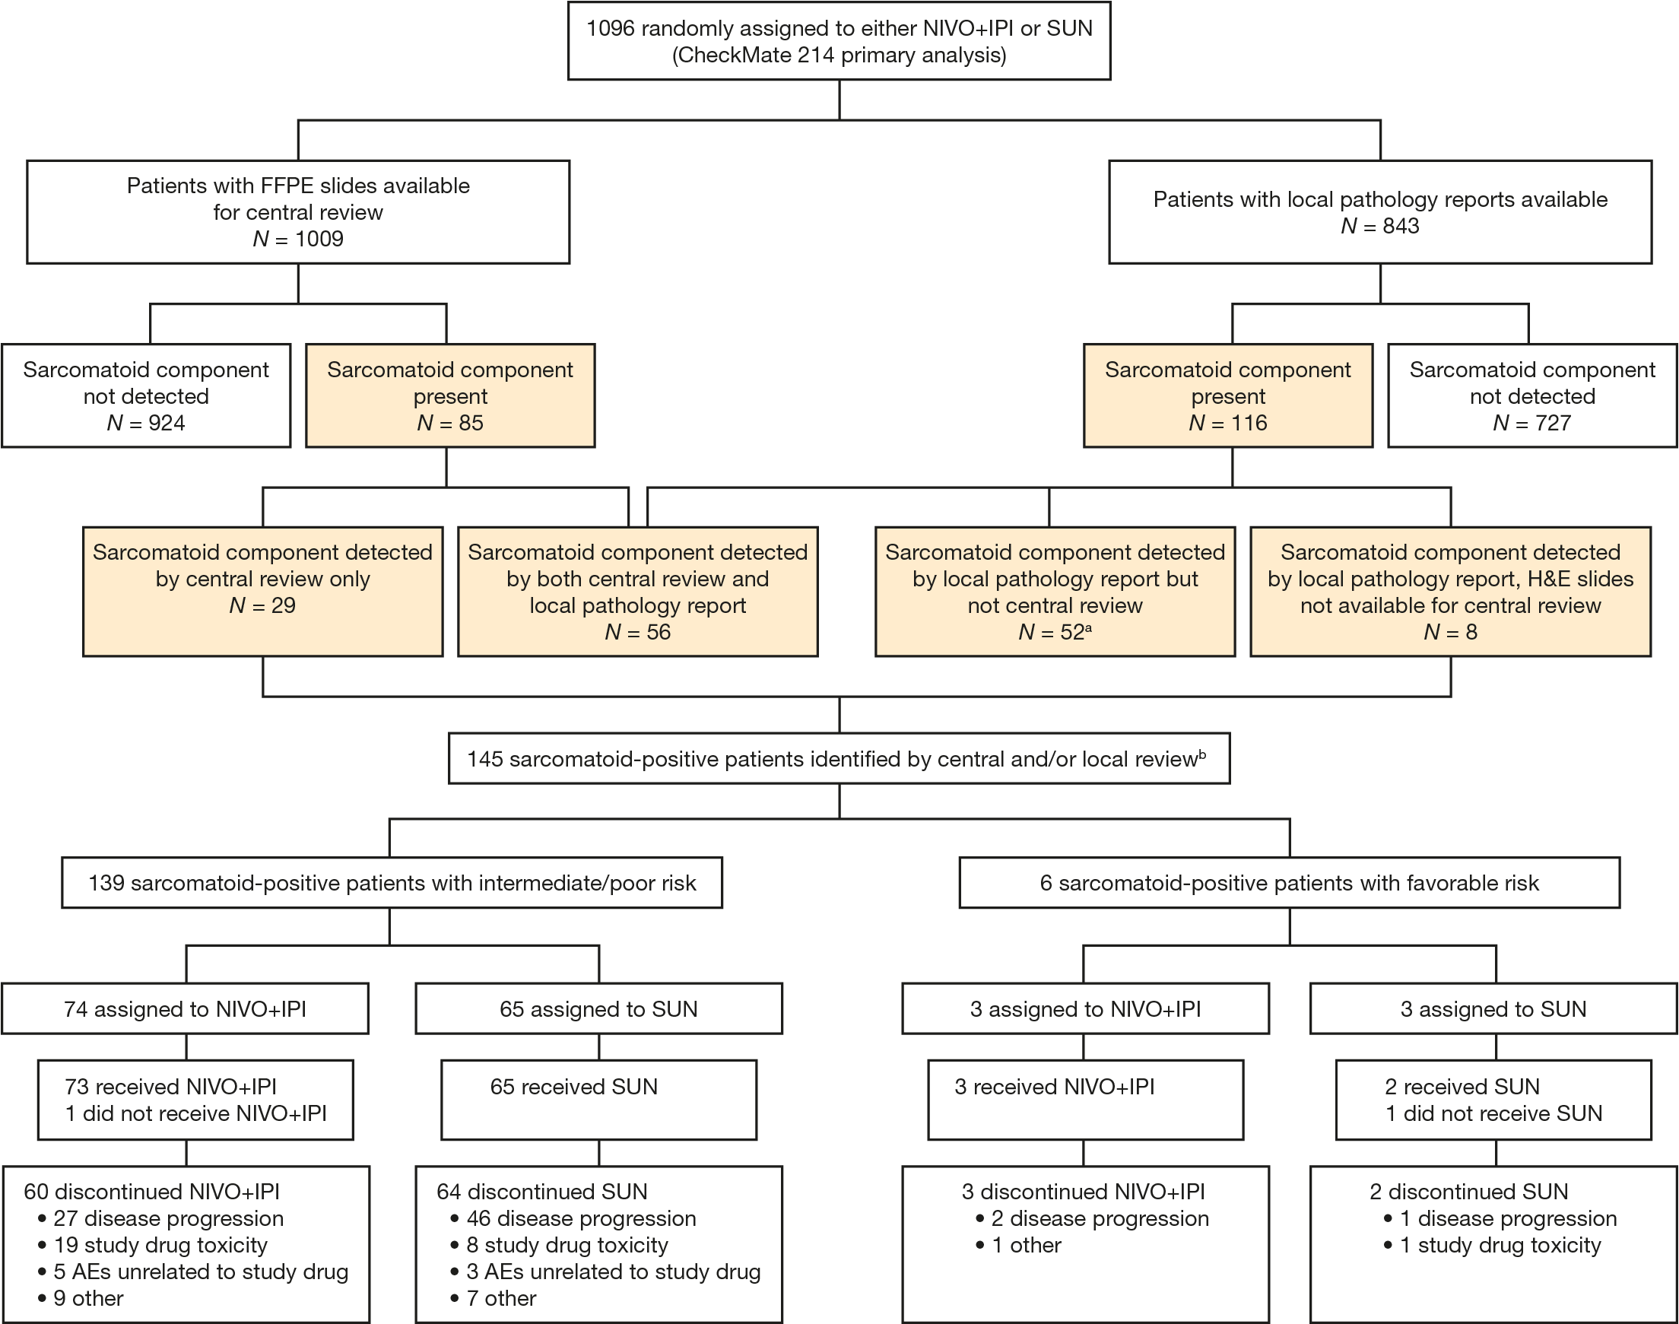
A diagnosis of sarcomatoid-positive renal cell carcinoma was made if any proportion of sarcomatoid component was present. Gray shaded boxes denote patient samples identified as sarcomatoid-positive and included in the present analysis.
ªIncludes four patients with N/A results. ^{b}Individual sarcomatoid-positive tumor samples from patients randomized to NIVO+IPI versus SUN comprised primary nephrectomy (93.5% vs. 92.6%) or metastatic biopsy (6.5% vs. 5.9%) sites (tumor sample site not reported for one patient in the SUN group).
H&E, hematoxylin and eosin.

