Supplementary Figure 1. CONSORT chart.
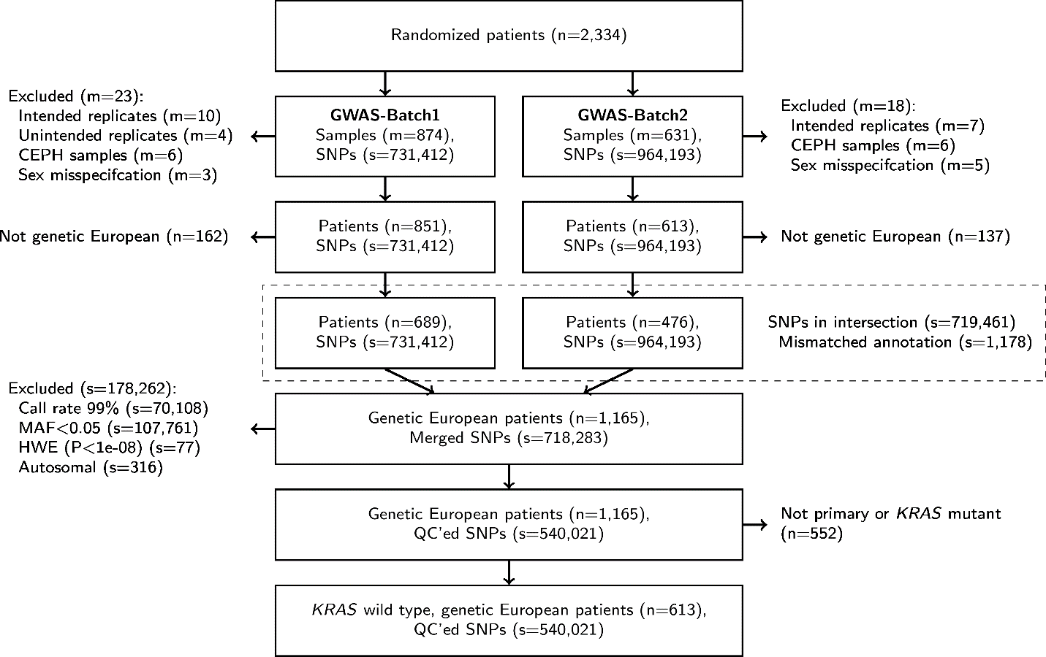

Supplementary Figure 2. Q-Q plot.
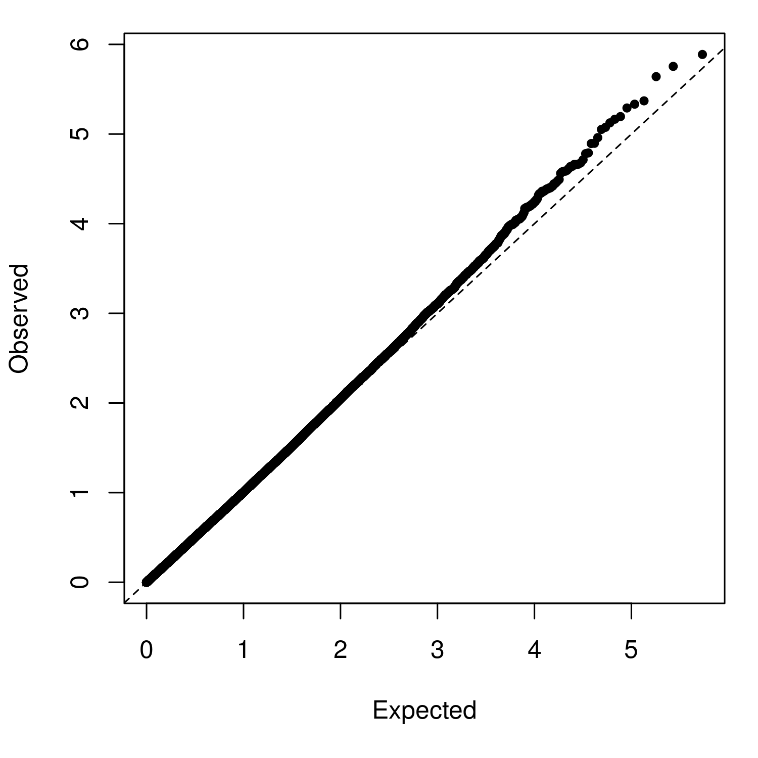

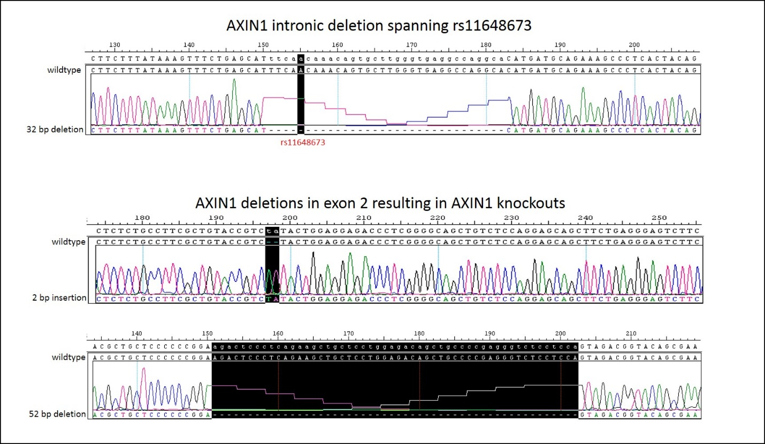
Supplementary Figure 3. Mutated sequences in AXIN1 by CRISPR.

Supplementary Figure 4. LocusZoom plots of A) AXIN1 SNPs, and B) intergenic SNPs between MGST1 and LMO3.

A)

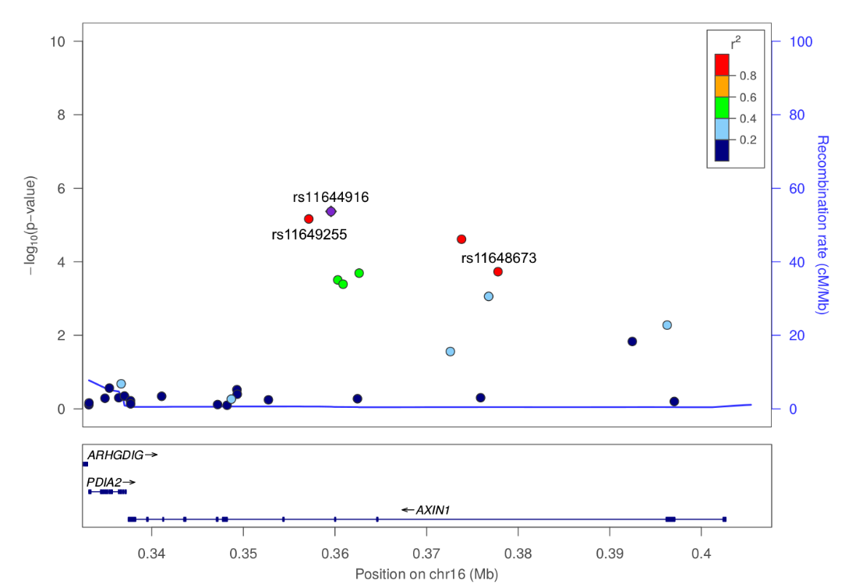

B)
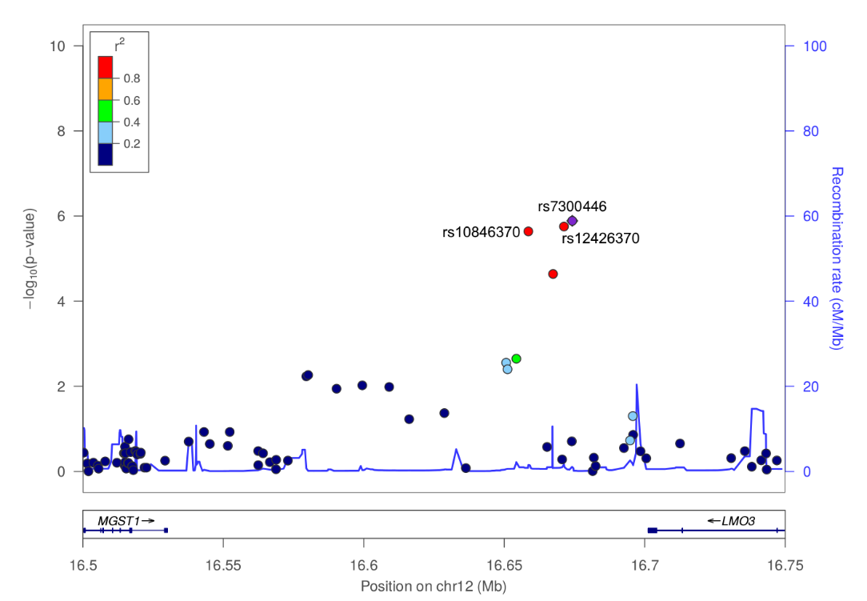

Supplementary Figure 5. Kaplan-Meier plots of OS for rs11648673 (G>A) in AXIN1 (the variant used for the functional assays) in CALGB/SWOG 80405.
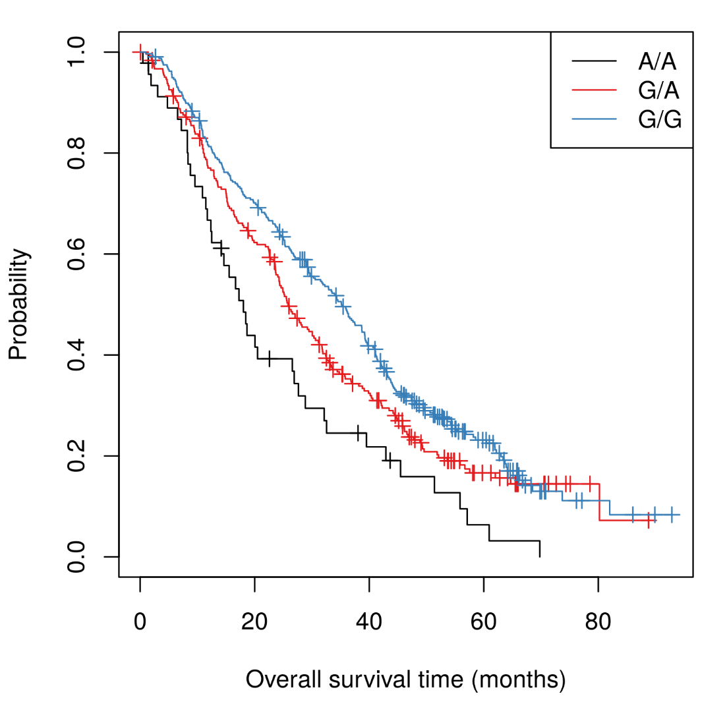
Supplementary Tables
Supplementary Table 1. Oligonucleotide sequences used for CRISPR.
Oligonucleotide Name | Forward Oligonucleotide 5’-3’ | Reverse Oligonucleotide 5’-3’
gRNA_AXIN1_rs11648673 | CACCGCATTTCAACAAACAGTGCTT | AAACAAGCACTGTTTGTTGAAATGC
gRNA1_AXIN1_KO | CACCGCTTCTGAGGGAGTCTTCCGGG | AAACCCCGAAGACTCCCTCAGAAGC
gRNA2_AXIN1_KO | CACCGCCTTCGCTGTACCGTCTACTGG | AAACCCAGTAGACGGTACAGCGAAGGC
gRNA_AXIN1_rs11648673_check | GCACTTACTGGCTACTGACC | CAGCCTGGTGAAGCATTTGT
gRNA1_AXIN1_KO_check | TTGGAATATACGAGGACAGGCT | GTCGGACTCACCTGAACTCTCT
gRNA2_AXIN1_KO_check | ATACCTGCCGACCTTAAATGAA | AGCTCTCGGAGGTGAGTACAGA
AXIN1_rs11648673_ssDNAdonor | TCCCACCCAGTCCCCTAACTAATGTGCAGGACACTTTGGTTGCTAGGCTGTAGTGAGGGCTTTCTGCATCATGTGCCTGGCCTCACCCAAGCACTGTTTGCTGAAATGCTCAGAAACTTTATAAAGA

Supplementary Table 2. Ten most statistically significant SNPs associated with OS in CALGB/SWOG 80405, adjusted for age (log10 transformed), sex, and tumor location (left vs. right/transverse). Wald p-values are presented.

RSID | Chr | Gene | Alleles | Feature | MAF | HR | 95% LCL | 95% UCL | P-value
rs7300446 | 12 | MGST1/LMO3 | A>G | Intergenic | 0.15 | 1.45 | 1.20 | 1.76 | 1.62x10⁻⁴
rs12426370 | 12 | MGST1/LMO3 | A>G | Intergenic | 0.15 | 1.45 | 1.20 | 1.76 | 1.62x10⁻⁴
rs10846370 | 12 | MGST1/LMO3 | A>G | Intergenic | 0.15 | 1.41 | 1.17 | 1.68 | 2.00x10⁻⁴
rs11644916 | 16 | AXIN1 | G>A | Intronic | 0.30 | 1.32 | 1.14 | 1.53 | 1.80x10⁻⁴
rs2461035 | 8 | STMN2/HEY1 | A>G | Intergenic | 0.33 | 0.71 | 0.61 | 0.82 | 3.27x10⁻⁶
rs16985284 | 2 | KCNS3/RDH14 | A>C | Intergenic | 0.12 | 1.65 | 1.34 | 2.02 | 2.52x10⁻⁶
rs11246159 | 11 | ANO9 | A>G | Intronic | 0.17 | 1.45 | 1.21 | 1.73 | 6.92x10⁻⁵
rs11649255 | 16 | AXIN1 | A>G | Intronic | 0.29 | 1.31 | 1.14 | 1.52 | 2.51x10⁻⁴
rs898838 | 2 | MSGN1/KCNS3 | A>G | Intergenic | 0.45 | 0.72 | 0.63 | 0.83 | 5.33x10⁻⁶
rs2467754 | 8 | STMN2/HEY1 | A>G | Intergenic | 0.33 | 0.71 | 0.61 | 0.82 | 5.66x10⁻⁶

Supplementary Table 3. SNPs from Supplementary Table 2 tested for associated with OS in CALGB/SWOG 80405, adjusted for age (log10 transformed), sex, BRAF V600E, MSI (MSI-H versus MSS), and CMS (1, 2, 3, 4). MAF and statistical results are based on 289 patients with non-missing BRAF V600E, MSI, and CMS data. Wald p-values are presented.

RSID | Chr | Gene | Alleles | Feature | MAF | HR | 95% LCL | 95% UCL | P-value
rs7300446 | 12 | MGST1/LMO3 | A>G | Intergenic | 0.13 | 1.55 | 1.15 | 2.09 | 4.37x10⁻³
rs12426370 | 12 | MGST1/LMO3 | A>G | Intergenic | 0.13 | 1.55 | 1.15 | 2.09 | 4.37x10⁻³
rs10846370 | 12 | MGST1/LMO3 | A>G | Intergenic | 0.14 | 1.43 | 1.09 | 1.87 | 9.67x10⁻³
rs11644916 | 16 | AXIN1 | G>A | Intronic | 0.32 | 1.38 | 1.13 | 1.68 | 1.25x10⁻³
rs2461035 | 8 | STMN2/HEY1 | A>G | Intergenic | 0.34 | 0.70 | 0.57 | 0.86 | 7.44x10⁻⁴
rs16985284 | 2 | KCNS3/RDH14 | A>C | Intergenic | 0.12 | 1.74 | 1.29 | 2.35 | 2.97x10⁻⁴
rs11246159 | 11 | ANO9 | A>G | Intronic | 0.16 | 1.43 | 1.09 | 1.88 | 1.06x10⁻²
rs11649255 | 16 | AXIN1 | A>G | Intronic | 0.32 | 1.36 | 1.12 | 1.65 | 2.17x10⁻³
rs898838 | 2 | MSGN1/KCNS3 | A>G | Intergenic | 0.45 | 0.75 | 0.62 | 0.91 | 3.78x10⁻³
rs2467754 | 8 | STMN2/HEY1 | A>G | Intergenic | 0.34 | 0.71 | 0.58 | 0.88 | 1.35x10⁻³

Supplementary Table 4. Bioinformatics analysis of SNPs associated with OS. The linkage disequilibrium (LD) r² reported for rs11648673 is in relation to rs11644916 in Europeans from the 1,000 Genomes Project. The SNP regions reported for rs11644916 and rs11648673 are relative to the AXIN1 gene. The SNP in bold (rs11644916) is the variant in AXIN1 that was associated with OS. The SNP in Italics is the one selected for the functional assays. RegulomeDB score represents the evidence that each SNP functions in a regulatory role (1-strong evidence, 6-weak evidence). ENCODE data includes experimental information for ChiP-seq and DNase I sensitivity, histone modifications, as well as transcription factor binding motifs that were identified using a combination of computational and experimental data. ND, not determined.

SNP | LD (r²) | Region | RegulomeDB score |  |  | ENCODE data
 |  |  |  | ChIP-seq | Transcription factor binding motifs |  | DNase I sensitivity region |  |  | Histone modification
rs11644916 | - | Intronic | 3a | CTCF, RAD21 | RFX3 |  | No |  | None
rs11648673 | 0.81 | Intronic | 1f | POLR2A | DBP, HNF4, TCF12 |  | ND |  | Enhancer
rs7300446 | ND | intergenic | 5 | SPI1 | ZBRK1 |  | ND |  | None
rs12426370 | ND | intergenic | 6 | ND | ND |  | ND |  | None
rs10846370 | ND | intergenic | No data | ND | ARNT, FOXD3, FOXL1, MYC |  | ND |  | None

Supplementary Table 5. AXIN1 variants tested in this study: extent of LD between each other, and the association with OS, either in CALGB/SWOG 80405, TCGA, or both (when available). The r² indicates the LD according to the 1,000 Genomes Project in Europeans.

RSID | Population | HR | 95% LCL | 95% UCL | P-value | r²
 |  |  |  |  |  | rs11644916 | rs11649255 | rs11648673
rs11644916 | CALGB | 1.40 | 1.20 | 1.59 | 4.26x10⁻⁶ |  | 0.99 | 0.81
rs11649255 | CALGB | 1.38 | 1.20 | 1.58 | 6.83x10⁻⁶ | 0.99 |  | 0.82
 | TCGA | 2.24 | 1.20 | 4.19 | 0.0096
rs11648673 | CALGB | 1.31 | 1.14 | 1.52 | 1.86x10⁻⁴ | 0.81 | 0.82

