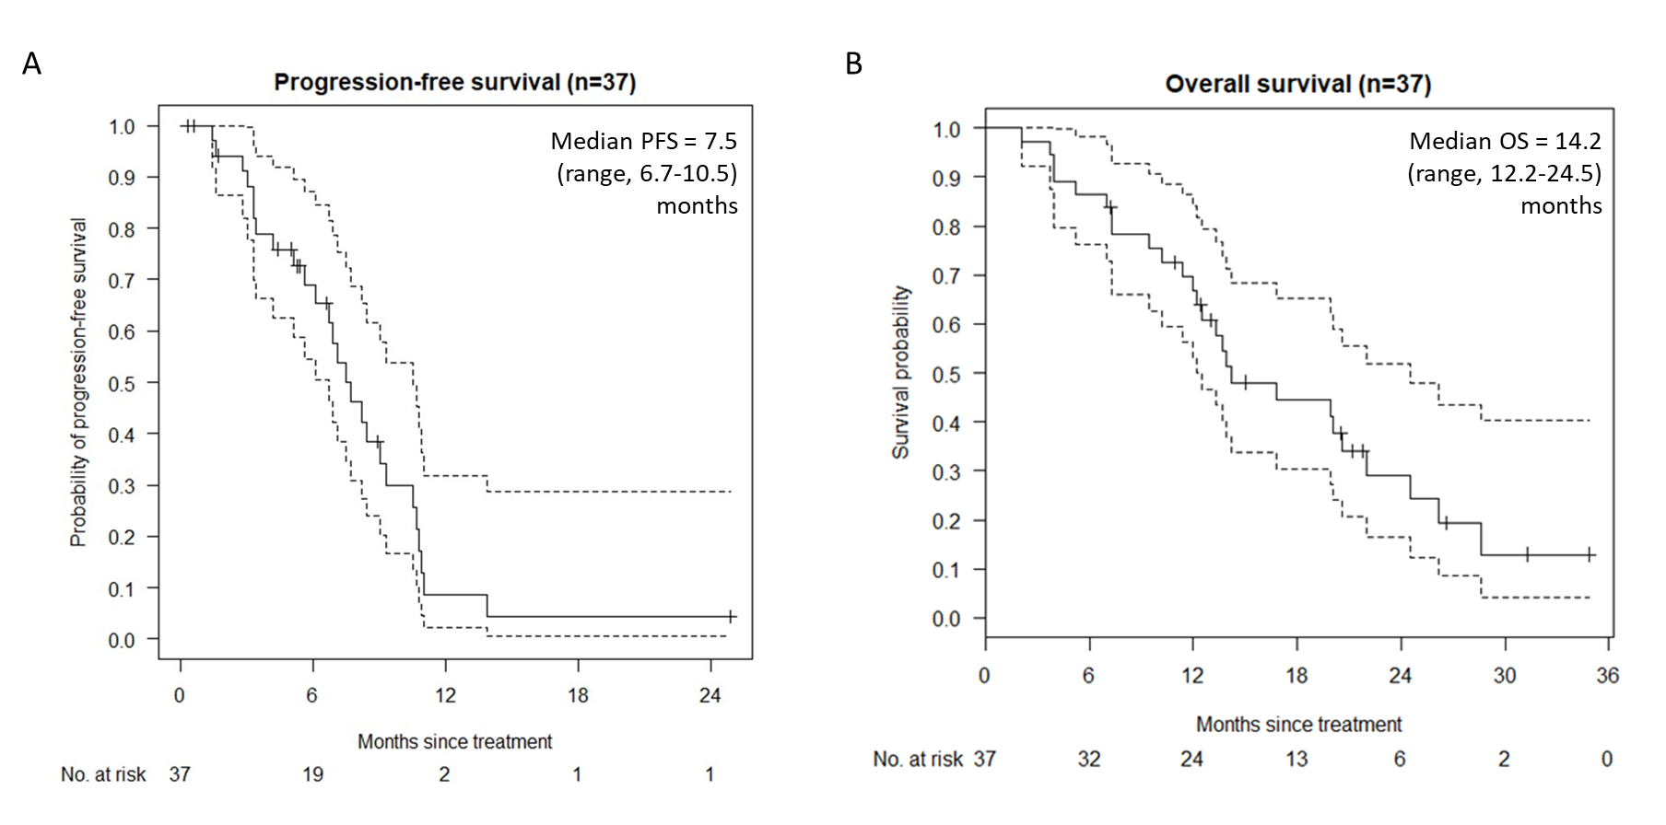
Figure S1: A) Kaplan Meier plot for progression-free survival and B) Kaplan Meier plot for overall survival. Dashed lines denote 95% confidence intervals. PFS, progression-free survival; OS, overall survival

