Supplementary Figure 1a. Box and whisker plot depicting timing of baseline draw relative to active disease and CTC detection.
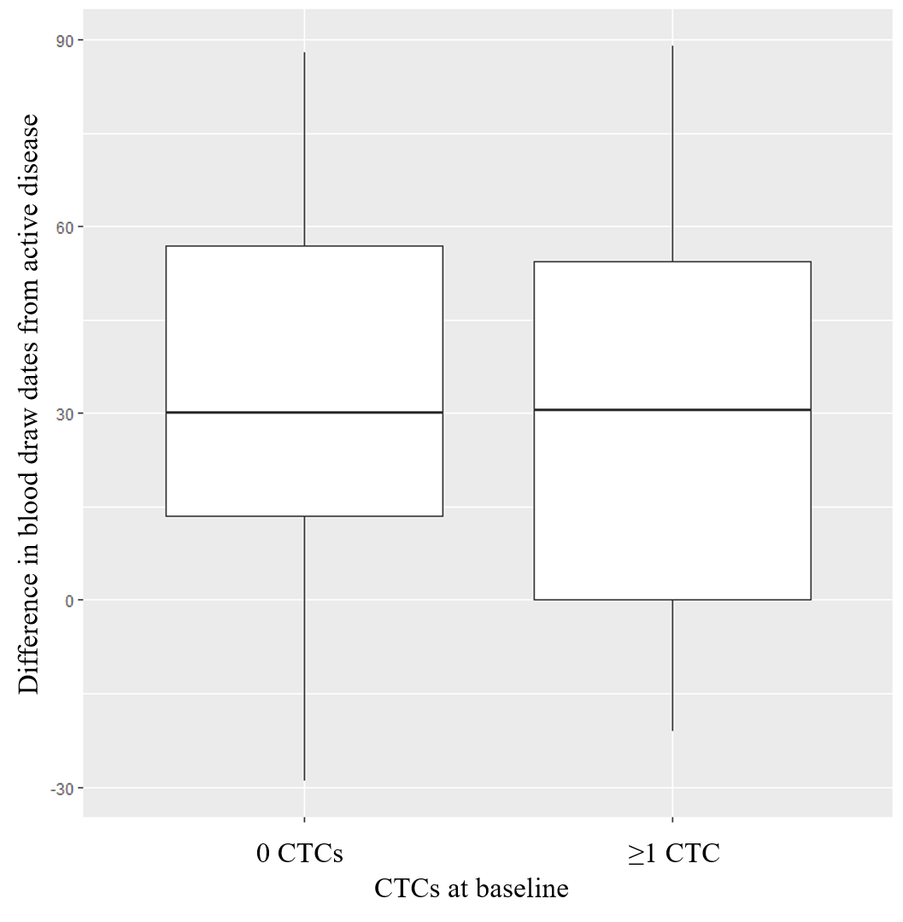

Supplementary Figure 1b. Box and whisker plot depicting timing of baseline draw relative to active disease and relapse within 6 months of baseline draw.
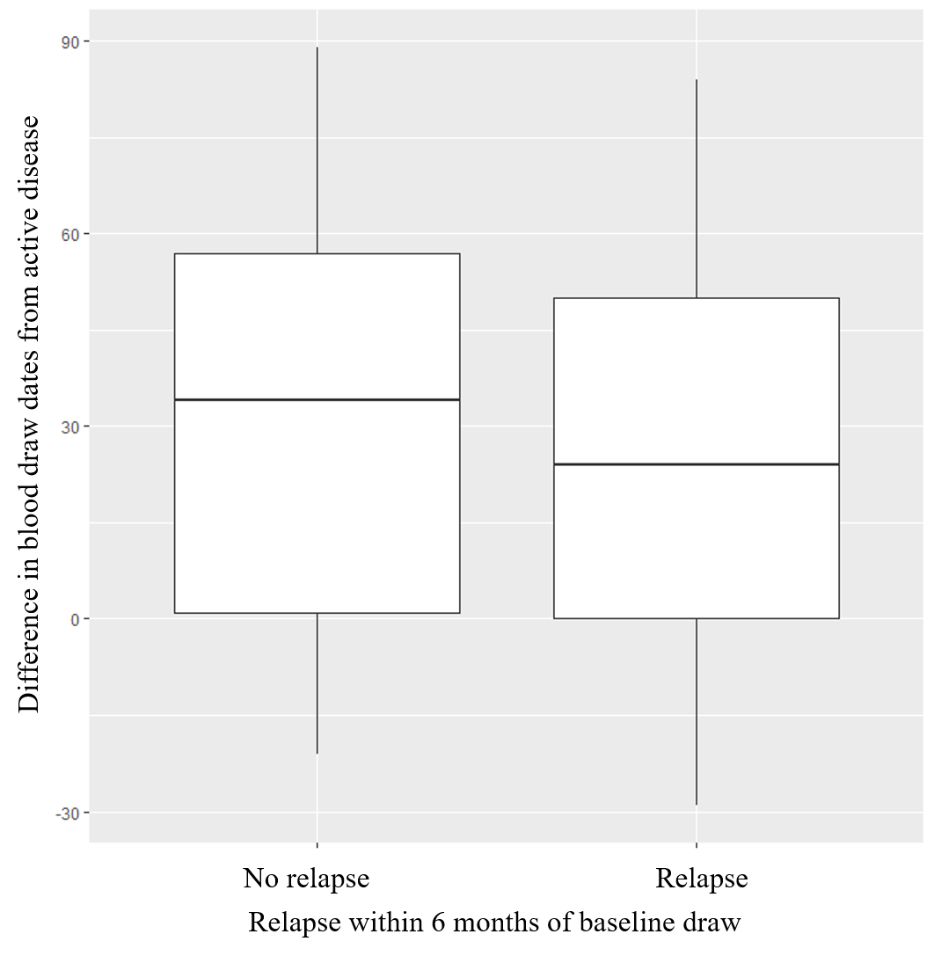

Supplementary Figure 1c. Box and whisker plot depicting timing of baseline draw relative to active disease and relapse within 54 months of baseline draw.
