Supplementary Information
Supplementary Figure S1: Comparison of stromal histology between BCR and non-BCR patients in different populations.
Voronoi Diagrams (a-d), minimal spanning trees (e-h), directionality colormaps (i-l), and global graphs (m-p) for stromal nuclei in AA-BCR+ (leftmost column), AA-BCR- (second column from left), CA-BCR+ (third column from left), and CA-BCR- (fourth column from left) patient samples.
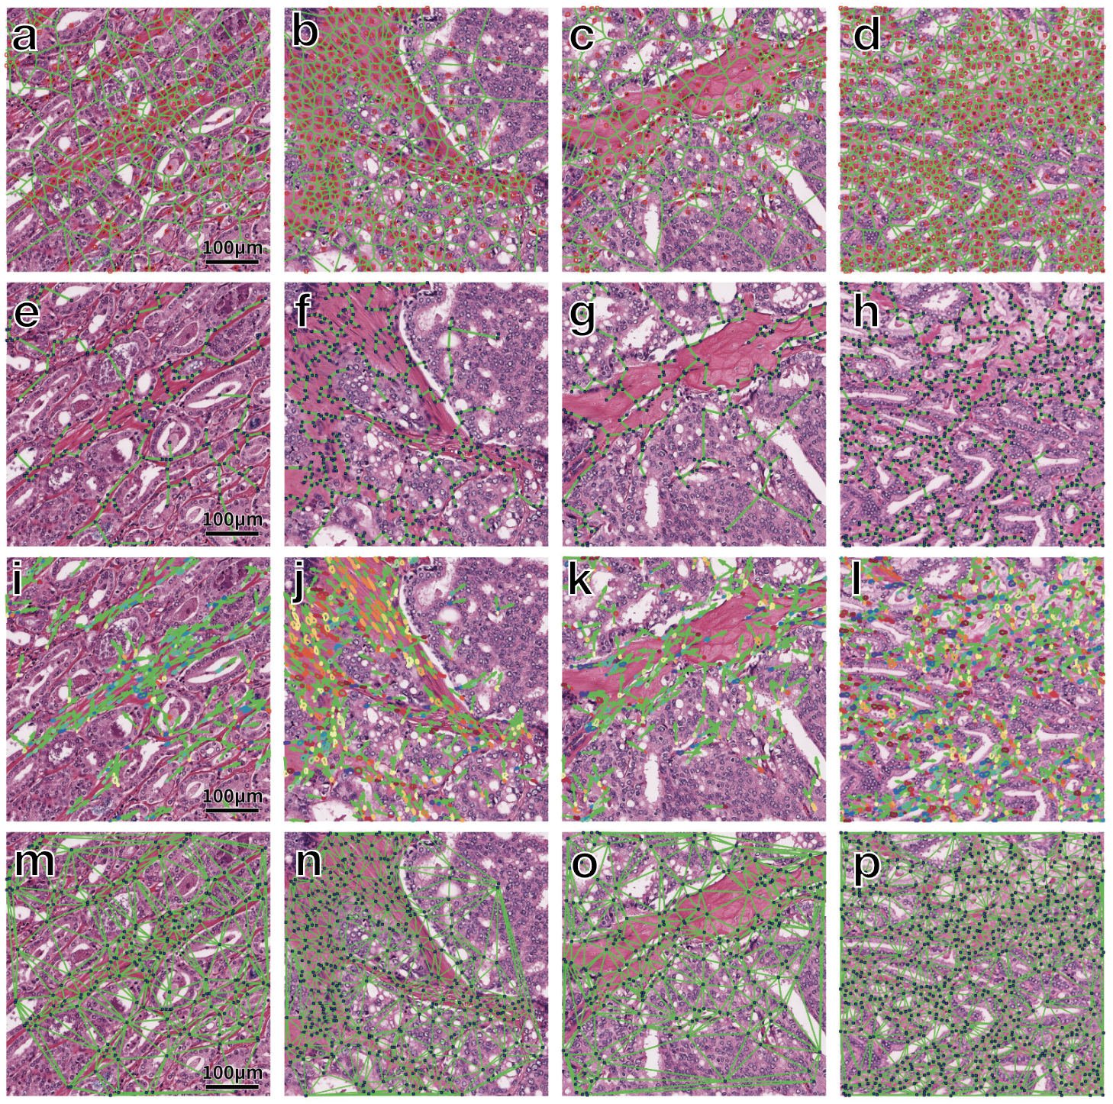

Supplementary Figure S2: CONSORT-style flow diagram depicting patient categorization and processing in the study.

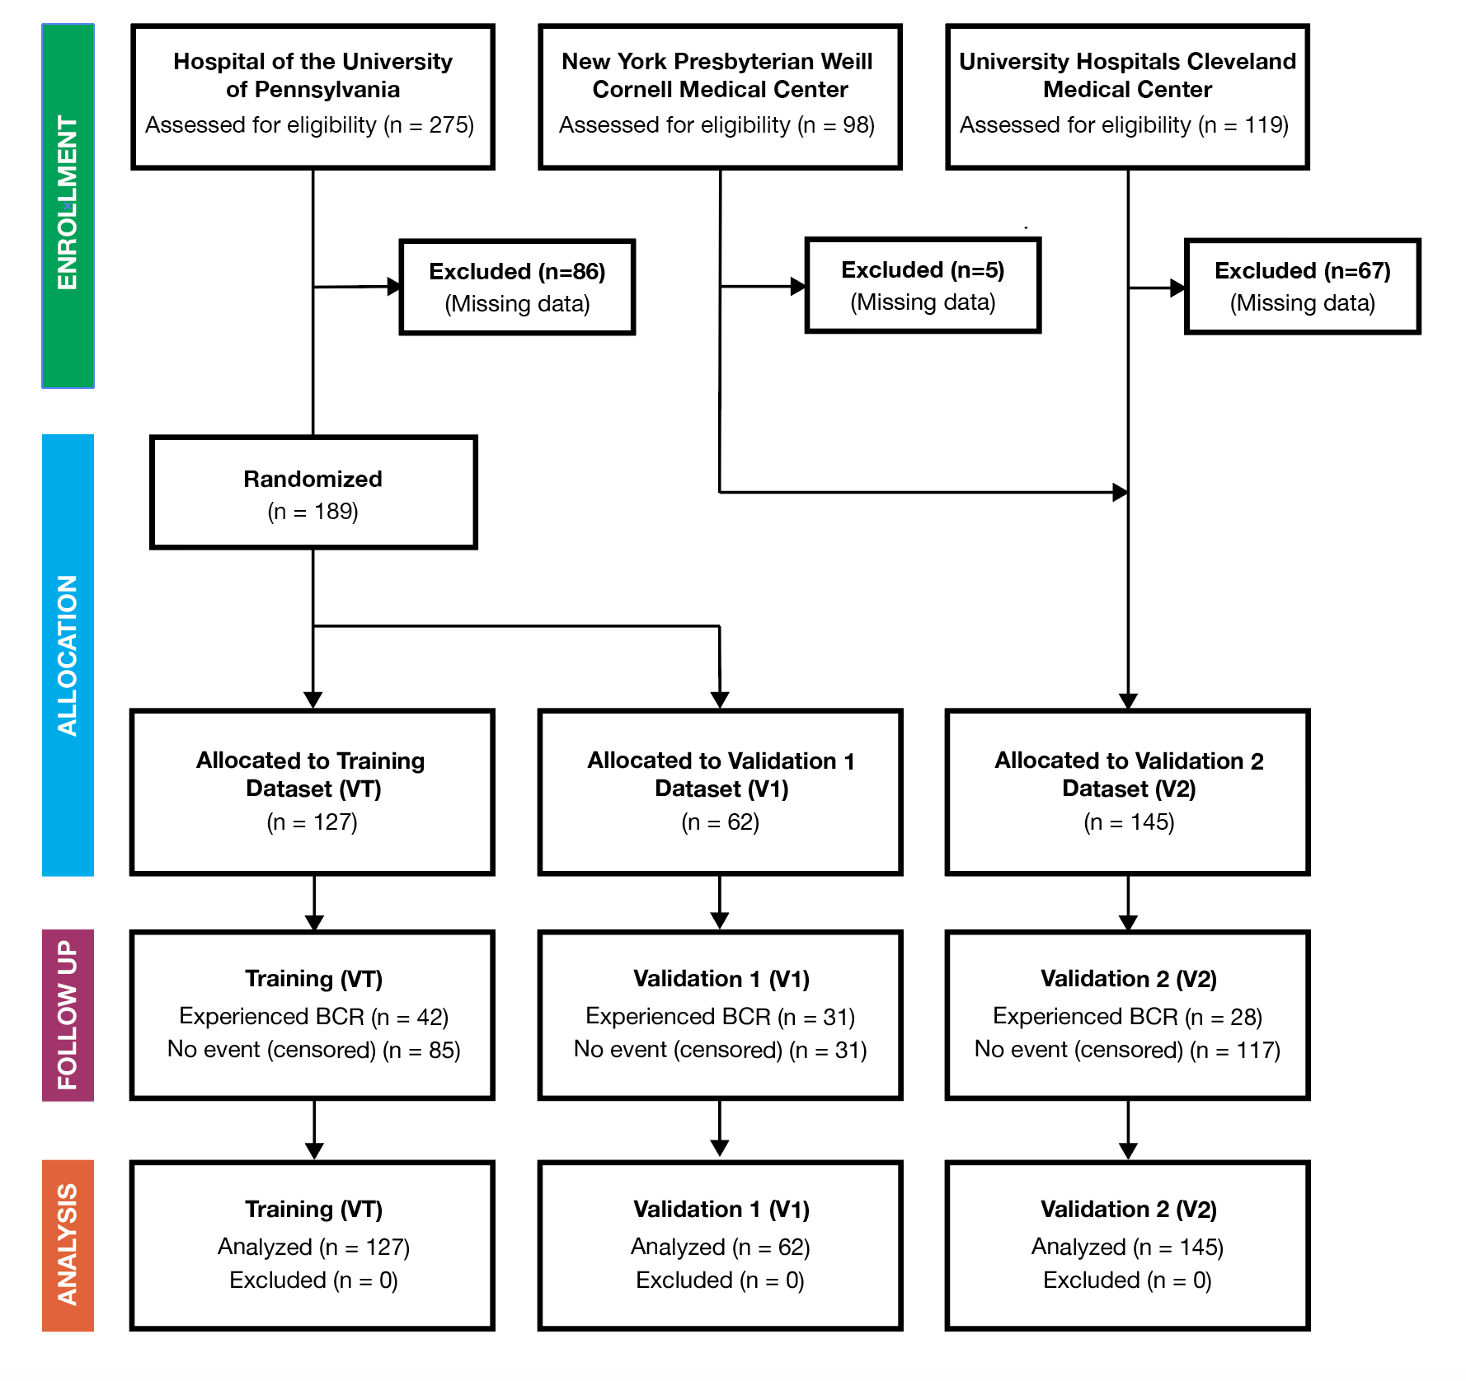

Supplementary Table S1: Results of ML and ENC classification experiments.
For each training and validation cohort combination, the results of Random Forest and Elastic Net Cox models are reported. Statistics reported are Area Under the Receiver Operating Characteristic Curve (AUC), Hazard Ratio (HR) between predicted high and low risk groups, 95% Confidence Interval (95% CI) for the HR, and p value (p). Statistically significant results are indicated in bold.
 | T_{AA} Training |  | T_{CA} Training |  | T_{AA+CA} Training
 | Random Forest | Elastic Net Cox | Random Forest | Elastic Net Cox | Random Forest | Elastic Net Cox
V1_{AA} | AUC: 0.85  HR: 3.03 (95% CI: 0.812 - 11.3)  p: 0.024 | AUC: 0.87  HR: 4.71 (95% CI: 1.65 - 13.4)  p: 0.0027 | AUC: 0.39  HR: 1.62 (0.569 - 4.63)  p: 0.62 | AUC: 0.48  HR: 1.74 (0.58 - 5.23)  p: 0.323 | AUC: 0.78  HR: 1.96 (0.65 - 5.85)  p: 0.14 | AUC: 0.55  HR: 0.83 (0.09 - 7.50)  p: 0.86
V2_{AA} | AUC: 0.75  HR: 4.51 (95% CI: 0.925 - 22)  p: 0.013 | AUC: 0.77  HR: 5.70 (95% CI: 1.48 - 21.9)  p: 0.014 | AUC: 0.60  HR: 1.15 (0.296 - 4.47)  p: 0.84 | AUC: 0.56  HR: 0.31 (0.0099 - 9.74)  p: 0.242 | AUC: 0.68  HR: 4.56 (1.1 - 18.9)  p: 0.018 | AUC: 0.56  HR: 0.61 (0.05 - 7.78)  p: 0.63
V1_{CA} | AUC: 0.33  HR: 0.466 (0.106 - 2.05)  p: 0.45 | AUC: 0.50  HR: 0.921 (0.338 - 2.51)  p: 0.87 | AUC: 0.56  HR: 0.987 (0.32 - 3.05)  p: 0.98 | AUC: 0.47  HR: 0.54 (0.17 - 1.69)  p: 0.22 | AUC: 0.49  HR: 1.01 (0.29 - 3.55)  p: 0.99 | AUC: 0.40  HR: 0.87 (0.29 - 2.58)  p: 0.79
V2_{CA} | AUC: 0.44  HR: 0.546 (95% CI: 0.183 - 1.62)  p: 0.33 | AUC: 0.49  HR: 1.74 (0.56 - 5.38)  p: 0.28 | AUC: 0.44  HR: 0.832 (0.299 - 2.32)  p: 0.72 | AUC: 0.49  HR: Infinite  p: 0.224 | AUC: 0.45  HR: 0.47 (0.16 - 1.37)  p: 0.22 | AUC: 0.46  HR: 1.47 (0.40 - 5.43)  p: 0.60
V1_{AA+CA} | AUC: 0.66  HR: 1.57 (0.56 - 4.43)  p: 0.31 | AUC: 0.68  HR: 1.84 (0.90 - 3.78)  p: 0.082 | AUC: 0.55  HR: 0.744 (0.368 - 1.51)  p: 0.40 | AUC: 0.46  HR: 0.84 (0.38 - 1.89)  p: 0.64 | AUC: 0.58  HR: 1.32 (0.53 - 3.30)  p: 0.51 | AUC: 0.46  HR: 0.61 (0.21 - 1.75)  p: 0.26
V2_{AA+CA} | AUC: 0.71  HR: 2.10 (0.83 - 5.32)  p: 0.21 | AUC: 0.61  HR: 2.37 (0.99 - 5.69)  p = 0.028 | AUC: 0.52  HR: 1.19 (0.593-2.38)  p: 0.63 | AUC: 0.54  HR: 1.67 (0.34 - 8.21)  p: 0.56 | AUC: 0.53  HR: 1.14 (0.62 - 2.08)  p: 0.68 | AUC: 0.49  HR: 1.06 (0.325 - 3.47)  p: 0.92

Supplementary Table S2: Performance of CAPRA-S and Kattan Classifiers on AA validation datasets. Statistics reported are Area Under the Receiver Operating Characteristic Curve (AUC), Hazard Ratio (HR) between predicted high and low risk groups, 95% Confidence Interval (95% CI) for the HR, and p value (p).
Model | V_{1,AA} Performance | V_{2,AA} Performance
CAPRA-S Nomogram | AUC: 0.74  HR: 2.53 (0.847 - 7.53)  p: 0.059 | AUC: 0.70  HR: 2.99 (0.603 - 14.8)  p: 0.086
Kattan Nomogram | AUC: 0.75  HR: 2.67 (0.826 - 8.65)  p: 0.045 | AUC: 0.62  HR: 2.20 (0.409 - 11.8)  p: 0.252
AAstroENC Classifier | AUC: 0.87  HR: 4.71 (1.65 - 13.4)  p: 0.0027 | AUC: 0.77  HR: 5.70 (1.48 - 21.9)  p: 0.014

Supplementary Table S3: Performance of CAPRA-S and Kattan Classifiers on CA datasets. Statistics reported are Area Under the Receiver Operating Characteristic Curve (AUC), Hazard Ratio (HR) between predicted high and low risk groups, 95% Confidence Interval (95% CI) for the HR, and p value (p).
Model | V_{T,CA} Performance | V_{1,CA} Performance
CAPRA-S Nomogram | AUC: 0.90  HR: 2.86 (1.15 - 7.13)  p: 0.0066 | AUC: 0.92  HR: 8.19 (1.17 - 57.20)  p: 3.91e-7
Kattan Nomogram | AUC: 0.82  HR: 3.18 (1.06 - 9.49)  p: 0.0035 | AUC: 0.92  HR: 8.19 (1.17 - 57.20)  p: 3.91e-7

Supplementary Table S3: Features selected by the AAstro models.
Model | Features
AAstroML | Shape: Min / Max Fourier Descriptor 4  Shape: Mean Fractal Dimension  Shape: Median Fractal Dimension  Haralick: Mean Information Measure 1  Shape: Std. Deviation Variance of Distance  Shape: Min / Max Distance Ratio
AAstroENC | Shape: Mean Distance Ratio  Shape: Mean Fractal Dimension  Shape: Std. Deviation Perimeter Ratio  Shape: Median Fractal Dimension  Shape: Min / Max Perimeter Ratio  Shape: Min / Max Fourier Descriptor 4  CGT: Mean Tensor Correlation  Sub-Graph: Number Isolated Nodes  Haralick: Mean Contrast Inverse Moment  Haralick: Mean Intensity Average

Supplementary Table S4. Association of stromal image features with tumor biomarkers. Pearson’s correlation coefficient (PCC) and associated p value are reported. Features prognostic of BRFS for AA patients are indicated in bold.
Biomarker | Feature Name | PCC | p-value
PTEN | Shape:Mean Fourier Descriptor 4 | -0.623 | 7.56E-03
RB (cyt.) | Shape:Mean Fractal Dimension | 0.606 | 4.97E-04
PTEN | Shape:Std. Deviation Fourier Descriptor 3 | -0.605 | 1.01E-02
RB (cyt.) | Shape:Mean Invariant Moment 2 | -0.601 | 5.59E-04
PTEN | Shape:Std. Deviation Fourier Descriptor 4 | -0.598 | 1.12E-02
PTEN | Shape:Std. Deviation Fourier Descriptor 8 | -0.586 | 1.34E-02
PTEN | Shape:Std. Deviation Fourier Descriptor 2 | -0.585 | 1.35E-02
PTEN | Shape:Std. Deviation Fourier Descriptor 10 | -0.583 | 1.40E-02
PTEN | Shape:Mean Fourier Descriptor 10 | 0.580 | 1.46E-02
PTEN | Shape:Std. Deviation Fourier Descriptor 9 | -0.576 | 1.54E-02
PTEN | Shape:Mean Fourier Descriptor 7 | 0.571 | 1.66E-02
PTEN | Shape:Mean Fourier Descriptor 8 | 0.565 | 1.81E-02
ERG | Delaunay:Triangle Area Disorder | -0.557 | 5.72E-03
PTEN | Shape:Mean Fourier Descriptor 1 | 0.552 | 2.15E-02
PTEN | Shape:Std. Deviation Fourier Descriptor 6 | -0.549 | 2.24E-02
PTEN | Shape:Std. Deviation Fourier Descriptor 1 | -0.547 | 2.29E-02
PTEN | Shape:Mean Distance Ratio | -0.536 | 2.65E-02
PTEN | Shape:Std. Deviation Fourier Descriptor 5 | -0.535 | 2.70E-02
ERG | Voronoi:Area Disorder | -0.454 | 2.96E-02
ERG | Haralick:Mean Information Measure 1 | -0.447 | 3.26E-02
C-MYC | Sub-Graph:Std. Deviation Edge Length | 0.446 | 2.38E-03
RB (nuc.) | Haralick:Mean Intensity Average | -0.439 | 1.06E-02
ERG | Shape:Min / Max Fourier Descriptor 8 | -0.438 | 3.64E-02
C-MYC | Sub-Graph:Kurtosis Edge Length | -0.422 | 4.37E-03
C-MYC | Sub-Graph:Mean Edge Length | -0.419 | 4.68E-03
AR | Shape:Mean Fractal Dimension | 0.414 | 4.12E-04
RB (cyt.) | Arch:Disorder of Nearest Neighbors in A 10 Pixel Radius | -0.412 | 2.64E-02
AR | Shape:Mean Distance Ratio | -0.410 | 4.72E-04
RB (nuc.) | Arch:Std. Deviation Nearest Neighbors in A 20 Pixel Radius | 0.404 | 1.97E-02

Supplementary Table S5: Overview of 242 features extracted.
Feature class | Derived attributes
Voronoi Tessellation (12 features) | Number of nodes, number of edges, area, chord parameters
Delaunay Triangulation (8 features) | Side lengths, triangle geometry
Minimum Spanning Tree (4 features) | Number of nodes, edge length, degree, number of neighbors
Local Nuclear Cluster Graph (26 features) | Structure of clusters, patterning of clusters within graph
Nuclear Shape (100 features) | Nuclear area, perimeter, Fourier descriptors, invariant moments
Cell Orientation Entropy (39 features) | Contrast energy, Contrast inverse moment, Contrast average, Contrast variance, Contrast entropy, Intensity average, Intensity variance, Intensity entropy, Entropy, Energy, Correlation, 2 measures of information
Sub-Graph Features (26 features) | Number of nodes, number of edges, eccentricity, clustering coefficients
Texture Features (26 features) | Texture, edges, gradients, spots, and homogeneity of the image. Entropy, variance, and energy are calculated from the co-occurrence matrix describing how often pixels of various intensities are found near pixels of another intensity.

Supplementary Table S6: Significantly Differing Features based on Cox Proportional Hazards Regression
Cohort | Feature Name | P Value | Haz. Ratio | BCR Mean | NR Mean | % Diff.
AA | Shape: Min / Max Fourier Descriptor 4 | 1.577E-05 | 4.334E-01 | -1.128 | -1.026 | 9.409
AA | Shape: Mean Fractal Dimension | 2.683E-05 | 3.041 | 2.580E-01 | 2.438E-01 | 5.684
AA | Shape: Median Fractal Dimension | 1.294E-04 | 2.131 | 2.309E-01 | 2.164E-01 | 6.526
AA | Haralick: Mean Information Measure 1 | 1.289E-02 | 1.950 | 3.346 | 3.261 | 2.581
AA | Shape: Std. Deviation Variance Of Distance | 1.456E-02 | 5.760E-01 | 1.774E-02 | 1.802E-02 | -1.592
AA | Shape: Min / Max Distance Ratio | 4.507E-02 | 1.619 | 5.936E-01 | 5.955E-01 | -.03137
CA | Delaunay: Triangle Area Std. Deviation | 5.777E-05 | 2.030 | 3.489E+01 | 2.145E+01 | 47.74
CA | CGT: Std. Deviation Tensor Contrast Energy | 3.370E-04 | 1.845 | 4.631E-01 | 6.099E-02 | 153.5
CA | Sub-Graph: Number Isolated Nodes | 7.278E-04 | 2.401 | 3.333E-01 | 1.538E-01 | 73.68
CA | CGT: Std. Deviation Tensor Information Measure 1 | 7.896E-04 | 1.703 | 5.529E-03 | 1.094E-03 | 133.9
CA | MST: Edge Length Disorder | 1.081E-03 | 2.280 | 4.453E-01 | 4.166E-01 | 6.655
CA | Delaunay: Side Length Disorder | 1.097E-03 | 2.081 | 4.658E-01 | 4.462E-01 | 4.290
CA | MST: Edge Length Std. Deviation | 3.902E-03 | 1.550 | 2.323 | 1.809 | 24.90
CA | Shape: Mean Fourier Descriptor 2 | 7.965E-03 | 5.440E-01 | 1.668E-05 | 3.271E-05 | -64.91
CA | CGT: Range Tensor Information Measure 1 | 8.150E-03 | 1.639 | 6.677E-02 | 2.066E-02 | 105.5
CA | Voronoi: Chord Minimum / Maximum | 1.080E-02 | 5.201E-01 | 5.451E-02 | 5.853E-02 | -7.112
CA | Arch: Disorder Of Distance To 3 Nearest Neighbors | 1.115E-02 | 1.827 | 3.622E-01 | 3.372E-01 | 7.151
CA | Shape: Mean Invariant Moment 3 | 1.307E-02 | 5.627E-01 | 3.623E-04 | 3.965E-04 | -9.023
CA | Delaunay: Side Length Minimum / Maximum | 1.535E-02 | 5.467E-01 | 6.983E-02 | 8.020E-02 | -13.82
CA | Voronoi: Perimeter Minimum / Maximum | 1.760E-02 | 5.664E-01 | 3.282E-02 | 3.487E-02 | -6.059
CA | Shape: Min / Max Perimeter Ratio | 2.067E-02 | 1.707 | 2.228E-01 | 2.151E-01 | 3.549
CA | Shape: Mean Invariant Moment 7 | 2.131E-02 | 6.458E-01 | -6.373E-10 | 9.628E-12 | 206.1
CA | Arch: Density Of Polygons | 2.625E-02 | 4.829E-01 | 4.553E-02 | 6.173E-02 | -30.21E
CA | Shape: Mean Area Ratio | 2.754E-02 | 1.705 | 3.552E-01 | 3.454E-01 | 2.792
CA | Sub-Graph: Std. Deviation Edge Length | 3.601E-02 | 1.450 | 6.416 | 6.304 | 1.752
CA | Voronoi: Perimeter Disorder | 3.674E-02 | 1.641 | 4.578E-01 | 4.474E-01 | 2.296
CA | Shape: Mean Invariant Moment 1 | 4.198E-02 | 6.477E-01 | 1.028E-01 | 1.052E-01 | -2.293
CA | Haralick: Std. Deviation Information Measure 2 | 4.338E-02 | 1.446 | 1.207E-01 | 1.099E-01 | 9.369
AA+CA | Sub-Graph: Number Isolated Nodes | 3.026E-05 | 1.941 | 2.143E-01 | 7.059E-02 | 101.0
AA+CA | Shape: Min / Max Fourier Descriptor 4 | 1.232E-03 | 6.268E-01 | -1.122 | -1.050 | 6.61
AA+CA | Delaunay: Triangle Area Std. Deviation | 1.755E-03 | 1.524 | 3.095E+01 | 2.263E+01 | 31.0
AA+CA | Delaunay: Triangle Area Disorder | 5.609E-03 | 1.622 | 6.611E-01 | 6.435E-01 | 2.69
AA+CA | Shape: Mean Invariant Moment 4 | 6.037E-03 | 6.019E-01 | 1.653E-05 | 1.817E-05 | -9.44
AA+CA | Shape: Mean Fractal Dimension | 1.092E-02 | 1.633 | 2.490E-01 | 2.432E-01 | 2.36
AA+CA | CGT: Std. Deviation Tensor Contrast Entropy | 1.171E-02 | 1.354 | 9.053E-03 | 2.386E-03 | 117.0
AA+CA | Shape: Mean Invariant Moment 1 | 1.175E-02 | 6.752E-01 | 1.027E-01 | 1.046E-01 | -1.83
AA+CA | Sub-Graph: Number Central Nodes | 1.645E-02 | 1.281 | 1.095 | 1.012 | 7.92
AA+CA | Shape: Median Fourier Descriptor 4 | 1.653E-02 | 7.686E-01 | -1.562E-06 | -8.570E-08 | 179.0
AA+CA | Haralick: Mean Correlation | 2.063E-02 | 6.941E-01 | -1.683E-01 | -1.500E-01 | 11.5
AA+CA | CGT: Range Tensor Energy | 2.358E-02 | 1.293 | 3.512E-02 | 9.824E-03 | 113.2
AA+CA | Shape: Median Fractal Dimension | 2.558E-02 | 1.461 | 2.219E-01 | 2.165E-01 | 2.48
AA+CA | CGT: Std. Deviation Tensor Intensity Variance | 3.151E-02 | 1.279 | 6.353E-02 | 1.866E-02 | 109.2
AA+CA | Shape: Mean Distance Ratio | 3.407E-02 | 1.427 | 5.649E-01 | 5.558E-01 | 1.62

Supplementary Table S8: Clinicopathologic features by dataset
Variable | Subvariables | Dataset V_{T} | Dataset V₁ | Dataset V₂
Number of Patients |  | 127 | 62 | 145
Age (years) |  | 58.68 (7.03) | 60.08 (7.02) | 60.2 (7.66)
Race | African-American  Caucasian-American | 64 (50.4%)  63 (49.6%) | 31 (50.0%)  31 (50.0%) | 93 (64.1%)  52 (35.9%)
Preop. PSA (ng/mL) | Recurrence  Non-Recurrence | 12.11 (13.12)  9.54 (12.97) | 10.50 (13.d14)  5.79 (13.01) | 10.07 (5.43)  5.98 (5.28)
Gleason Grade Group | 6 or less  Equal to 7  8 or greater | 46 (36.2%)  69 (54.3%)  12 (9.4%) | 29 (46.8%)  26 (41.9%)  7 (11.3%) | 44 (35.3%)  91 (62.8%)  10 (6.9%)
Pathological Stage | T2x  T3x  Either T2x or T3x (data unavailable) | 73 (57.5%)  52 (40.9%)  2 (1.6%) | 35 (56.5%)  27 (43.5%)  0 (0%) | 59 (40.2%)  16 (11.0%)  60 (41.4%)
Time to Event (days) | Recurrence  Last follow-up (non-recurrence) | 1019.95 (1419.36)  1728.67 (1455.13) | 1237.16 (1416.10)  1859.26 (1474.48) | 783.74 (1296.84)  1796.0 (1287.31)

Supplementary Table S9: Number of patients with nonzero values for each biomarker, number of patients assayed, and mean IHC H-Score for each biomarker in V1_{AA}.
Biomarker | Number Nonzero | Number of Cases | Mean H-Score
ERG | 23 | 76 | 56.81
PTEN | 17 | 76 | 32.38
PMSA | 61 | 76 | 89.61
RACEMASE | 71 | 76 | 174.24
C-MYC | 44 | 76 | 37.05
AR | 69 | 76 | 155.99
Ki-67 | 81 | 95 | 1.55
P-53 | 67 | 76 | 89.79
RB-Nuc | 33 | 76 | 22.11
RB-Cyt | 29 | 76 | 24.87

