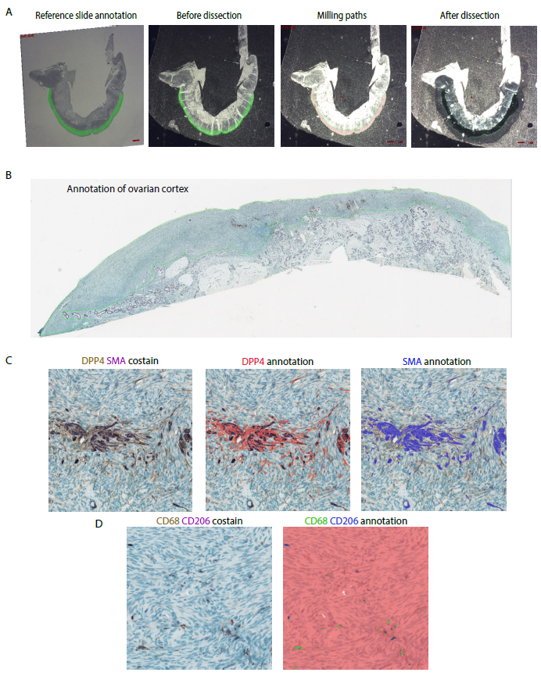
Figure S2. Automated microdissection and immunohistochemical analysis of the human ovarian cortex. A. Representative images of ovarian cortex microdissection. A hematoxylin stained reference slide is used as a guide to annotate the region to be collected (before dissection). The milling path is calculated and tissue is collected. B-D. Example of automated analysis of immunohistochemical staining of the human ovarian cortex using ImagePro Premier software. B. All immunohistochemical staining was quantified over the entire ovarian cortex of each patient sample, outlined in green. C. Representative annotations of DPP4 and SMA double immunohistochemistry (presented in Fig. 3 f, g). D. Representative annotations of CD68 and CD206 double immunohistochemistry (presented in Fig. 3 b, c).

