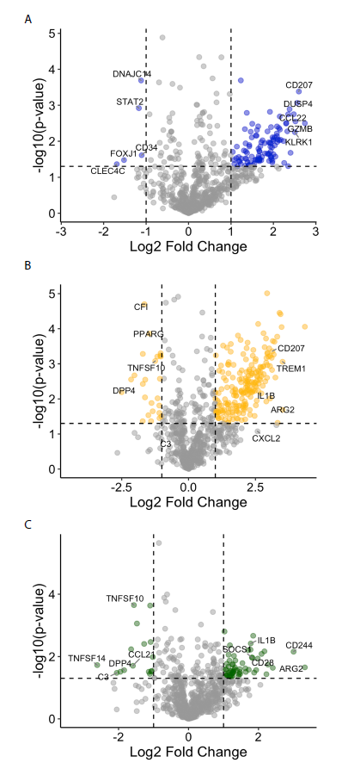
Figure S3. Differential gene expression in non-fibrotic, fibrotic, and metformin ovaries with samples from women taking gliptins omitted. Fold changes in RNA expression among all pairwise comparisons are presented. The top five upregulated and downregulated genes among all pairwise comparisons are labelled for A. fibrotic vs. non-fibrotic, B. metformin vs. non-fibrotic, and C. metformin vs. fibrotic.

