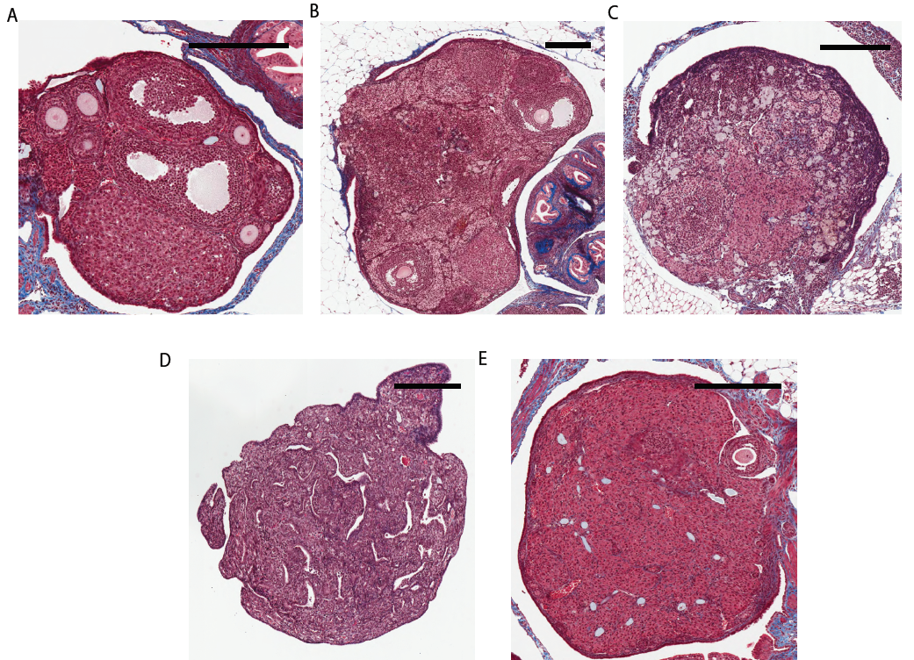
Figure S1. Ovarian aging heterogeneity is not replicated by VCD treatment. Representative images of ovarian histology in C57BL/lcrfa mice by Masson’s trichrome staining of A. 0-12 months, B. 12-20 months, C. >20 months with ovarian fibrosis, D. >20 months without ovarian fibrosis, and E. 60 days post-VCD treated ovaries. Collagens – blue, erythrocytes and fibrin – red, nuclei – purple. All scale bars = 300μm.

