**Supplemental Table and Figures for:**

**Enhanced detection of treatment effects on metastatic colorectal cancer with volumetric CT measurements for tumor burden growth rate evaluation**

Michael L. Maitland1,2, Julia Wilkerson3, Sanja Karovic1, Binsheng Zhao4, Jessica Flynn5, Mengxi Zhou3, Patrick Hilden5, Firas S. Ahmed4, Laurent Dercle4, Chaya S. Moskowitz5, Ying Tang6, Dana E. Connors7, Stacey J. Adam7, Gary Kelloff7, Mithat Gonen5, Tito Fojo3, Lawrence H. Schwartz4, and Geoffrey R. Oxnard8

**Supplemental Figure 1**

**Plots of model fits for all 988 subjects for whom data was available.**

**Note, subject id’s were modified to be specific to this investigation to preserve subject confidentiality.**

**See attached pdf**

|  |
| --- |
| **Supplemental Table 1 Best model fits and basis for exclusion of each patient with imaging data from CRC trials** |

|  |  |  |  |  |  |  |  |  |  |  |  |  |  |
| --- | --- | --- | --- | --- | --- | --- | --- | --- | --- | --- | --- | --- | --- |
|  |  | **Excluded (Not evaluable)** | | | | **Evaluable** | | | | | | | |
| **Measurement** | **Treatment** | **n=0 eval** | **1 eval** | **n=2 not 20%** | | **dx** | **gd** | **gdphi** | **gx** | | **Not fit / eval** | | |
| **Unidimensional** | **FOLFIRI + placebo** | 20 (6.9) | 1 (0.3) | 34 (11.8) | | 20 (6.9) | 104 (36.1) | 20 (6.9) | | 74 (25.7) | 15 (6.4) | |
| **FOLFIRI + aflibercept** | 22 (7.8) | - | 17 (6) | | 37 (13.1) | 132 (46.8) | 28 (9.9) | | 30 (10.6) | 16 (6.6) | |
| **Volumetric** | **FOLFIRI + placebo** | 20 (6.9) | 1 (0.3) | 15 (5.2) | | 28 (9.7) | 81 (28.1) | 32 (11.1) | | 91 (31.6) | 20 (7.9) | |
| **FOLFIRI + aflibercept** | 22 (7.8) | - | 7 (2.5) | | 43 (15.2) | 93 (33) | 53 (18.8) | | 49 (17.4) | 12 (5.9) | |
| **Unidimensional** | **FOLFOX** | 19 (9) | 1 (0.5) | | 12 (5.7) | 25 (11.8) | 90 (42.7) | 33 (15.6) | | 20 (9.5) | 11 (6.1) |
| **FOLFOX + panitumumab** | 17 (8.2) | 2 (1) | | 9 (4.3) | 31 (15) | 91 (44) | 28 (13.5) | | 17 (8.2) | 12 (7.2) |
| **Volumetric** | **FOLFOX** | 19 (9) | 1 (0.5) | | 5 (2.4) | 40 (19) | 62 (29.4) | 38 (18) | | 30 (14.2) | 16 (8.6) |
| **FOLFOX + panitumumab** | 17 (8.2) | 2 (1) | | 5 (2.4) | 49 (23.7) | 63 (30.4) | 39 (18.8) | | 21 (10.1) | 11 (6) |

**Supplemental Figure 2 Generation of study data set for modeling analyses**

570 for analysis

1,266 enrolled

-570, 50% reserved for validation

-126, missing CRF or images

PRIME trial KRAS WT

656 enrolled

418 for analysis

-208, 33% reserved for validation

-30, missing CRF or images

VELOUR

**Supplemental Figure 3. Effects of aflibercept and panitumumab on *d* detected with uni-dimensional vs. volume measurements of tumor burden on CT images.**

**Supplemental Figure 3**: Dot-plots of data in Table 2 comparing the distribution of log ***d*** values in the two clinical trials derived from unidimensional (**a. PRIME, b. VELOUR**)or volumetric measures (**c. PRIME, d. VELOUR**). In the PRIME trial, the difference was small magnitude and statistically significant. In VELOUR, there was no statistically significant difference with either uni-dimensional or volumetric measurement data.

d.

b.

c.

b.

a.

b.

b.

**Supplemental Figure 4.**

**The growth rate, *g*, correlates with overall survival in CRC by tertile of *g***

**A.**

**B.**

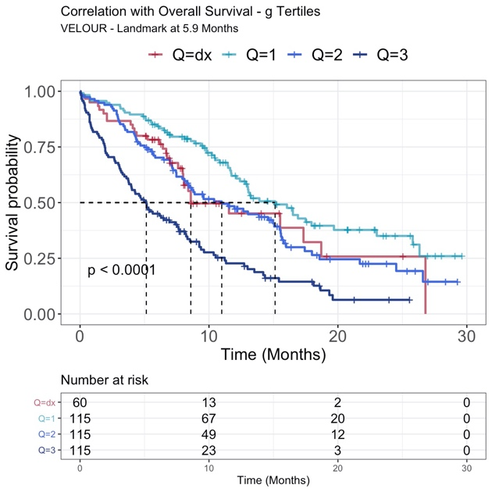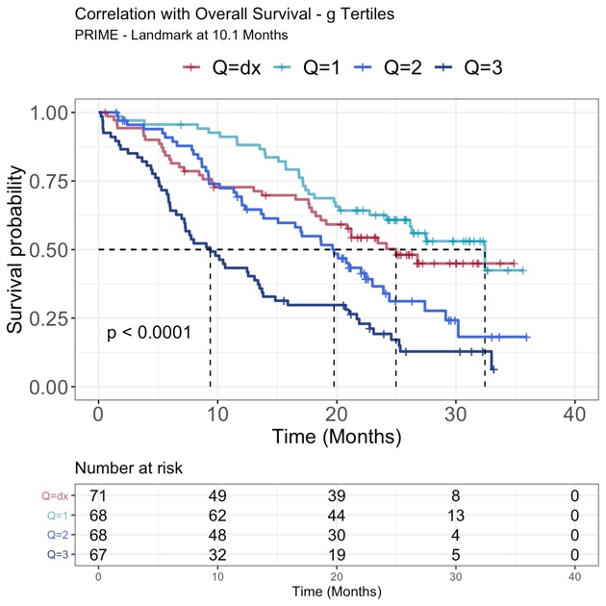

**Supplemental Figure 4**: Kaplan-Meier plots demonstrating the growth rate constant, ***g***, as a biomarker for overall survival. The correlation was assessed by conducting a landmark analysis in each clinical trial, **A.** PRIME, and **B.** VELOUR. Because data are from one first-line and one second-line trial the time at which to landmark the data was chosen as the time at which 75% of the data had been collected, rather than an arbitrary time in months. This was at 10.1 months for PRIME and 5.9 months for VELOUR. The tertiles are of the patient data that had a calculable ***g*** within the landmark constraints and for which there was either a known OS value or evidence of when they were still alive allowing for censoring. The fourth curve is that for patients whose data was best fit by the ***dx*** equation and in whom a ***g*** could not be calculated.

**Supplemental Figure 5. The decay rate, *d*, does not correlate with overall survival in CRC**



Kaplan-Meier plot demonstrating the decay/regression rate constant, ***d***, has a more limited association with overall survival. The predictive value was assessed by conducting a landmark analysis. The time at which to landmark the data was chosen as the time at which 75% of the data had been collected, rather than an arbitrary time in months. This was a time of 10.1 months for PRIME and 5.9 months for VELOUR. For this analysis data from both VELOUR and PRIME were pooled together to demonstrate the value of ***d*** in this respect is indifferent to the trial from which it was gathered, and in this case to whether the trial was being conducted as first or second line therapy for metastatic CRC. The tertiles are of the patient data that had a calculable ***d*** within the landmark constraints and for which there was either a known OS value or evidence of when they were still alive allowing for censoring. The three tertiles have median OS values [95% confidence intervals] of 13.9 [10.5, 19.9], 16.6 [14, 21.7] and 17.7 [14.1, 21.1] months respectively for those with the highest ***d*** values, intermediate ***d*** values and lowest ***d*** values from left to right, respectively. There is no measurable association among the magnitude of the estimated ***d*** values and overall survival. However, the fourth curve is that for patients whose data was best fit by the ***gx*** equation and in whom a ***d*** could not be calculated. Not surprisingly these patients whose tumor was growing despite initiation of treatment have clearly worse overall survival of 6.1 [5, 9.2] months.