Supplemental Material

Methods

Evaluation by gene expression
Gene expression data from RNA-Seq were log2 transformed and floored to 0. Cox regression analysis was conducted to investigate potential interaction between mRNA levels of drug targets (ESR1 and AR expression) and categorized as below the median or above the median and treatment effect in terms of progression-free survival. Hazard ratios and 95% CIs were estimated. Pearson’s correlation was computed between ESR1 and AR mRNA levels. Data analyses were performed using R and Matlab. All tests were 2-sided, unless otherwise noted.

Supplemental Table 1. Grade ≥3 treatment-emergent adverse events occurring in ≥2 patients in either cohort in the safety population
 | Cohort 1: No Prior  Advanced ET |  | Cohort 2: 1 Prior  Advanced ET
 | Enzalutamide Arm  (n=62) | Control  Arm  (n=63) | Enzalutamide Arm  (n=60) | Control  Arm  (n=60)
Hypertension | 6 (9.7) | 2 (3.2) | 0 | 1 (1.7)
Anemia | 1 (1.6) | 0 | 4 (6.7) | 2 (3.3)
Hypercalcemia | 2 (3.2) | 1 (1.6) | 2 (3.3) | 2 (3.3)
Back pain | 0 | 2 (3.2) | 1 (1.7) | 1 (1.7)
Fatigue | 1 (1.6) | 0 | 3 (5.0) | 0
Headache | 0 | 0 | 3 (5.0) | 0
Increased AST | 0 | 3 (4.8) | 1 (1.7) | 0
Pain in extremity | 1 (1.6) | 2 (3.2) | 0 | 0
Dyspnea | 0 | 2 (3.2) | 0 | 1 (1.7)
Pleural effusion | 0 | 2 (3.2) | 0 | 0
Hypoesthesia | 0 | 0 | 1 (1.7) | 1 (1.7)
Hyponatremia | 1 (1.6) | 1 (1.6) | 1 (1.7) | 0
Abbreviation: AST, aspartate transaminase.
Data are no. (%) unless otherwise indicated.
Supplemental Figure 1. Progression-free survival by subgroup in (A) cohort 1 and (B) cohort 2
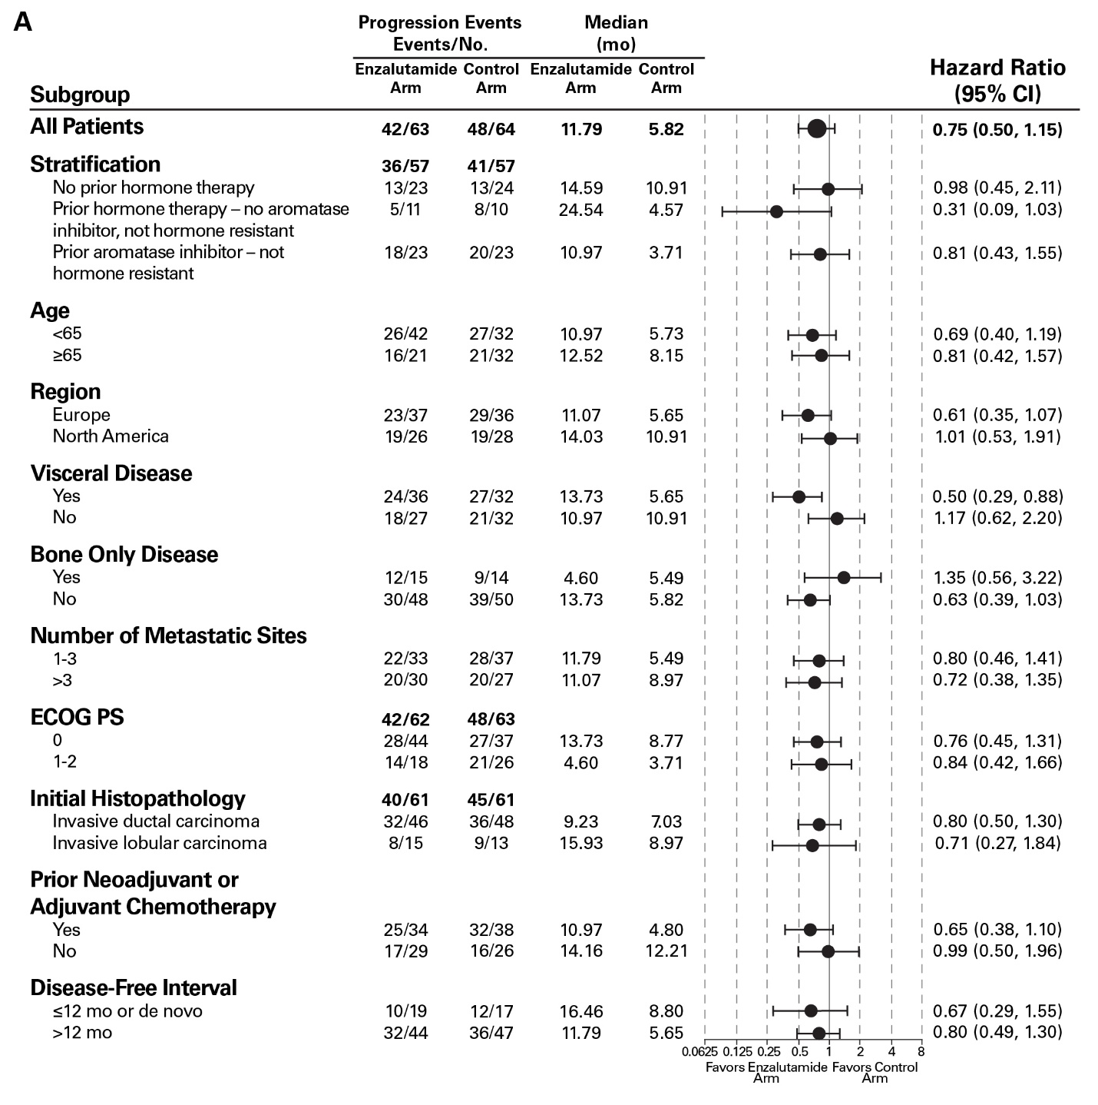
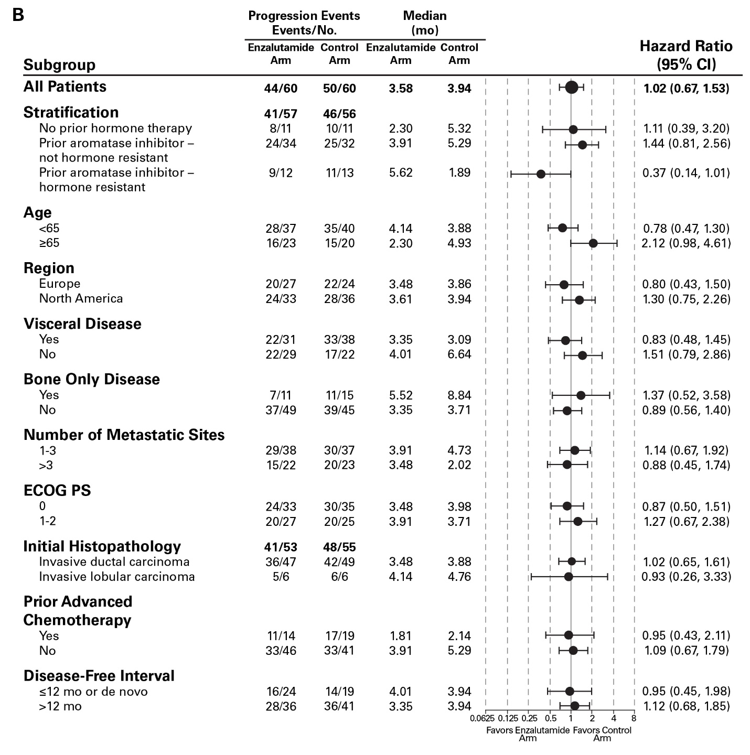
HR based on unstratified Cox regression model with <1 favoring enzalutamide arm.
Abbreviations: ECOG PS, Eastern Cooperative Oncology Group Performance Status; HR, hazard ratio.

Supplemental Figure 2. mRNA expression of (A) AR and (B) ESR1 and correlations between AR and ESR1 in (C) cohort 1 (no prior advanced ET) and (D) cohort 2 (1 prior advanced ET)
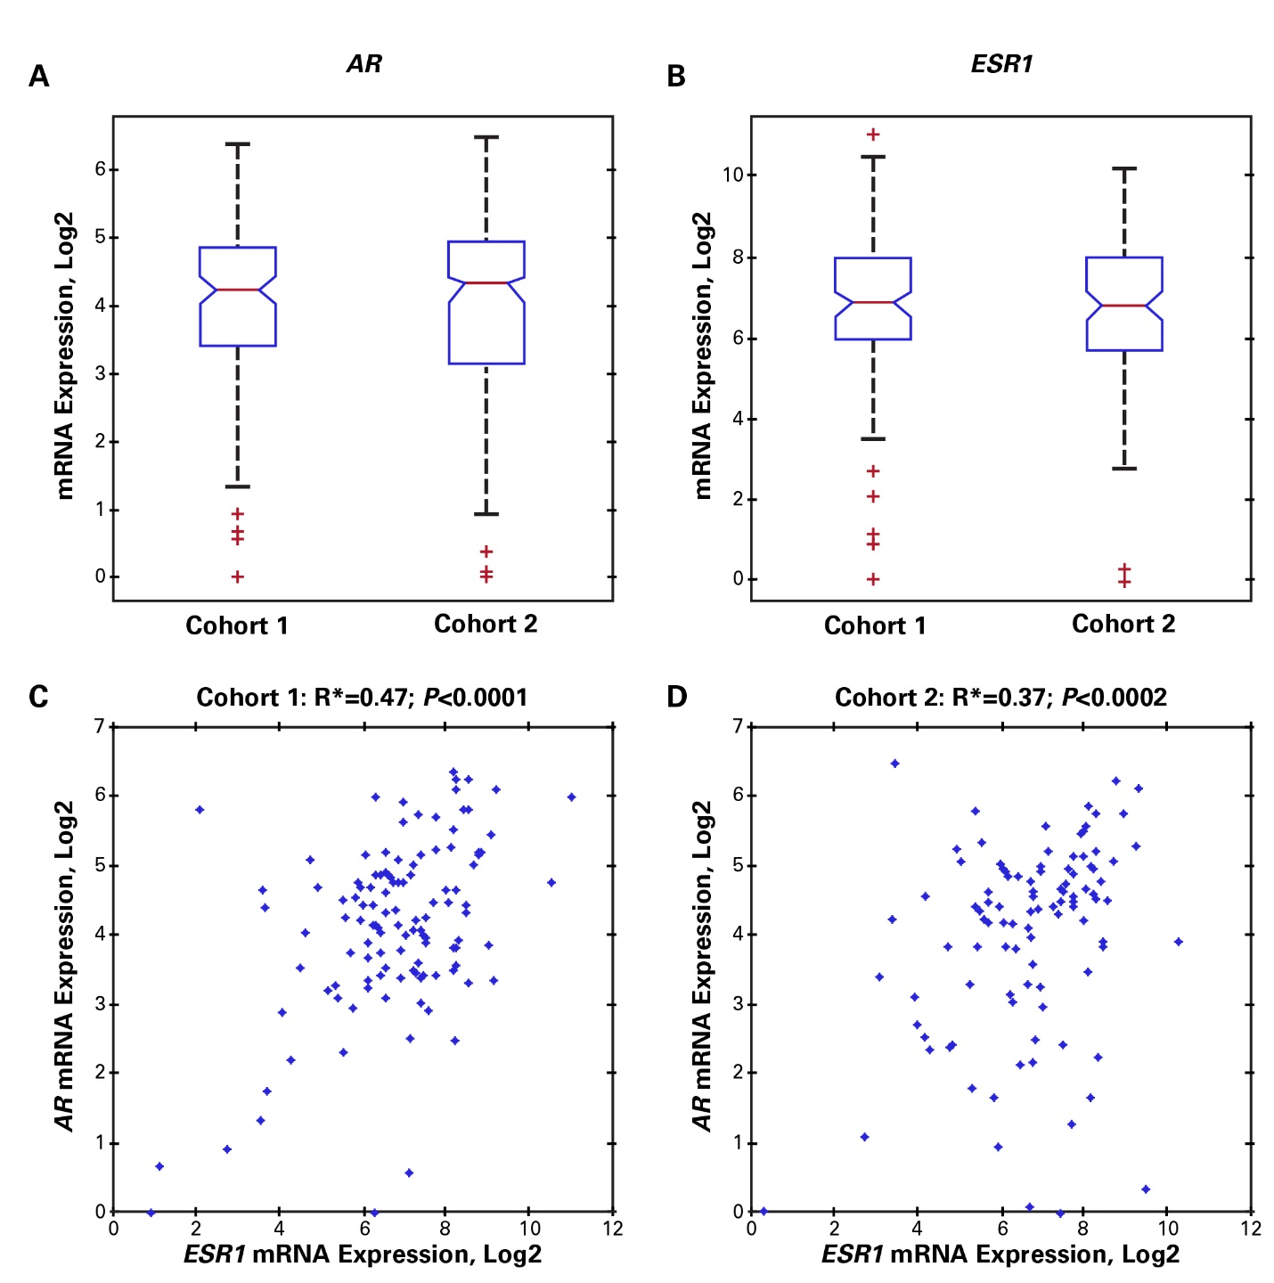
*R calculated using a Pearson correlation.
Abbreviation: ET, endocrine therapy

Supplemental Figure 3. Plasma trough concentrations by week for (A) enzalutamide and (B) exemestane
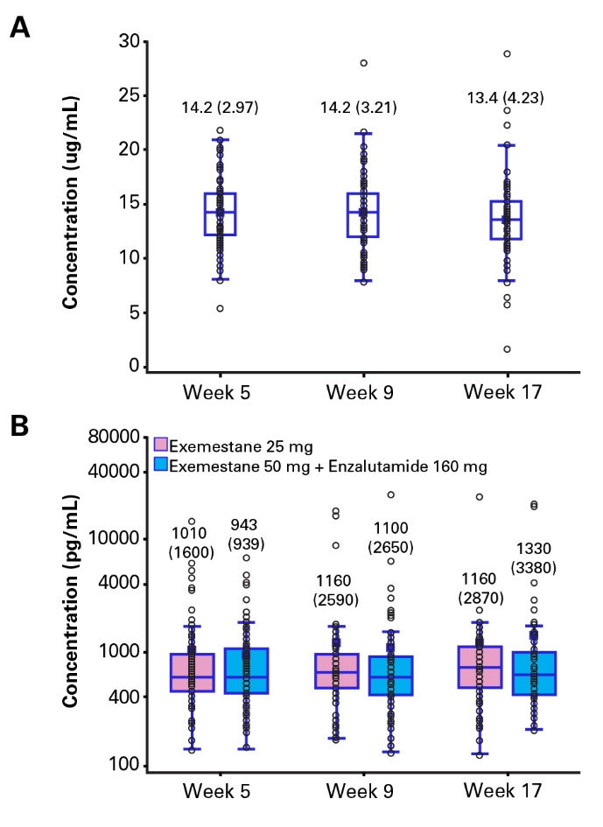
The labeled values denote mean (SD). The open circles denote trough concentration values of individual patients. Solid squares and vertical lines denote mean with error bars by one SD in both directions.
Abbreviations: SD, standard deviation.

