Supplement 7 Quality of Life GHS and utility score during LenMT
a. Estimated utility score
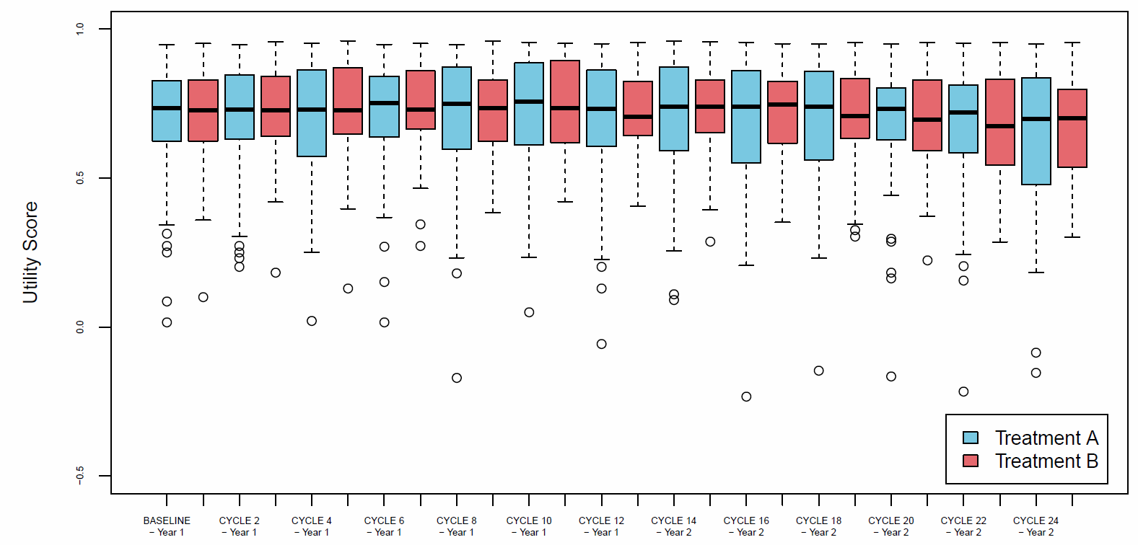
b. Global Health and QoL score
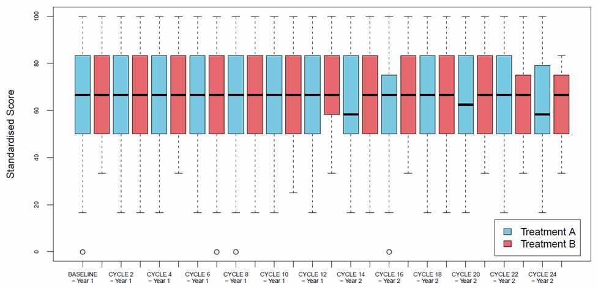

Estimated utility and Global Health Score (GHS)/Quality of Life (QoL) scores were high and remained constant throughout LenMT without significant differences between treatment arms (blue: 25 mg; red: 5 mg)

